CRITERION - 7



7.2.1
Best Practice-1
School Visit Photos

Photos of Workshop on “Basics of Arduino Programming” for students of SDPT, Kateel conducted on 17.02.2023

The aim of the workshop was to teach the Basics of Arduino Programming for the students of SDPT, Kateel by first- and Second-year Engineering Students.
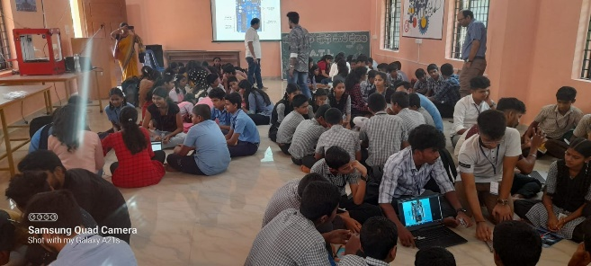

Workshop in progress

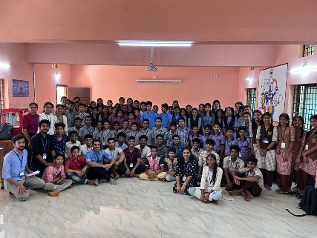

Students of AJIET and SDPT, Kateel

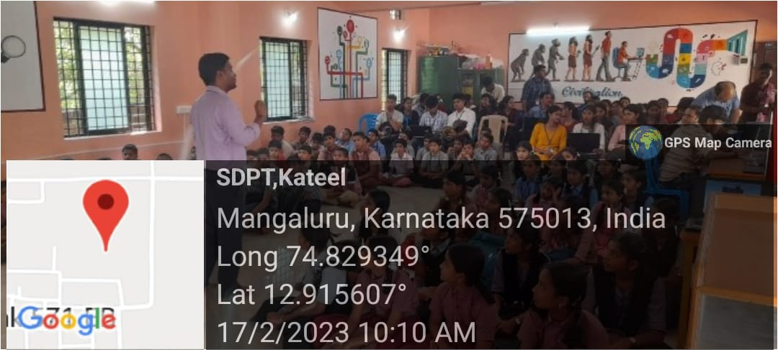

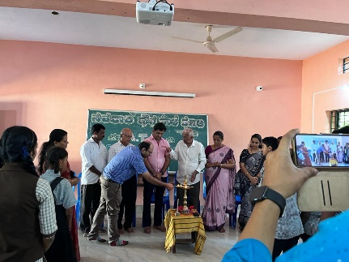

Inauguration of workshop

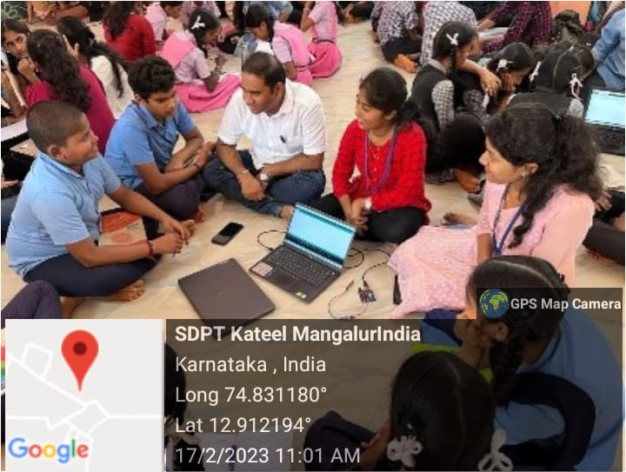

Interaction with students

Photos of Workshop on “Basic of Arduino Programming” for high School Students of SDPT, Kateel held on 28.03.2023

The Aim of the event was to teach the Basics of Arduino Programming for high School Students of SDPT, Kateel.

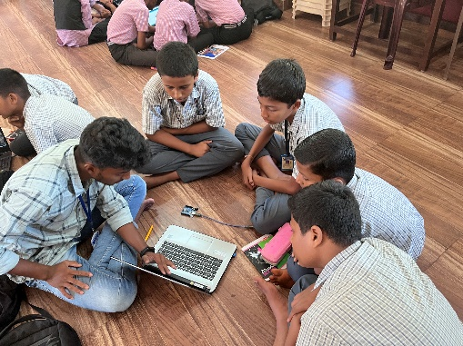

Workshop in progress

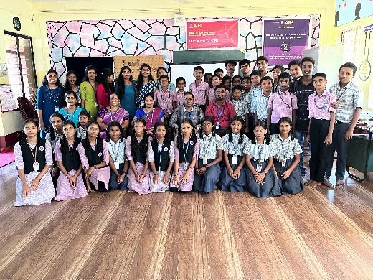

Students of AJIET and SDPT, Kateel with faculty

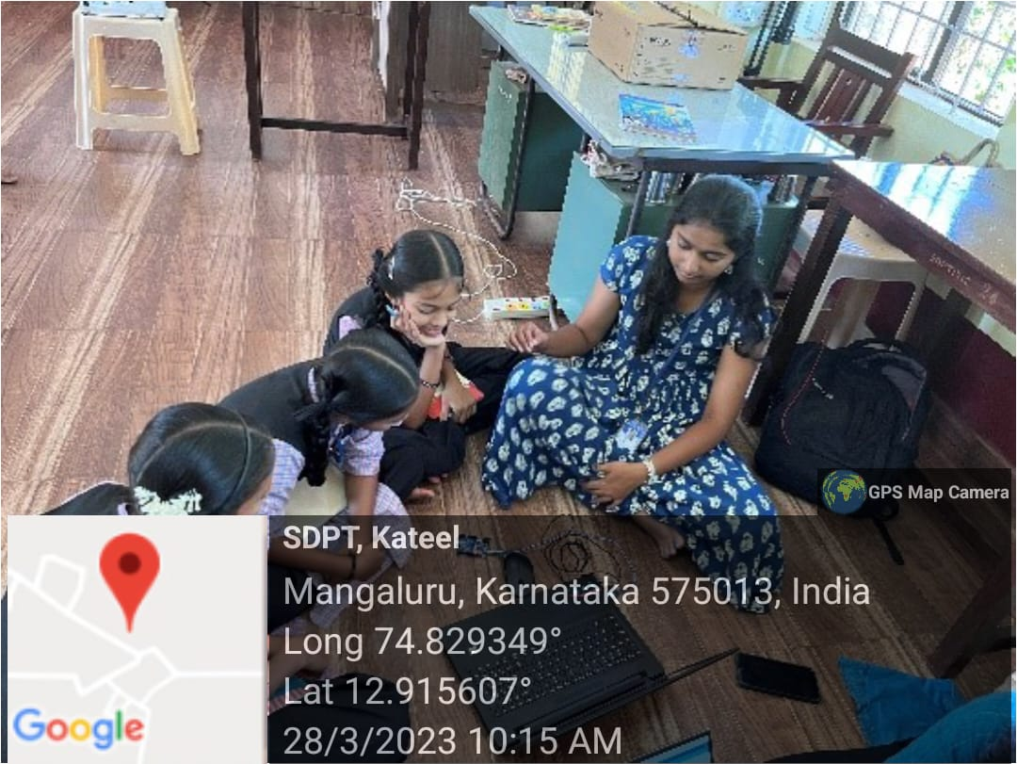

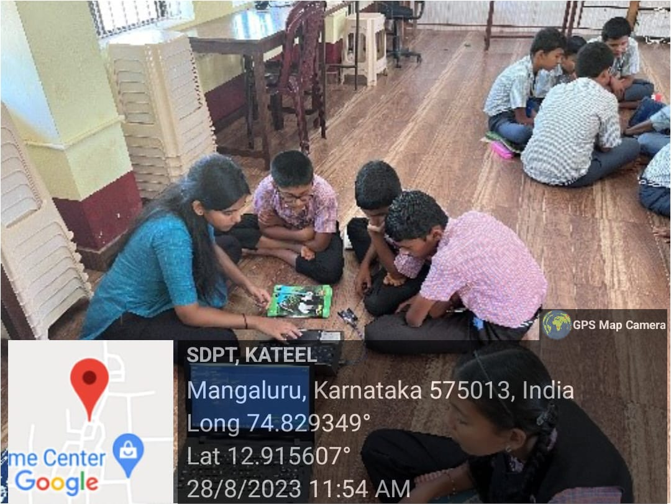

Photos of workshop on “Basics of Electronics” for students of SDPT, PU College on 04.08.2023
The Aim of the workshop was to teach the “Basics of Electronics” for students of SDPT, PU College.

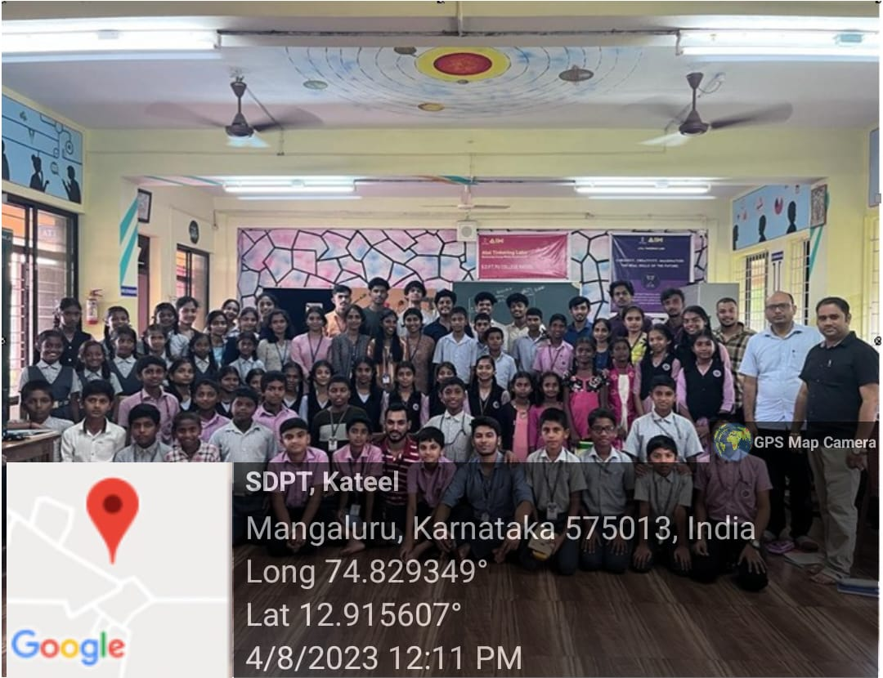
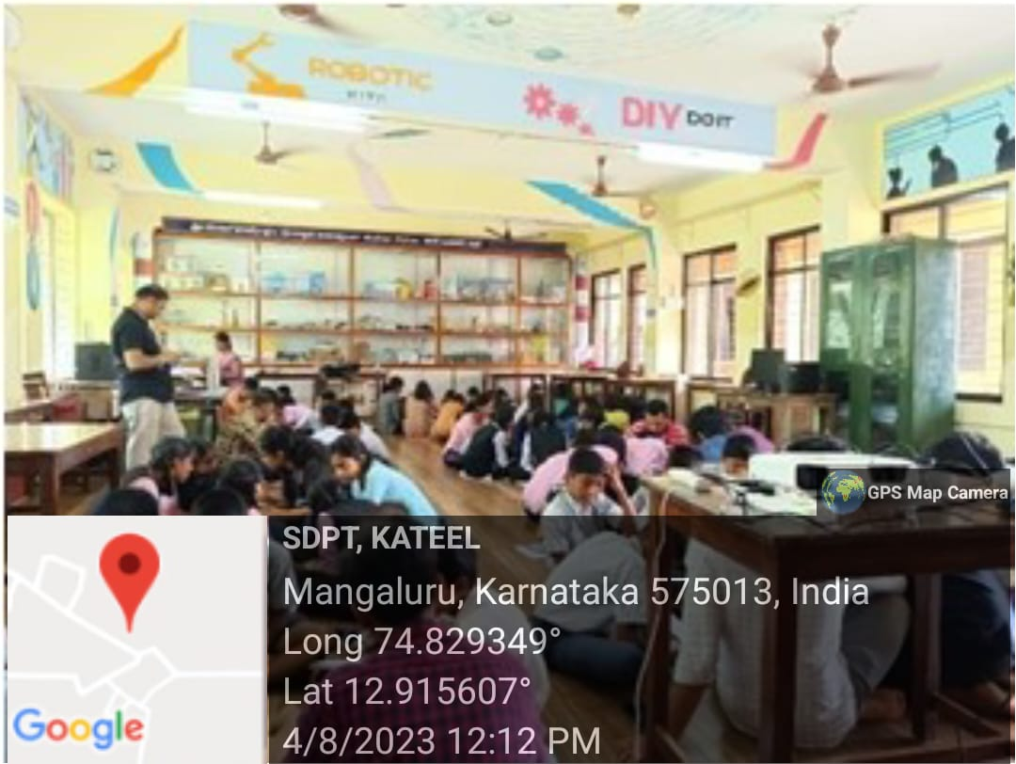

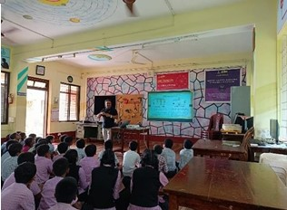

Photos of Workshop on “Basics of Electronics” for high School Students of Government High school, Koyla 25.07.2023
The Aim of the event was to teach the Basics of Electronics for high School Students of Government High school, Koyla

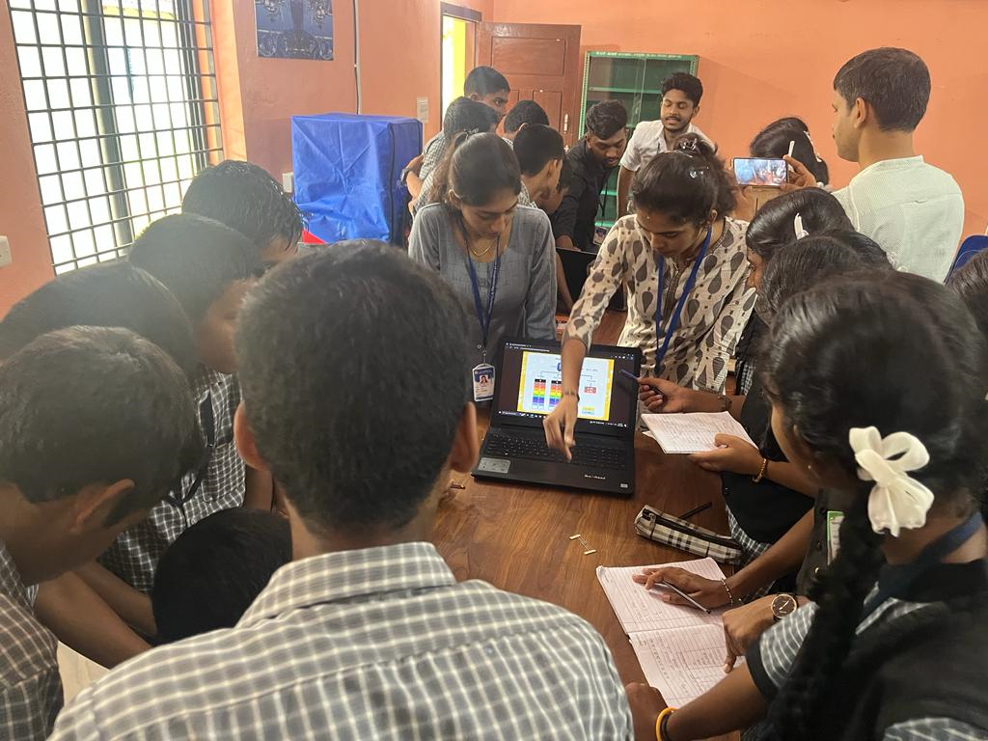
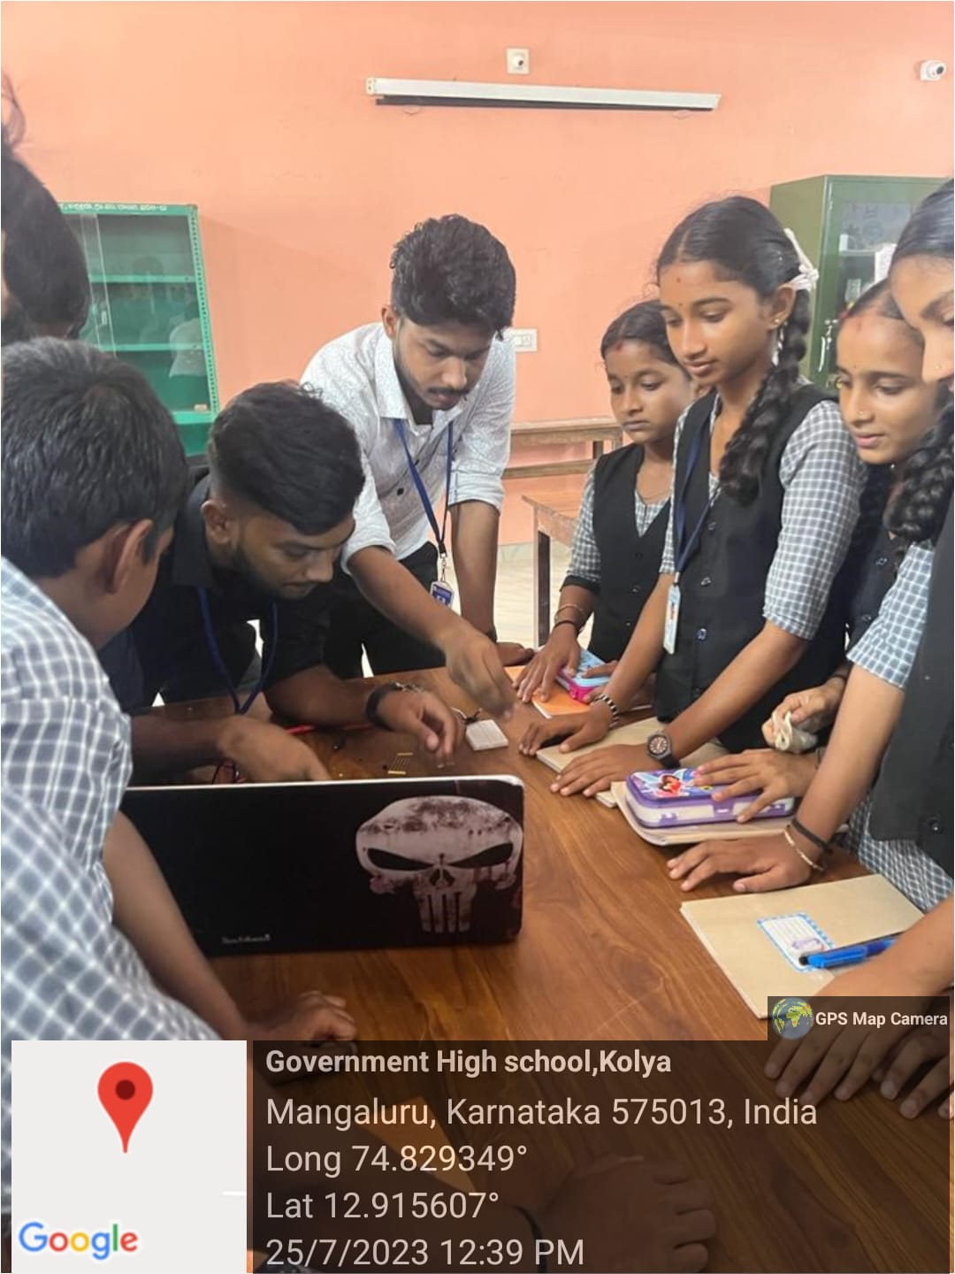
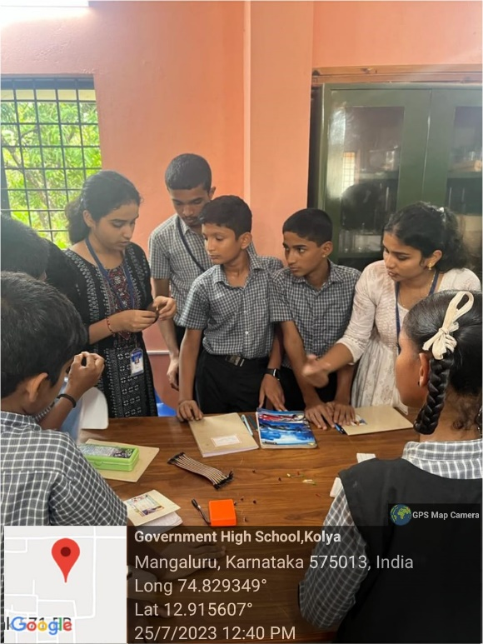
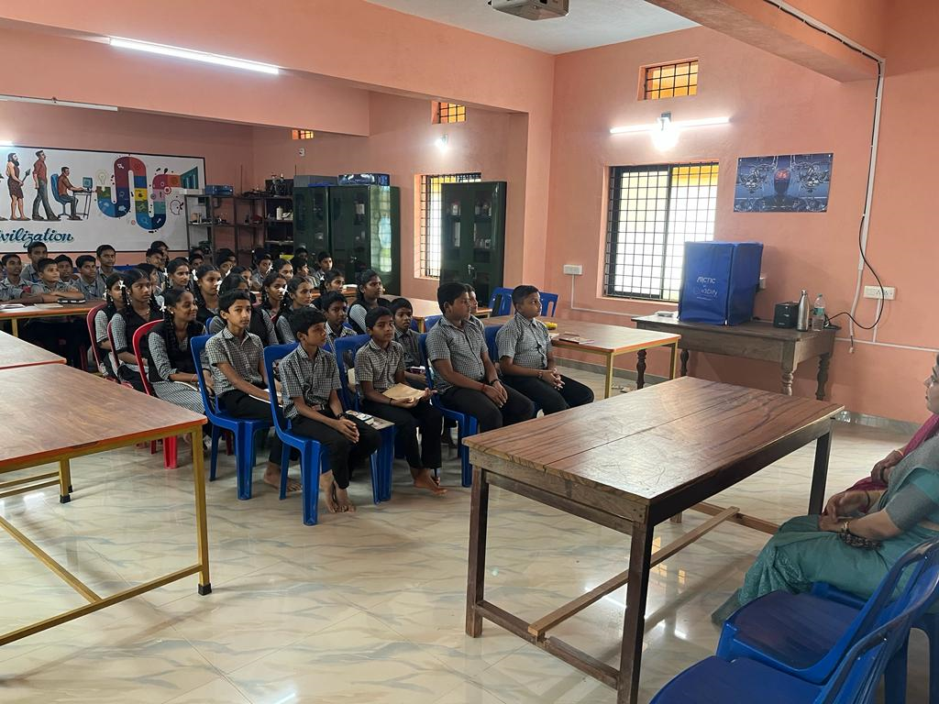
Photos of Outreach program conducted on D.K.Z.P.M. Higher Primary School, Kodical, Mangaluru 06.04.2022
IEEE student Branch of AJIET organised 1-day Visit to D.K.Z.P.M. Higher Primary School, Kodical, Mangaluru. The main Aim of the Visit is to, interact with Faculties & Students.

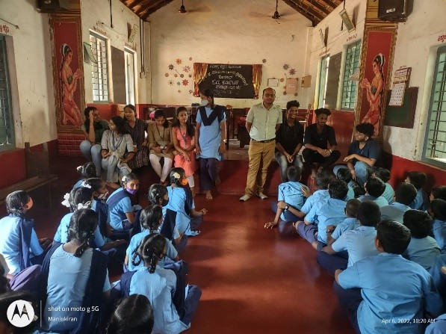
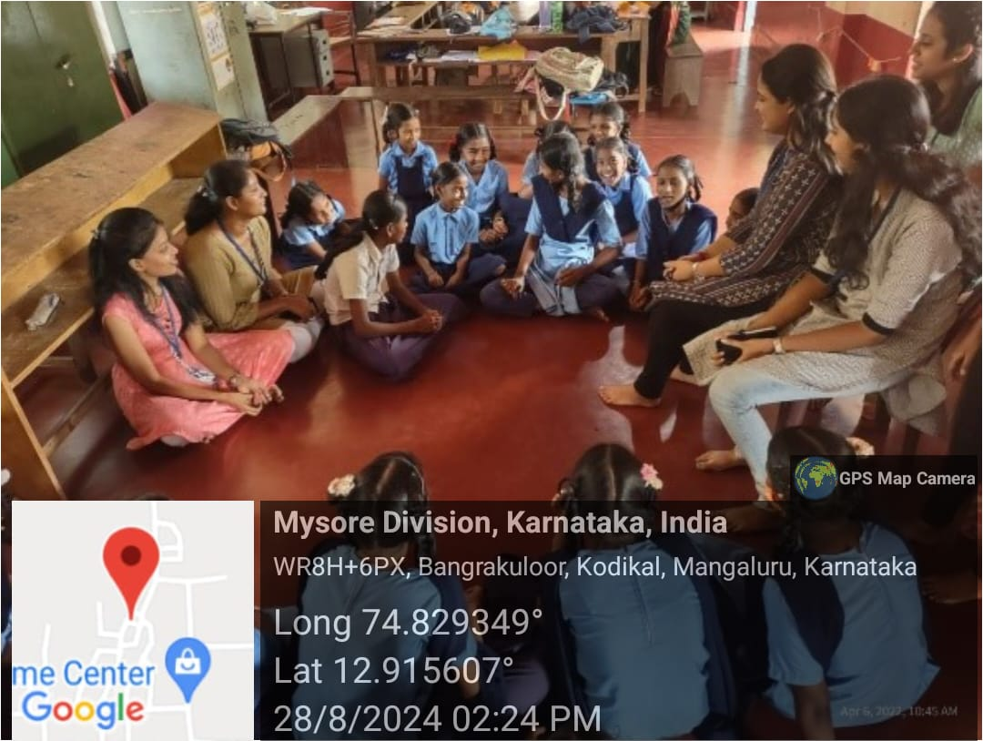

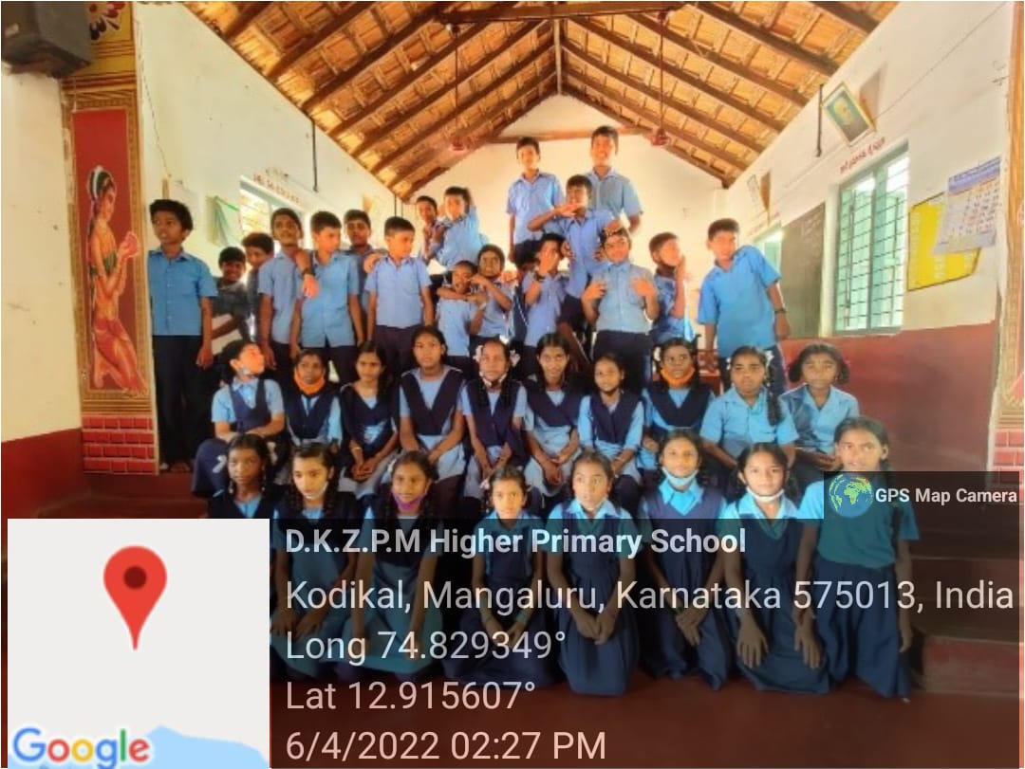
Report on “One day exposure visit by school students vidyadayinee High School, Surathkal to IIC Institute and interaction with AJIET Student Innovators ” 30.07.2024

The primary objective of a project exposure visit is to enable participants (such as community members, practitioners, or development professionals) to learn from the experiences of others outside their own community.
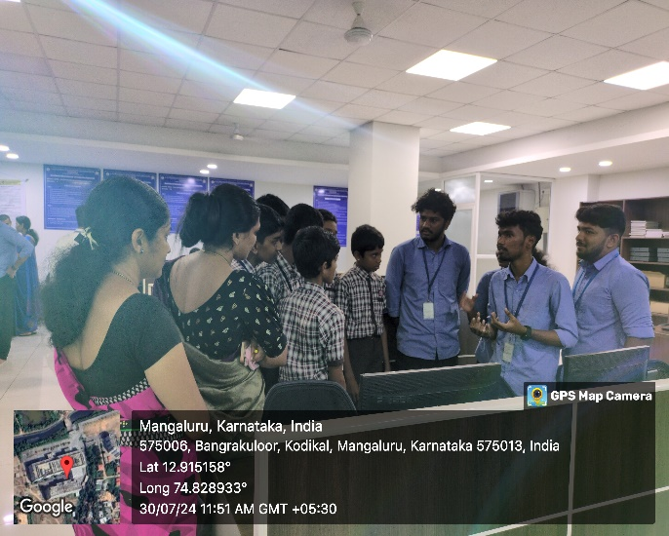
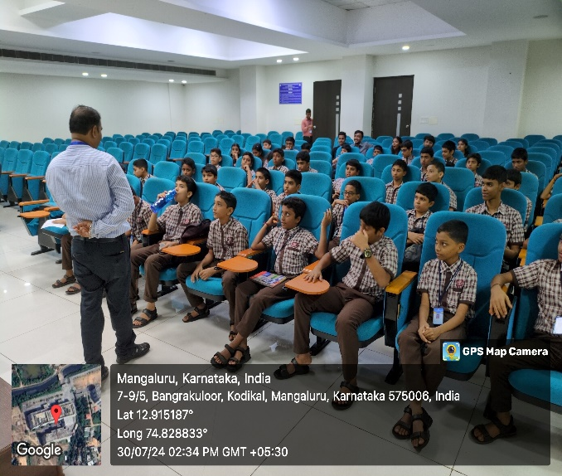

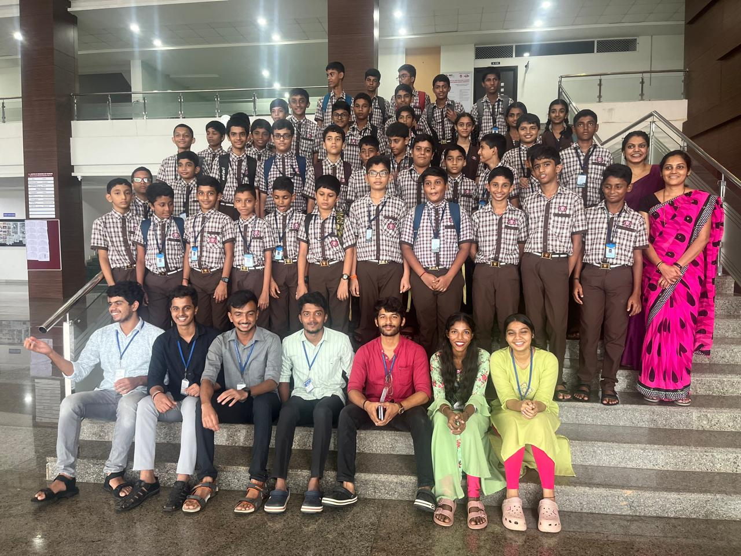
Photos of “ATAL TINKERING LAB 1 DAY Workshop in Government High School Koila, Mangalore.”on 04/03/2024

A team of 10 students from various departments and one faculty members (Dr. Sreejith B K), visited Government High School Koila on 26/02/2024 (10 am – 4 pm) to conduct ATAL TINKERING LAB 1 DAY Workshop. The participants learned how to make a 3D Design a Spanner and 3D Print it, as well as wood work to make a Birdhouse.

