Date: 30/10/2023
Report on Technical Talk of
“Introduction to AI+data+CRM by salesforce”

Name of the Program: | Technical talk on “Introduction to AI+data+CRM by salesforce:Learn on Trailhead” | Program Date & Timings: |  | 30/10/2023,  11:00 AM onwards
Organized by  (Clubs/ Dept.) | Dept of CSE & ISE | In Association  with (clubs)
Number of Participants | 200 | Students | 180 | Faculty | 20
Program Outcome (PO)  Mapping | PO1, PO2, PO3, PO4, PO5, PO6,PO9
Coordinators | Mr.Stanley D’souza-Coordinator Dept.of CSE Mrs.Ashwitha Shetty-Coordinator Dept.of CSE Mrs.Arpitha .G-Coordinator Dept.of ISE

Objectives: The program enable students/ faculty to:
- Introducing history of AI and various projects that use artificial intelligence.
- Importance of CRM and its applications.
- Introduction to some of the areas of research that can be considered for study.
- Discussion on some of the current technologies and its uses.

About the Program:
The technical talk was held with a lot of fervour and determination on October 30, 2023, at 11:00 AM in seminar hall-1 at the A J Institute of Engineering and Technology, Mangalore. To introduce the concept of AI+Data+CRM was the goal of the talk.
The master of ceremonies for the event was Prakruthi Shetty, a final-year student in the department of computer science and engineering (CSE). The event started with invoking God's blessing by a prayer song by Athreya, a Final-year student from the Computer Science and Engineering (CSE) department.
Mr.Stanley D’souza, Assistant Professor from the Computer science Department, delivered a heartfelt welcome speech, evoking a sense of joy among the attendees. A floral welcome was extended to the

distinguished guests. A ceremonial lighting of the lamp was conducted to symbolize the spread of knowledge and positivity. Esteemed guests graced the occasion by participating in the lamp lighting.
Dr. Shantharama Rai C, the respected principal of AJIET, shared his thoughts on the value of keeping up with the latest technological developments and how they aid in students' placement.
Mrs.Ashwitha shetty, Assistant Professor from the CSE department, introduced the esteemed chief guest, setting the stage for a valuable exchange of ideas.
Mr. Santosh Rebello, University Programme Manager for Salesforce Mulesoft in India, gave a thought-provoking keynote address that offered insightful observations. In addition to giving an overview of AI data and CRM, his session gave attendees a sense of the newest and most popular research topics and technological advancements. He also discussed the benefits and limitations of some of the technology currently in use.
In recognition of Mr. Santosh Rebello's insightful speech, a memento was given to him. In order to foster a sense of cohesion and collective success, Mrs. Arpitha G, Assistant Professor in the Department of Information Science, sincerely thanked everyone who helped make the event a success.
Outcomes: On successful completion of program the student should be able to:Know about the growth of artificial intelligence and its various projects.Students gained an understanding of CRM's significance, its applications across a range of industries, and the reasons behind an organization's use of CRM.The students acquired information about popular research topics and resources for obtaining quality problem statements for their impending projects.
Articulation Matrix:

Course Outcomes (CO) | Program Outcomes (PO)
Course Outcomes (CO) | 1 | 2 | 3 | 4 | 5 | 6 | 7 | 8 | 9 | 10 | 11 | 12
1 | 2 | 2 | 1
2 |  |  |  |  | 3 | 1
3 |  |  |  | 1 |  |  |  |  | 2
Average | 2 | 2 | 1 | 1 | 3 | 1 |  |  | 2

Photos:

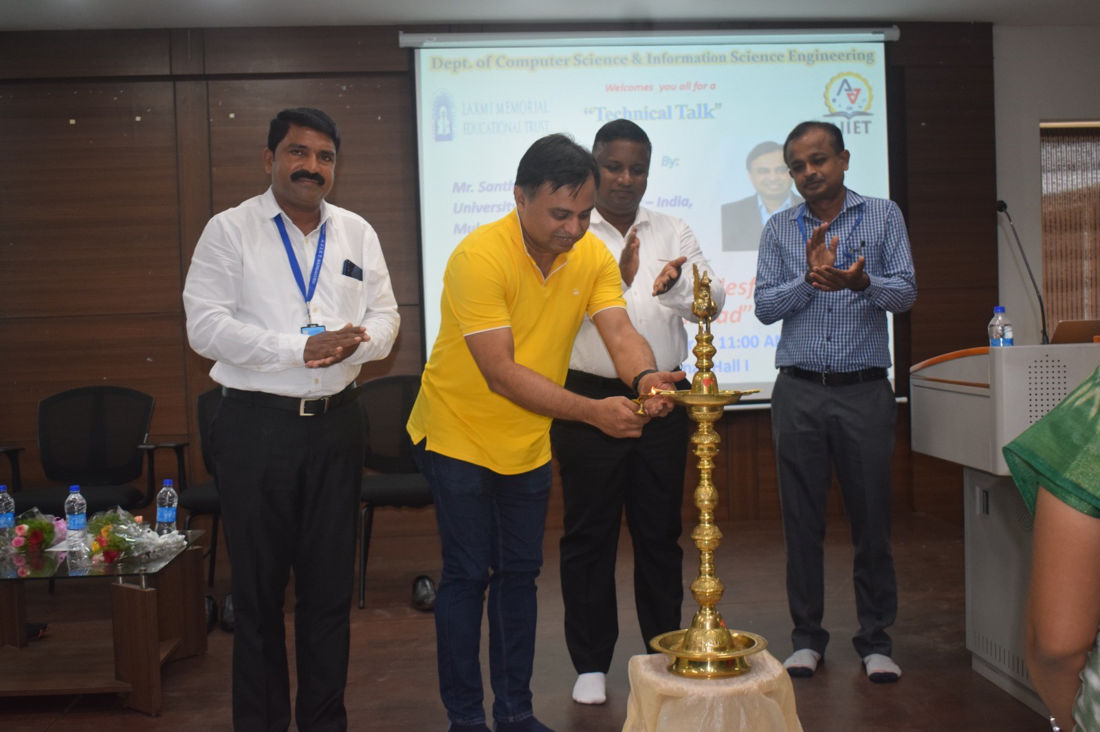
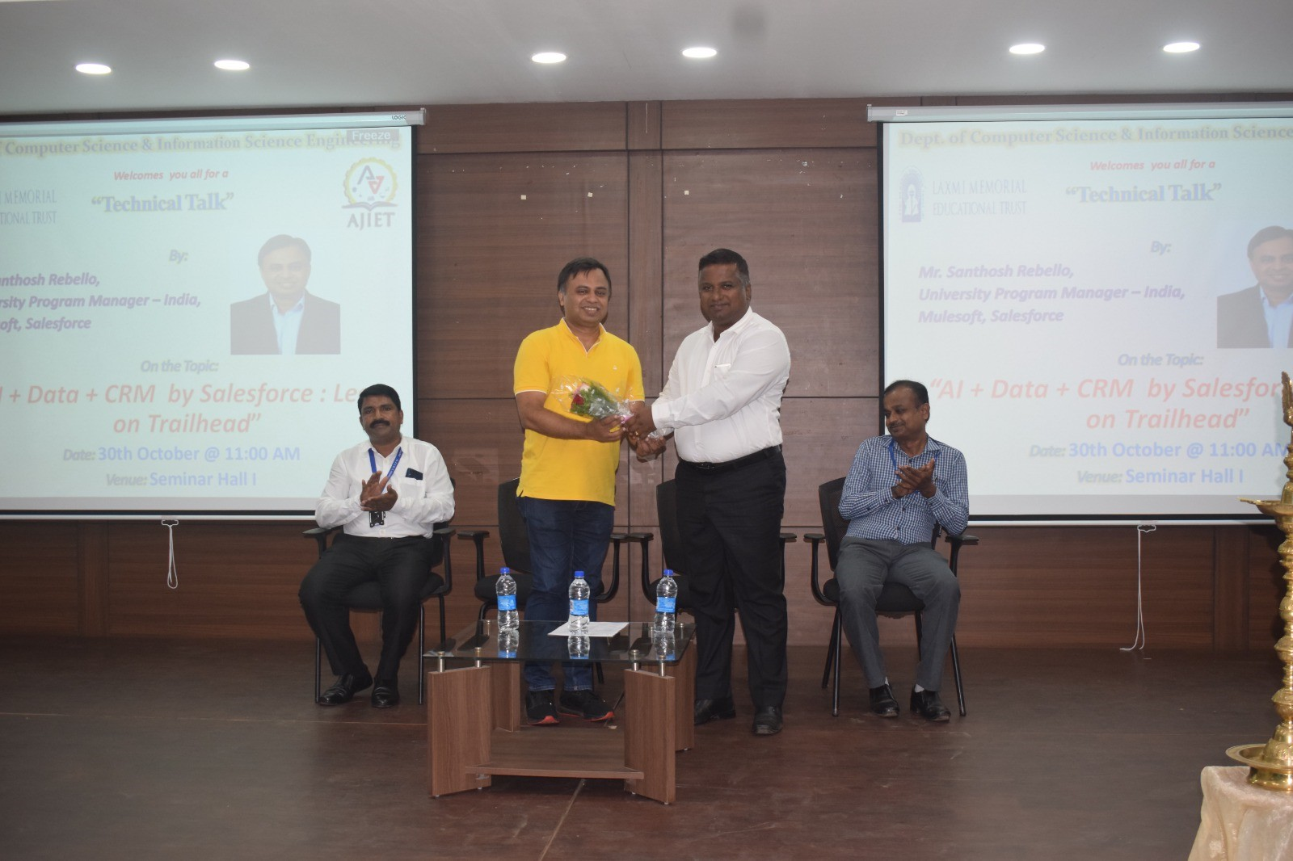
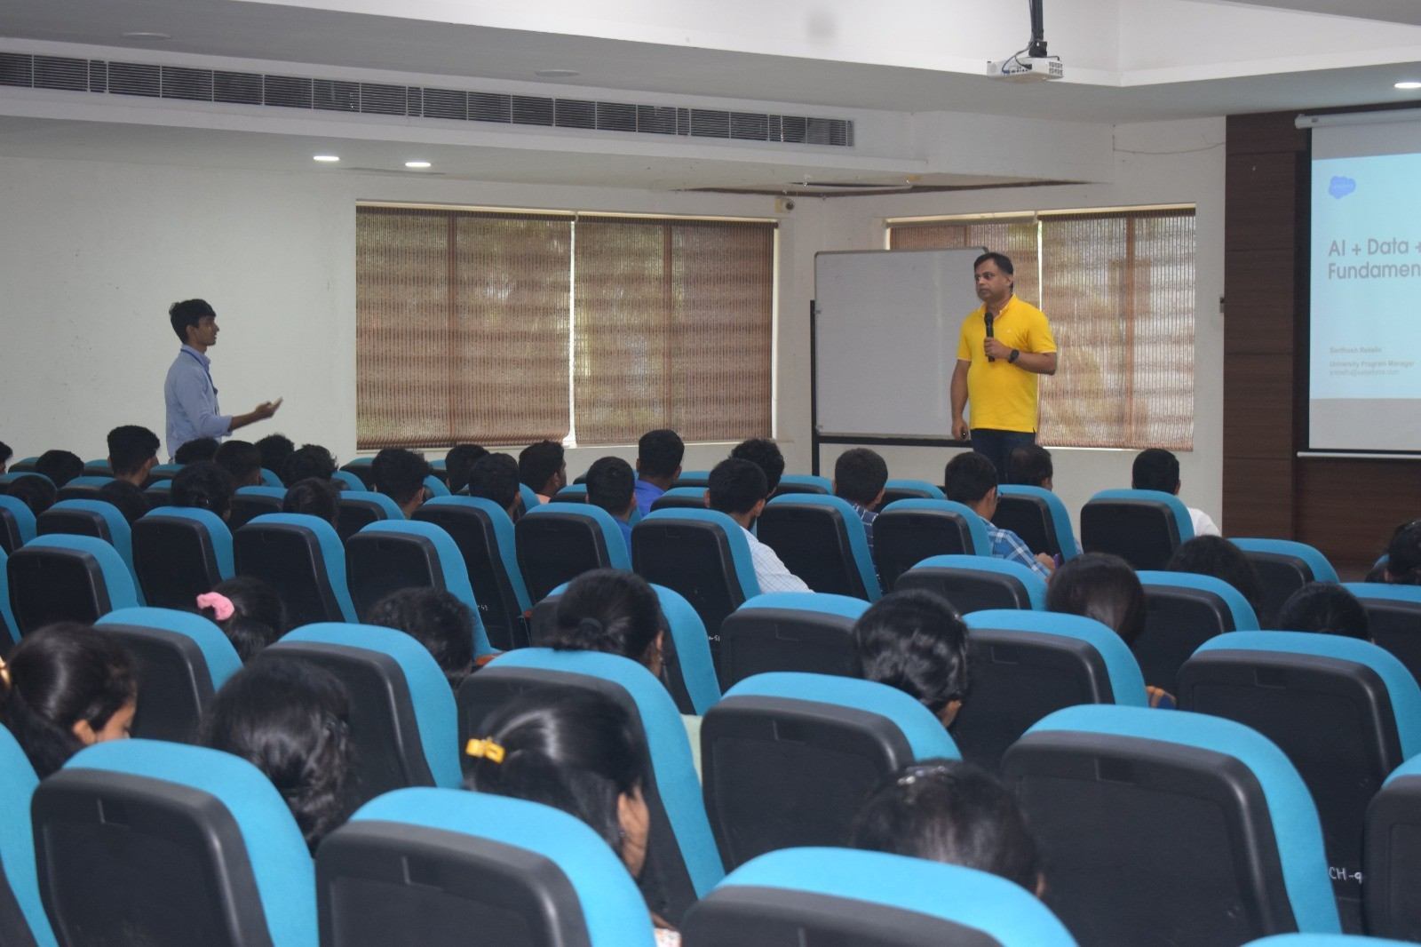
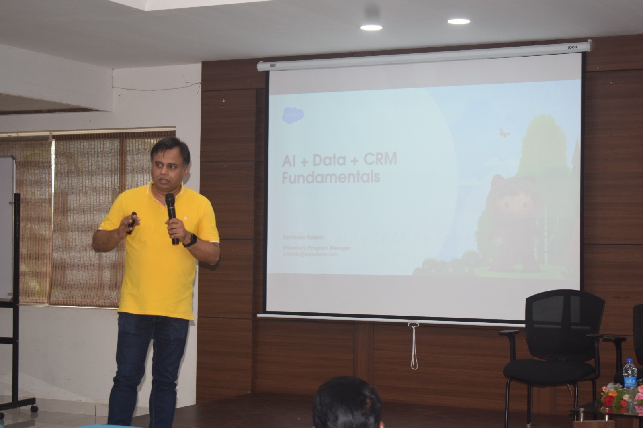
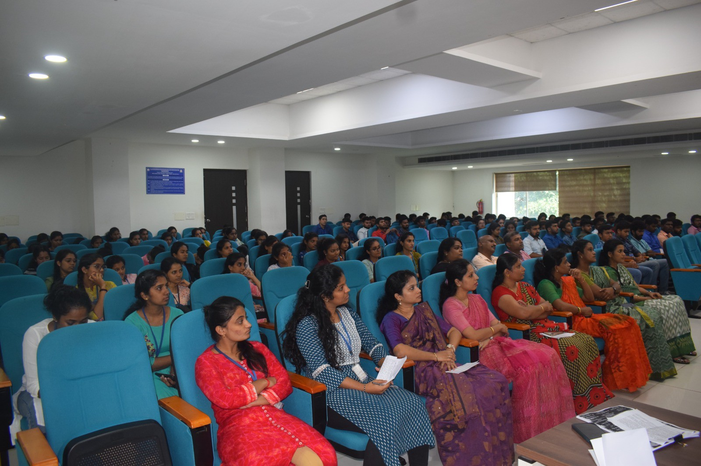

Mr.Stanley D’souza | Mrs. Ashwitha shetty | Mrs. Arpith G
Coordinator Dept. of CSE | Coordinator Dept. of CSE | Coordinator Dept. of ISE

Dr.Suresha .D | Dr.Antony P J | Dr.Shantharama Rai.C
HOD | Vice principal & HOD | Principal ,AJIET
Dept.of ISE,AJIET | Dept. of CSE,AJIET

