CRITERION - 7


7.1. 2.1
Alternate sources of energy and energy conservation measures
Supporting Documents

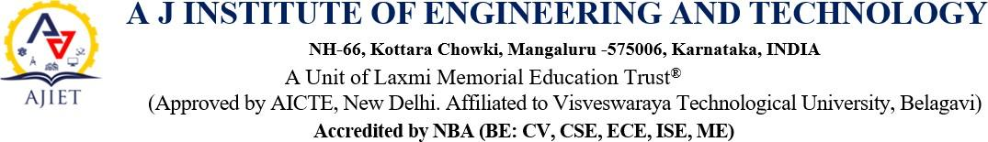

: The Institution has facilities for
      - Alternate sources of energy and energy conservation measures

Management of the various types of degradable and non-degradable waste
      - Water conservation

Green campus initiatives
      - Disabled-friendly, barrier free environment

BILLS
The institution has facilities and initiatives for |  |  | Bills
1 | Alternate Sources of  energy and energy conservation measures | 1. Solar energy | View Document
1 |  | 2. Use of LED Bulbs/Power  efficient Equipment’s | View Document
2 | Management of various types of degradable and  non-degradable waste | Solid/Liquid waste management and recycling system | View Document
3 | Water conservation | Rain water harvesting, Conservation and recycling | View Document
4 | Green campus initiatives | Landscaping with trees and Plants | View Document
5 | Disabled friendly barrier free environment | Lift | View Document
5 | Disabled friendly barrier free environment | Wheelchair | View Document

