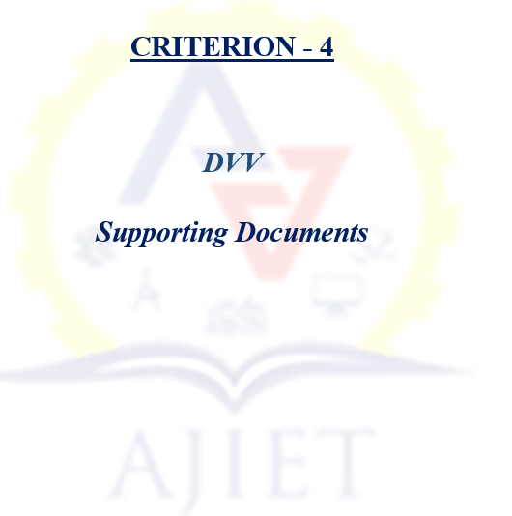

Metric | DVV Findings | Description | Document
4.1.2 | 1.HEI is requested to kindly note that Focus of this metric is on to acquiring new infrastructure. Thus, Expenditure on the Camera, Computer & Accessories, Gym Material, Library Books, Software & Networking. etc are not considered. So please relook and provide correct revised data. | As mentioned, the expenditure on the Camera, Computer & Accessories, Gym Material, Library Books, Software & Networking. etc are removed and the data is revised as per the requirement.  Institutional data in the prescribed format is attached. | View Document  (To be updated)
4.1.2 | 2. Kindly note that Audited statement of Income and Expenditure should be in the name of applicant HEI only, but not in the name of TRUST. / SOCIETY. /FOUNDATION | As mentioned, the Audited statement of Income and Expenditure is in the name of HEI: A J Institute of Engineering and Technology, Kottara Chowki, Mangaluru | 2019-20 Audit Report  2020-21 Audit Report  2021-22 Audit Report  2022-23 Audit Report  2023-24 Audit Report
4.1.2 | 3.Kindly Must provide Year-wise audited income and expenditure statement and highlight the expenditure, excluding salary for infrastructure augmentation during the last five years, duly sealed and signed by the head of the institute and C.A both. As per revised data.
4.1.2 | 4.Kindly provide a CA certificate for Expenditure for infrastructure augmentation, excluding salary year- wise during the last five years (INR in lakhs) duly signed and sealed by the Head of the Institute and C.A. both.
4.1.2 | 5. Kindly provide any relevant data or documents related in this metrics (if available).
4.3.2 | 1.HEI is requested to Please provide stock register and HIGHLIGHT the entries of computers purchased in the stock register.
4.3.2 | 2.Please provide bills for the purchase of computers and kindly HIGHLIGHT the relevant entries bills for the purchased of the computer.
4.3.2 | 3.Kindly note that number of computer available for students use only to be considered.
4.3.2 | 4.Please note that computer purchased after the latest completed A.Y will not be considered.
4.3.2 | 5.Please note that computer for office and faculty will not be considered under this metric.
4.4.1 | 1. HEI is requested to kindly note that Focus of this metric is only on the repair and maintenance of physical facilities and AMC for academic facility. Thus, Expenditure on Examination Fee Paid, Vehicle Maintenance, Remuneration to exam conduction, Electricity Charges, Mess Bill Housekeeping Expenses, etc., should not be considered, so please relook and provide correct revised data.
4.4.1 | 2.Kindly note that Audited statement of Income and Expenditure should be in the name of applicant HEI only, but not in the name of TRUST. /SOCIETY. /FOUNDATION.
4.4.1 | 3.Kindly Must provide Year-wise Audited income and expenditure statement and HIGHLIGHT the expenditure, excluding salary for maintenance during the last five years, duly sealed and signed by the head of the institute and C.A both. As per revised data.
4.4.1 | Kindly provide a CA certificate for Expenditure for maintenance, excluding salary year- wise during the last five years (INR in lakhs). duly signed and sealed by the Head of the Institute and C.A. both.
4.4.1 | Kindly provide any other relevant data or documents related in this metrics (if available).

