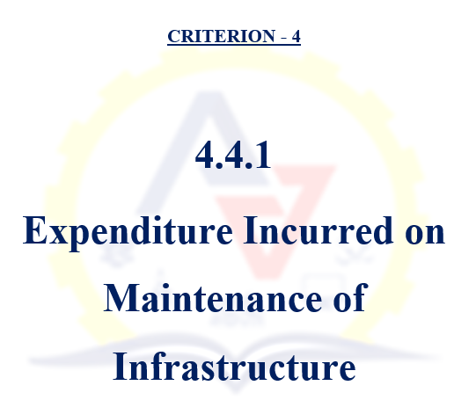

    - Expenditure incurred on maintenance of physical facilities and academic support facilities excluding salary component year wise during last five years (INR in lakhs)
Sl. No. | Description |  | Document
1 | Institutional details as per data template |  | View Document
2 | Letter of expenditure incurred on maintenance |  | View Document
3 | Audited statement | 2023-24 | View Document
3 | Audited statement | 2022-23 | View Document
3 | Audited statement | 2021-22 | View Document
3 | Audited statement | 2020-21 | View Document
3 | Audited statement | 2019-20 | View Document
4 | Maintenance Policy |  | View Document
5 | Sample Bill Copy of Maintenance | Lift | View Document
5 | Sample Bill Copy of Maintenance | Water Purifier | View Document
5 | Sample Bill Copy of Maintenance | UPS | View Document
5 | Sample Bill Copy of Maintenance | Sewage Treatment | View Document
5 | Sample Bill Copy of Maintenance | Anti-Termite Treatment | View Document
5 | Sample Bill Copy of Maintenance | AC | View Document
5 | Sample Bill Copy of Maintenance | Tally Software | View Document

