CRITERION - 4
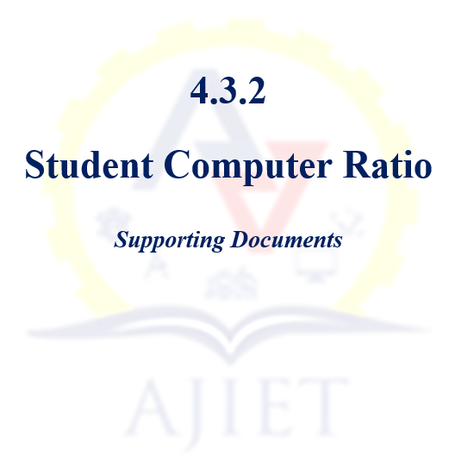

4.3.2 Student – Computer ratio (Data for the latest completed academic year):

Number of Students: 1250
Number of Computers: 826

Sl. No. | Description | Document
1 | Statistics of number of computers in the Institution | View Document
2 | Computing facilities in the Institution certified by the Principal | View Document
3 | Stock Register Extract | View Document
4 | Invoice of the computer purchase | View Document

