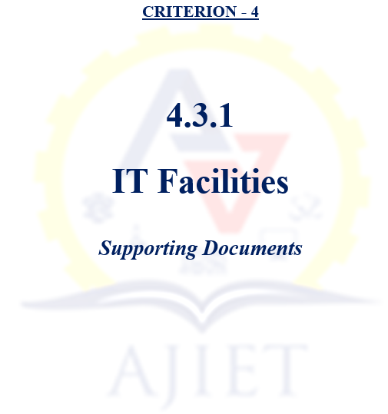

4.3.1 Institution has an IT policy covering wi-fi, cyber security, etc., and allocated budget for updating its IT facilities. The details are given below.

Sl. No. | Description | Document
1 | IT Policy | View Document
2 | Computing facilities in the Institution certified by the Principal | View Document
3 | Stock Register Extract | View Document
4 | Invoice of the computer purchase | View Document
5 | Invoice of the Laptop purchase | View Document
6 | Sample photos of computing facilities in the Institution | View Document
7 | Internet upgrading documents from 300 Mbps to 500 Mbps | View Document
8 | System Software and Application software list | View Document
8 | Invoice of System Software | View Document
8 | Invoice of Application Software | View Document
9 | Networking Facilities (Sever, firewall) | View Document
9 | Invoice of Networking Facilities (Sever, firewall) | View Document
10 | Projector Details | View Document
10 | Invoice of Projector | View Document
11 | Printer Details | View Document
11 | Invoice of Printer | View Document
12 | UPS Details | View Document
12 | Invoice of UPS | View Document
13 | CCTV Installation Details | View Document
13 | Invoice of CCTV Purchase | View Document

