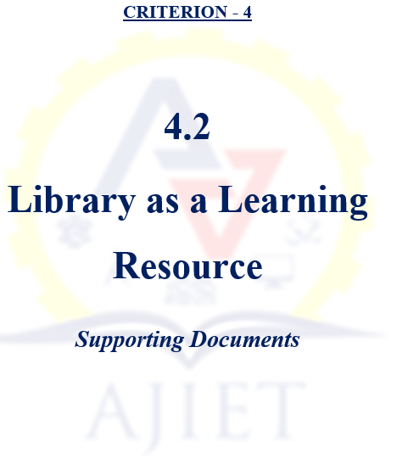

4.2.1 Library is automated using Integrated Library Management System (ILMS), subscription to e-resources, amount spent on purchase of books, journals and per day usage of library and the details are as follows:

Sl. No. | Description | Document
1 | Library Flow | View Document
2 | EASYLIB Library Management System Software Screenshot | View Document
3 | Library Policy and its Usage | View Document
4 | Geotag photos library Infrastructure | View Document
5 | Library Usage | View Document
6 | Accession Register | View Document
7 | Library Book Purchase Bill 2023-24 | View Document
7 | Library Book Purchase Bill 2022-23 | View Document
7 | Library Book Purchase Bill 2021-22 | View Document
7 | Library Book Purchase Bill 2020-21 | View Document
7 | Library Book Purchase Bill 2019-20 | View Document
8 | Library Easylib Software Purchased and AMC Bills | View Document
9 | NDLI Membership Details | View Document
10 | Print Journals 2023-24 | View Document
10 | Print Journals 2022-23 | View Document
10 | Print Journals 2021-22 | View Document
10 | Print Journals 2020-21 | View Document
10 | Print Journals 2019-20 | View Document
11 | Students Login Information Sample | View Document
12 | Screenshot of e-resources | View Document
13 | VTU E-resources 2023-24 | View Document
13 | VTU E-resources 2022-23 | View Document
13 | VTU E-resources 2021-22 | View Document
13 | VTU E-resources 2020-21 | View Document
13 | VTU E-resources 2019-20 | View Document

