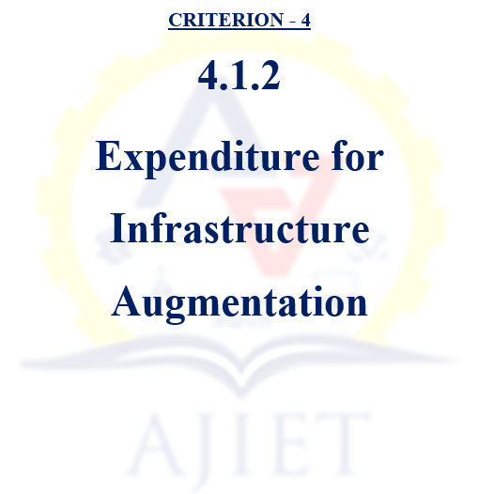

4.1.2 Percentage of expenditure, excluding salary for infrastructure augmentation during last five
years (INR in Lakhs)
Sl. No. | Description |  | Document
1 | Institutional details as per data template |  | View Document
2 | Letter of expenditure infrastructure augmentation |  | View Document
3 | Audited statement | 2023-24 | View Document
3 | Audited statement | 2022-23 | View Document
3 | Audited statement | 2021-22 | View Document
3 | Audited statement | 2020-21 | View Document
3 | Audited statement | 2019-20 | View Document

