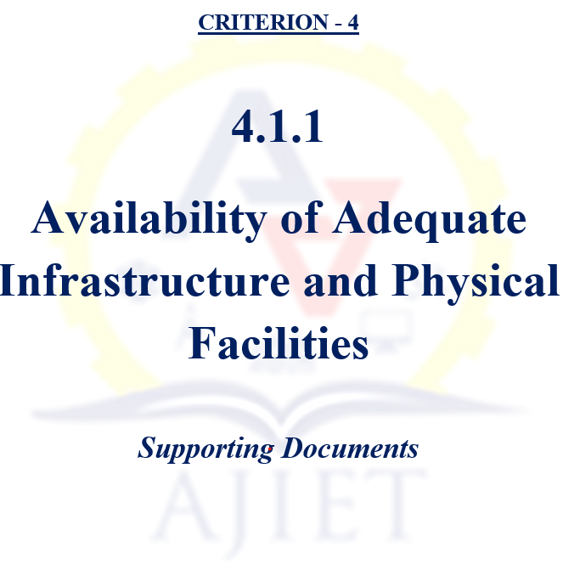

4.1 Physical Facilities

4.1.1 The Institution has adequate infrastructure and physical facilities for teaching- learning and the details are given below:
Sl. No. | Description | Document
1 | Classrooms | View Document
2 | Laboratories | View Document
3 | Seminar Halls | View Document
3 | Auditorium | View Document
3 | Conference & Board rooms | View Document
4 | Academic Section | View Document
5 | Exam Section | View Document
6 | Canteen | View Document
7 | Medical Facility | View Document
8 | Cultural Facility | View Document
8 | Cultural Policy | View Document
9 | Sports Policy | View Document
9 | Indoor Games Facility | View Document
9 | Outdoor Games Facility | View Document
10 | Gym Facility | View Document
11 | Yoga Hall | View Document
12 | Transportation | View Document
13 | Hostel | View Document

