ISE_A109_DEPARTMENT LIBRARY
FRONT VIEW
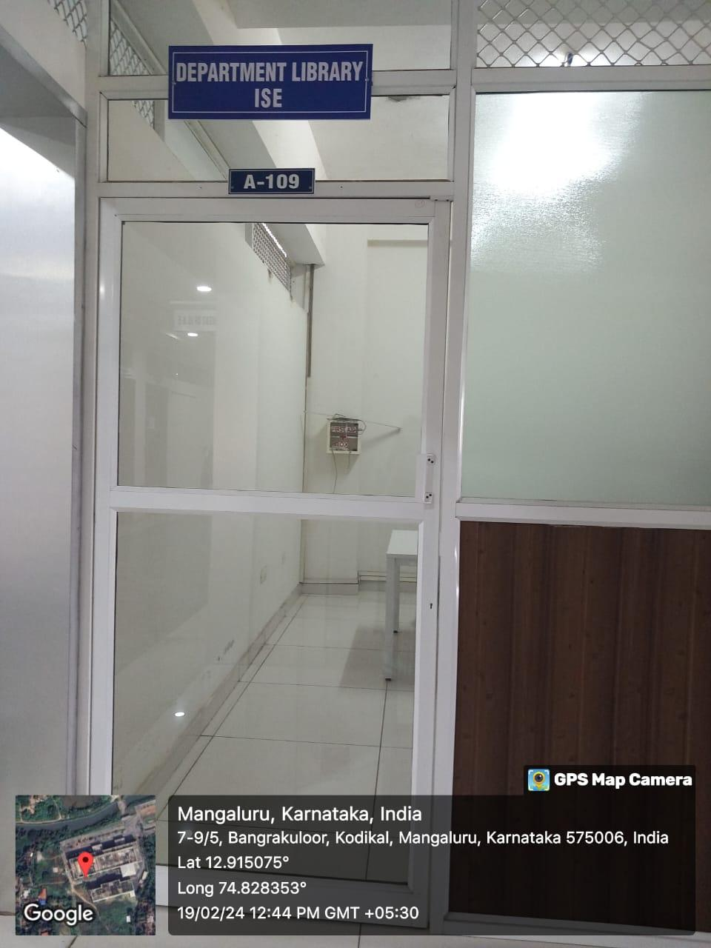

INNER VIEW
