ISE_A309_COMPUTING LABORATORY
FRONT VIEW
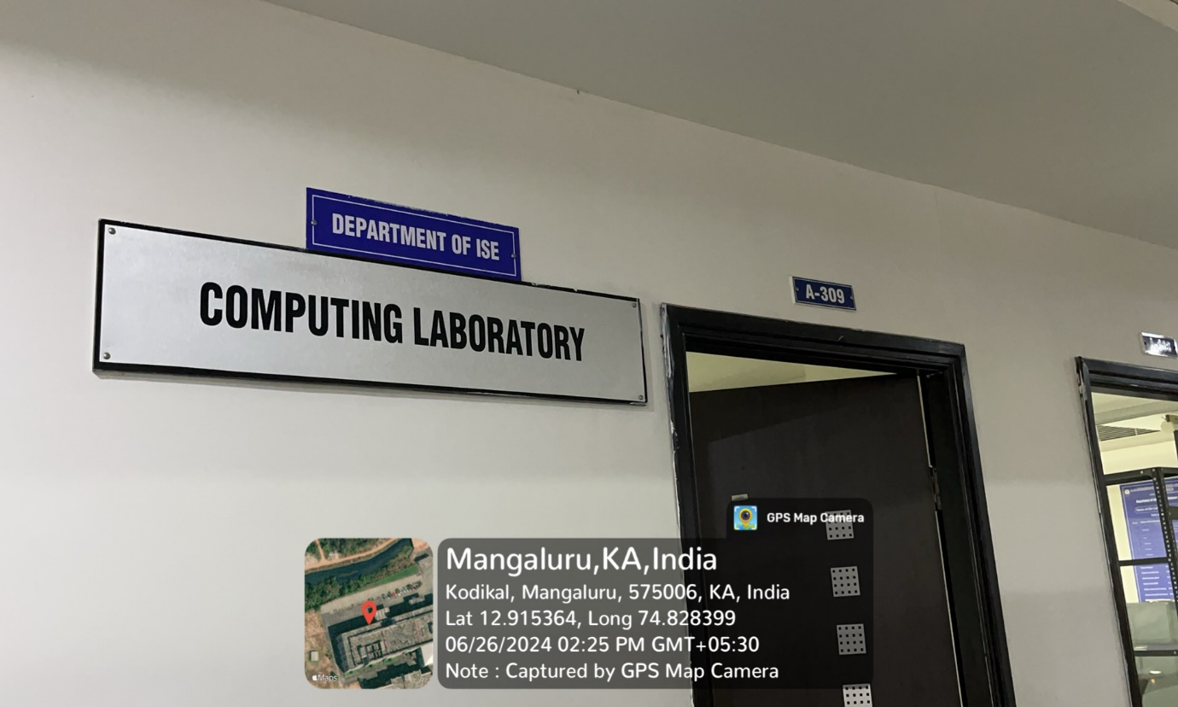

INNER VIEW
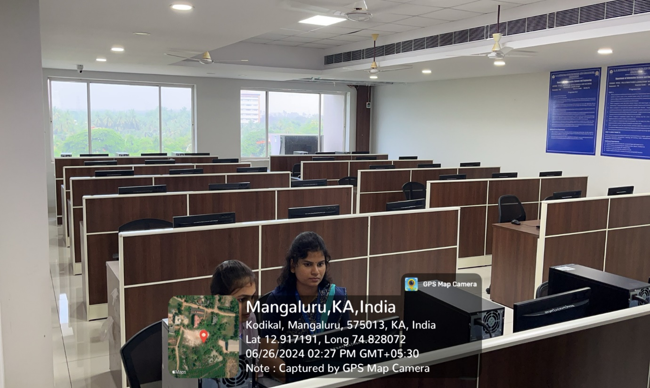

PROJECTOR (ICT TOOL)
