ISE_A308_DATA PROCESSING LABORATORY
FRONT VIEW
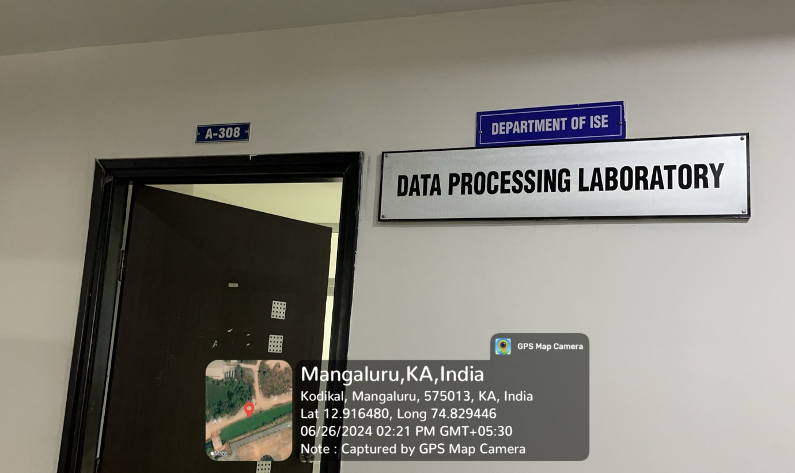

INNER VIEW
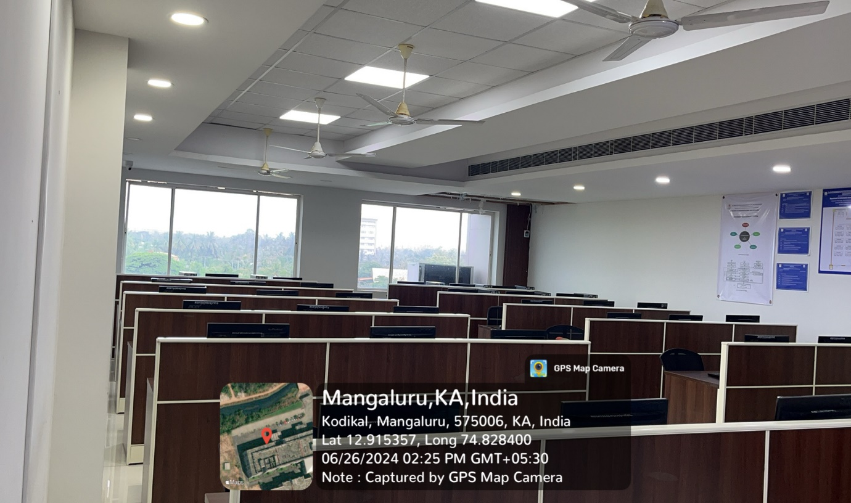

PROJECTOR (ICT TOOL)
