ISE_A306_HARDWARE LABORATORY
FRONT VIEW
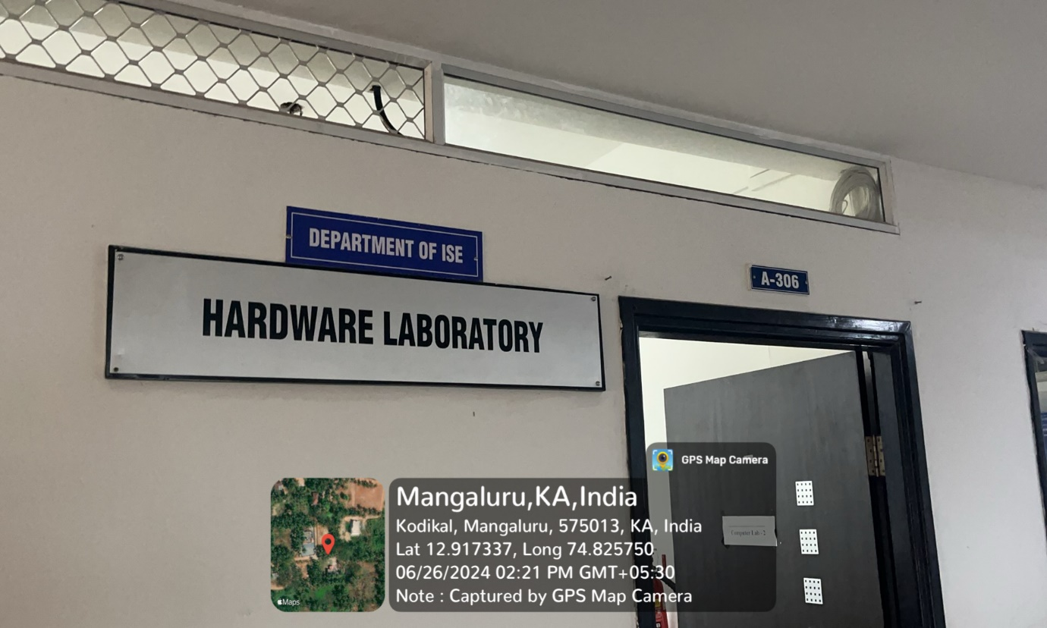

INNER VIEW_1
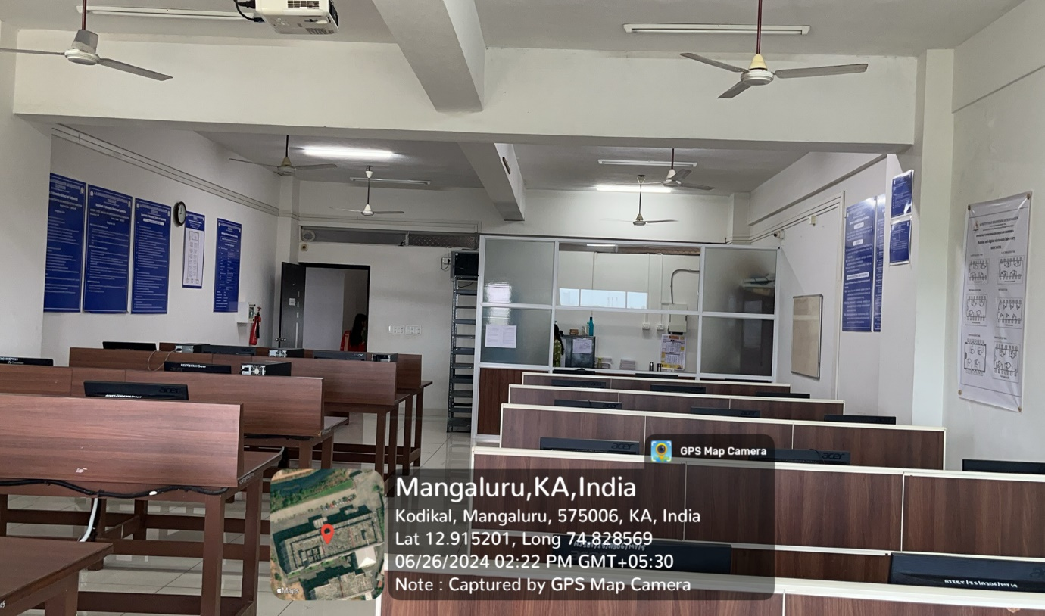

INNER VIEW_2
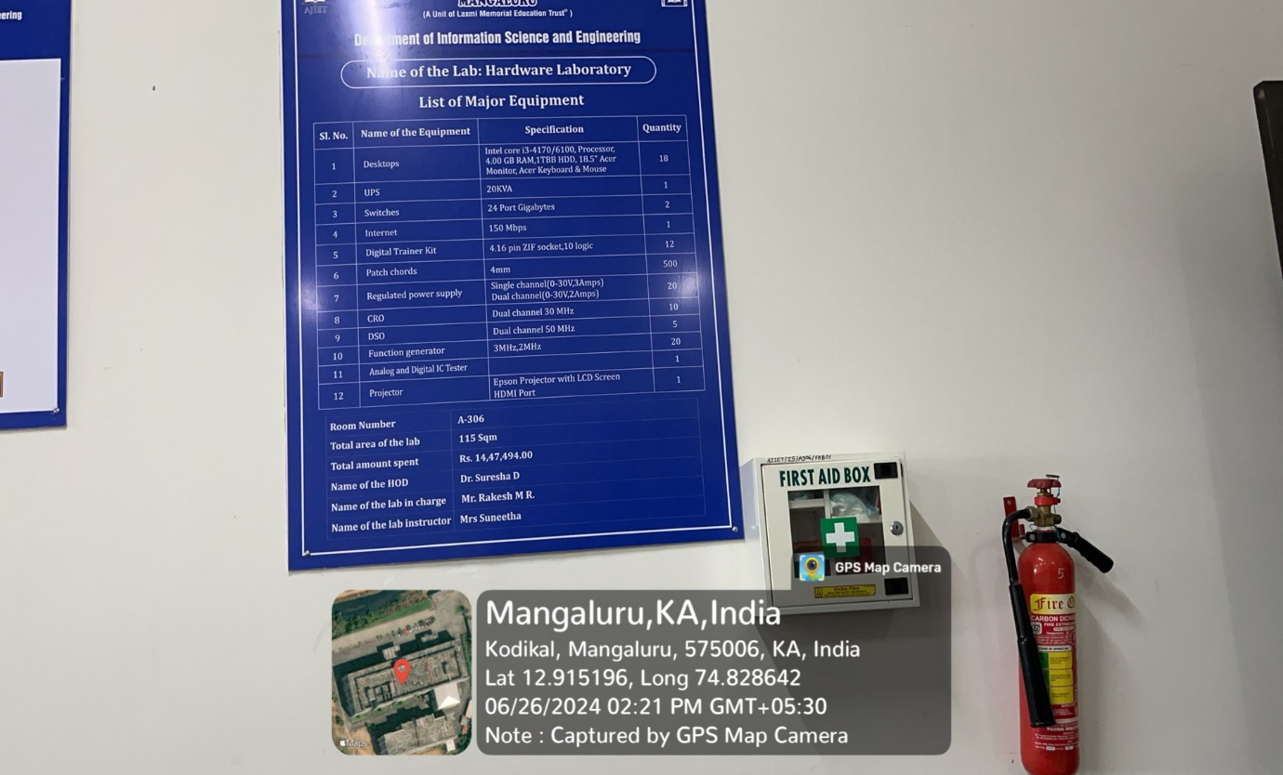

PROJECTOR (ICT TOOL)
