ISE_A305_PROJECT/RESEARCH LABORATORY
FRONT VIEW
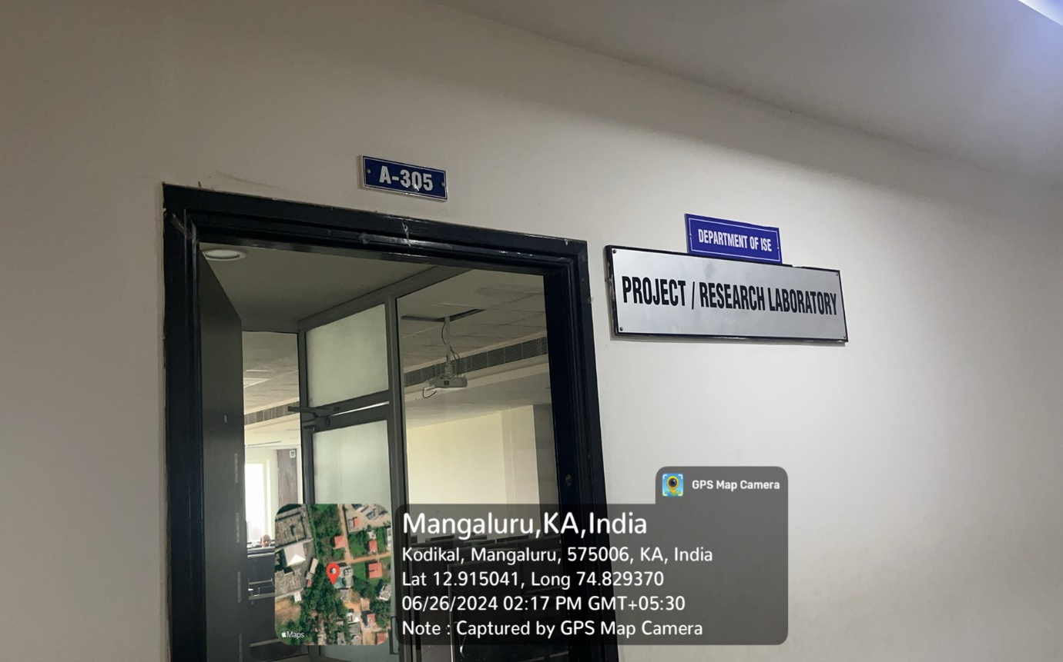

INNER VIEW
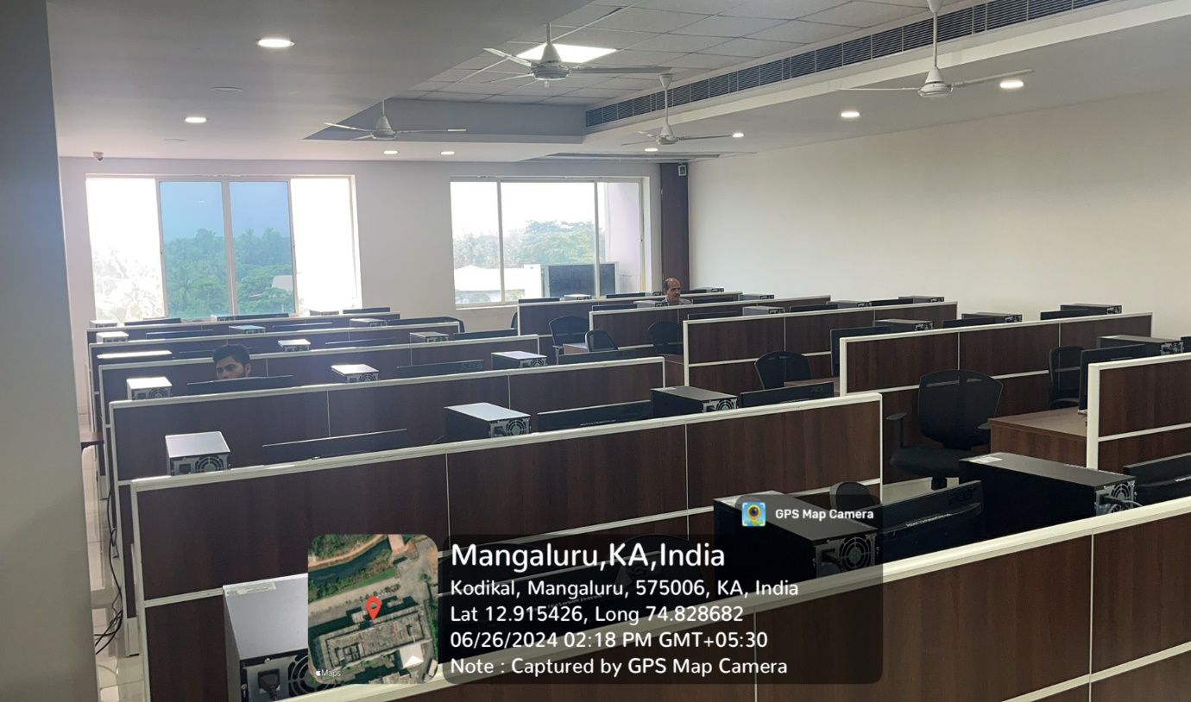

PROJECTOR (ICT TOOL)
