CLASS ROOM_A214
FRONT VIEW
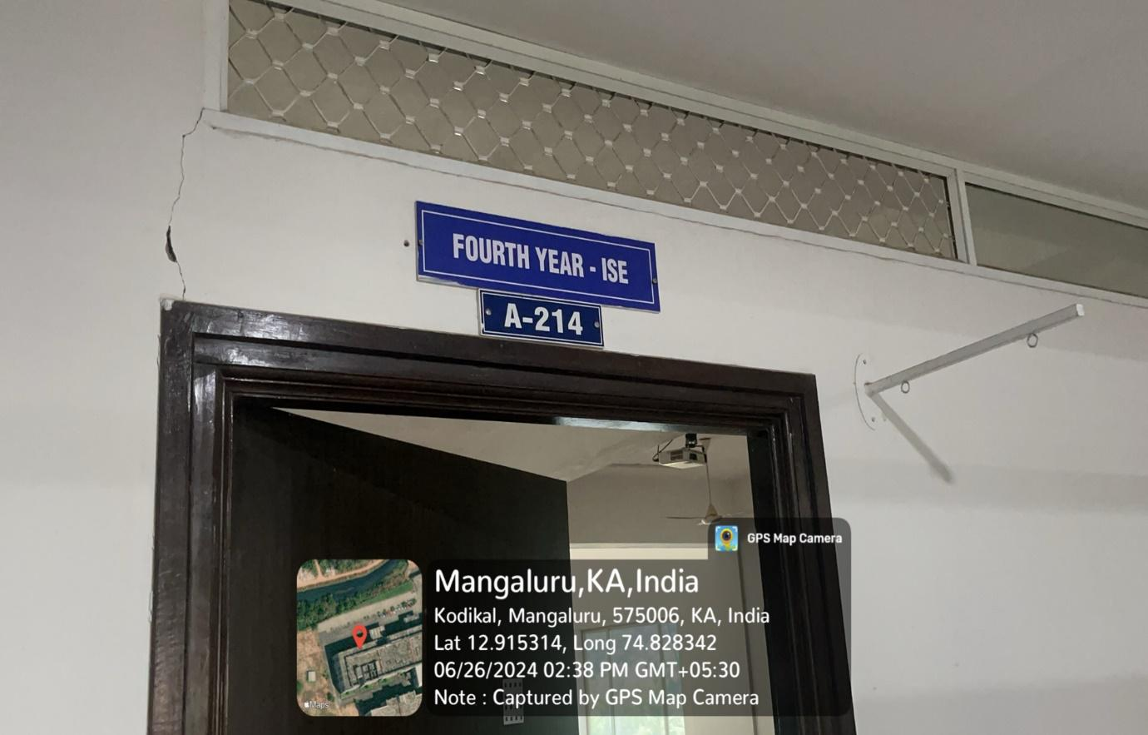

INNER VIEW
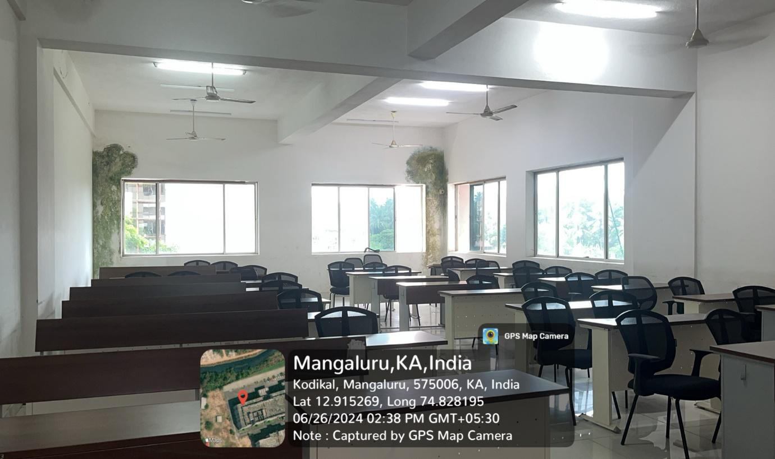

PROJECTOR (ICT TOOL)
