CLASS ROOM_A211
FRONT VIEW
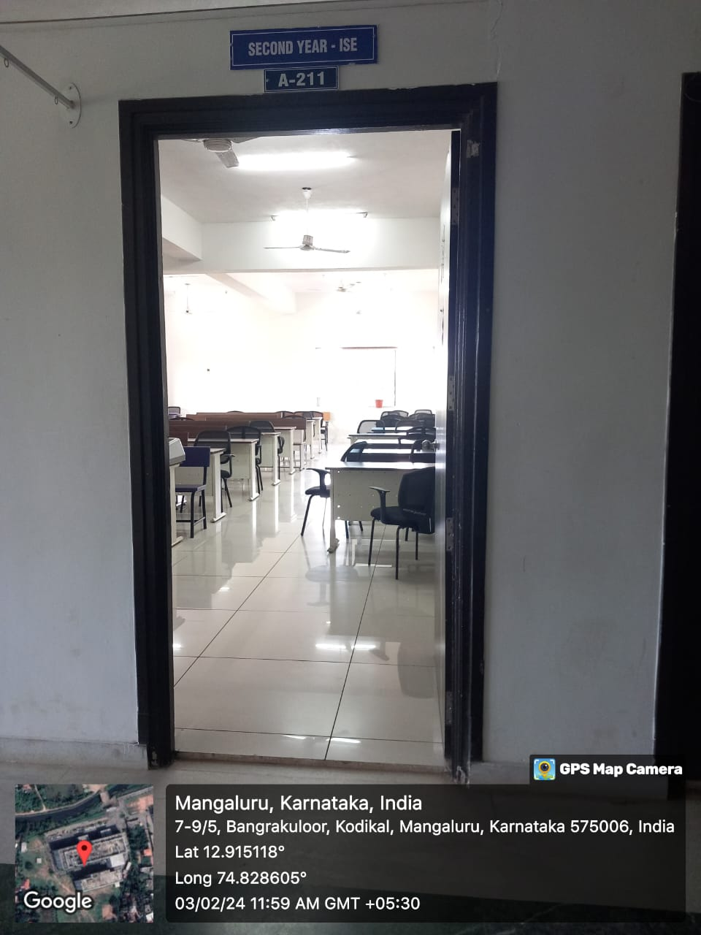

INNER VIEW
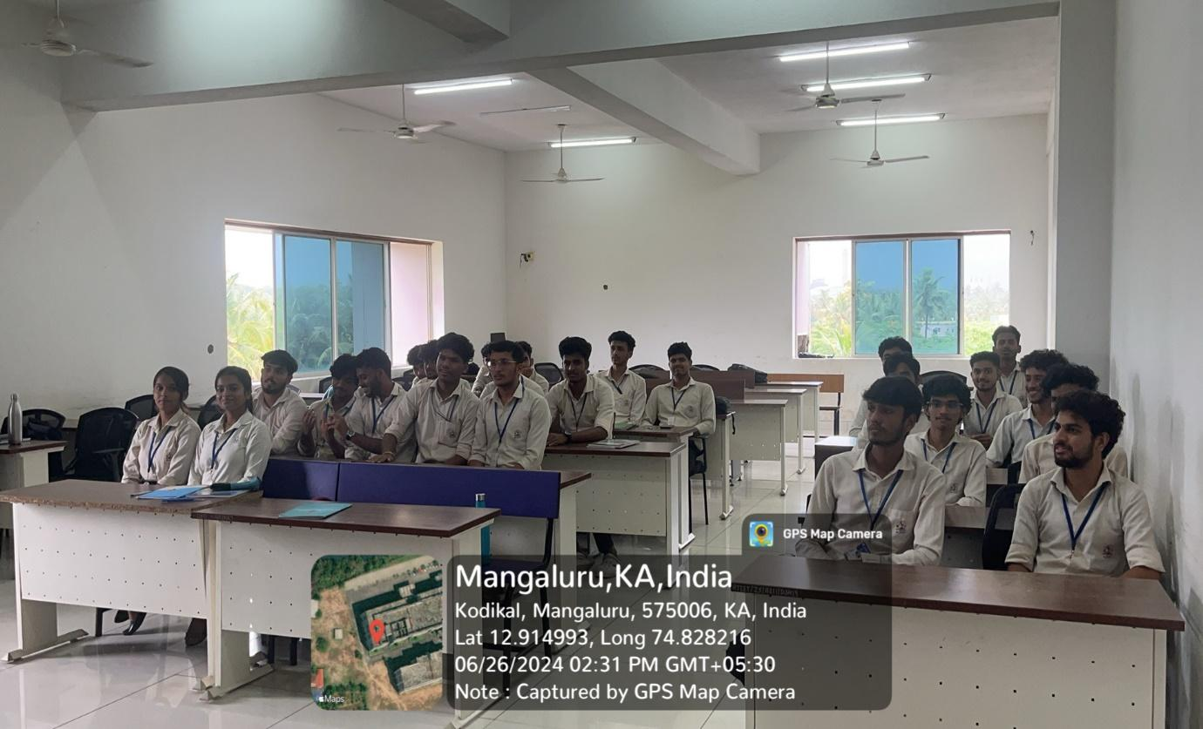

PROJECTOR (ICT TOOL)
