CLASS ROOM_A209
FRONT VIEW
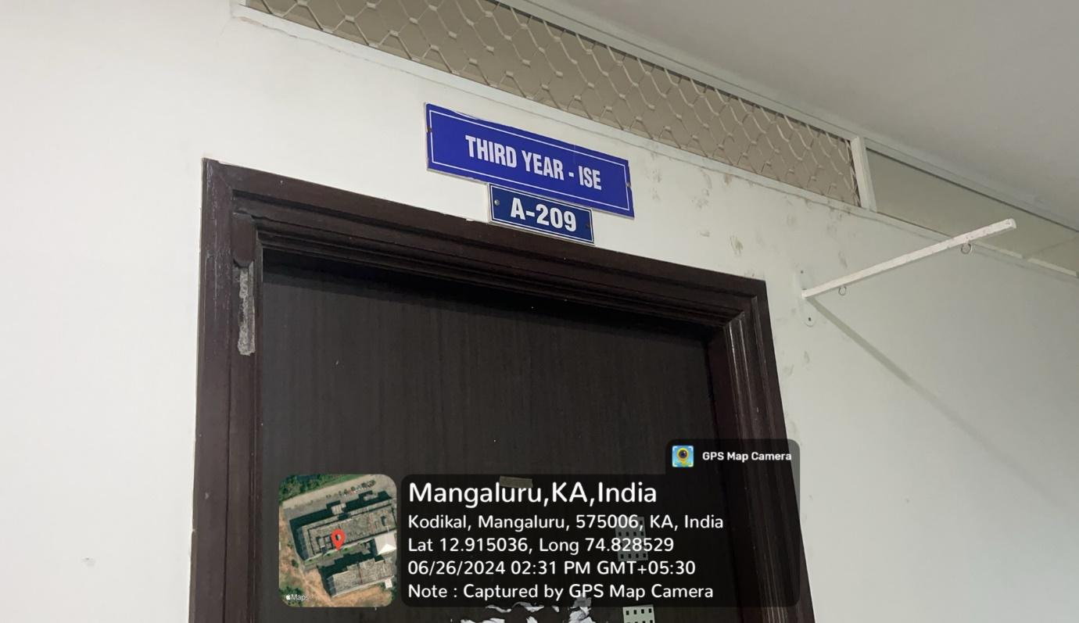

INNER VIEW
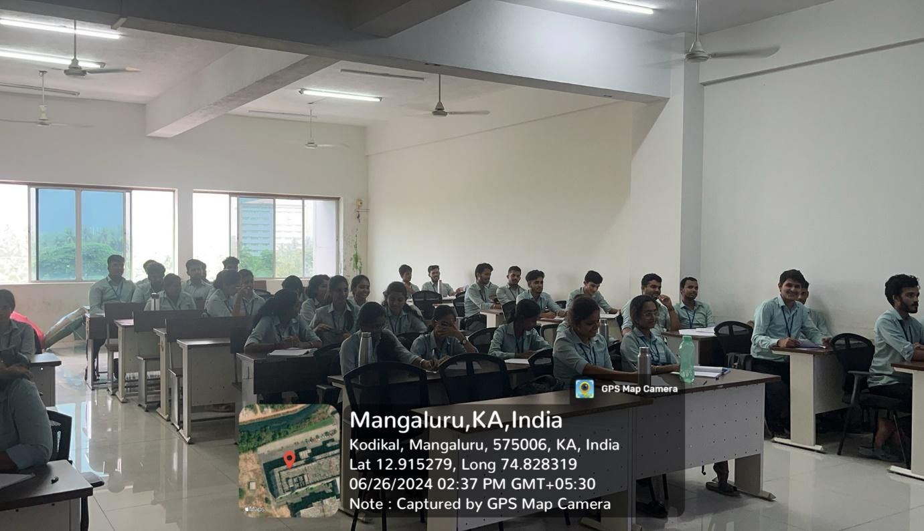

PROJECTOR (ICT TOOL)
