ECE_ A226_SeminarHall_2
FRONT VIEW
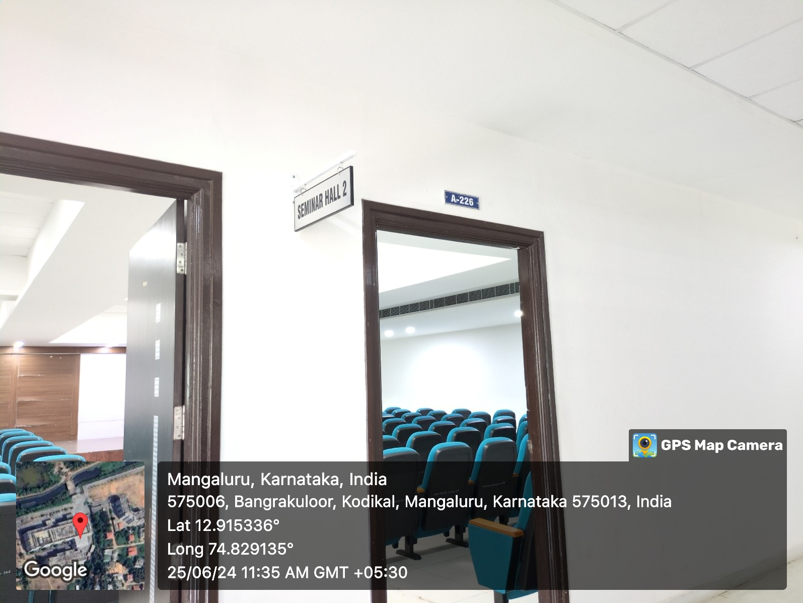

INNER VIEW
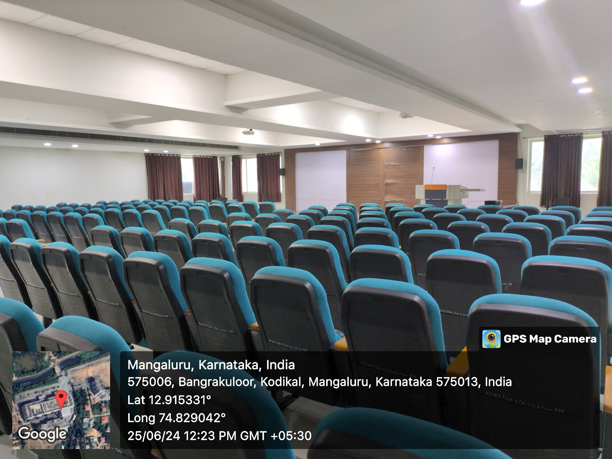

PROJECTOR (ICT TOOL)
