ECE_A224_SoftwareLab_1
FRONT VIEW


INNER VIEW
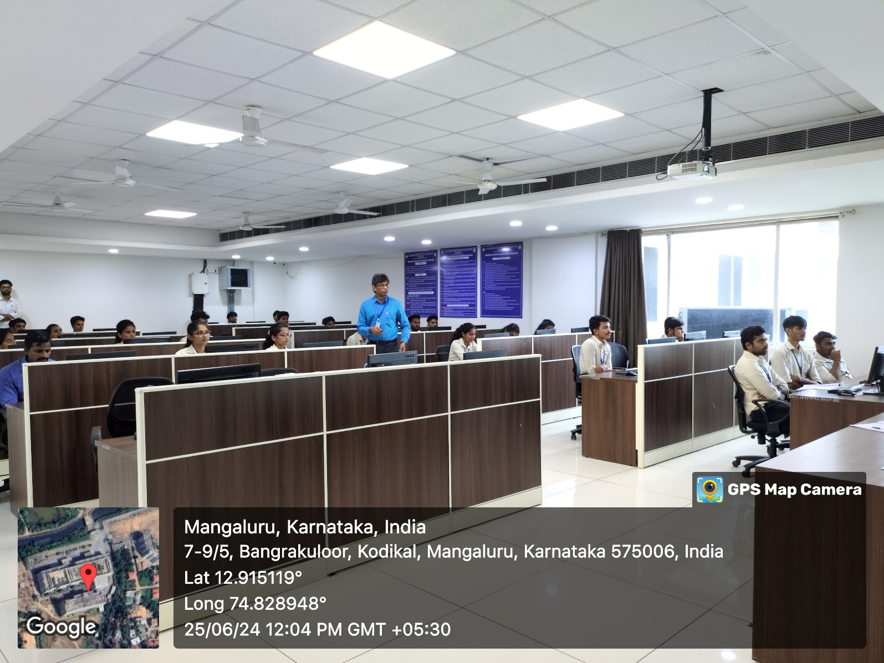

PROJECTOR (ICT TOOL)
