ECE_A223_SoftwareLab_2
FRONT VIEW
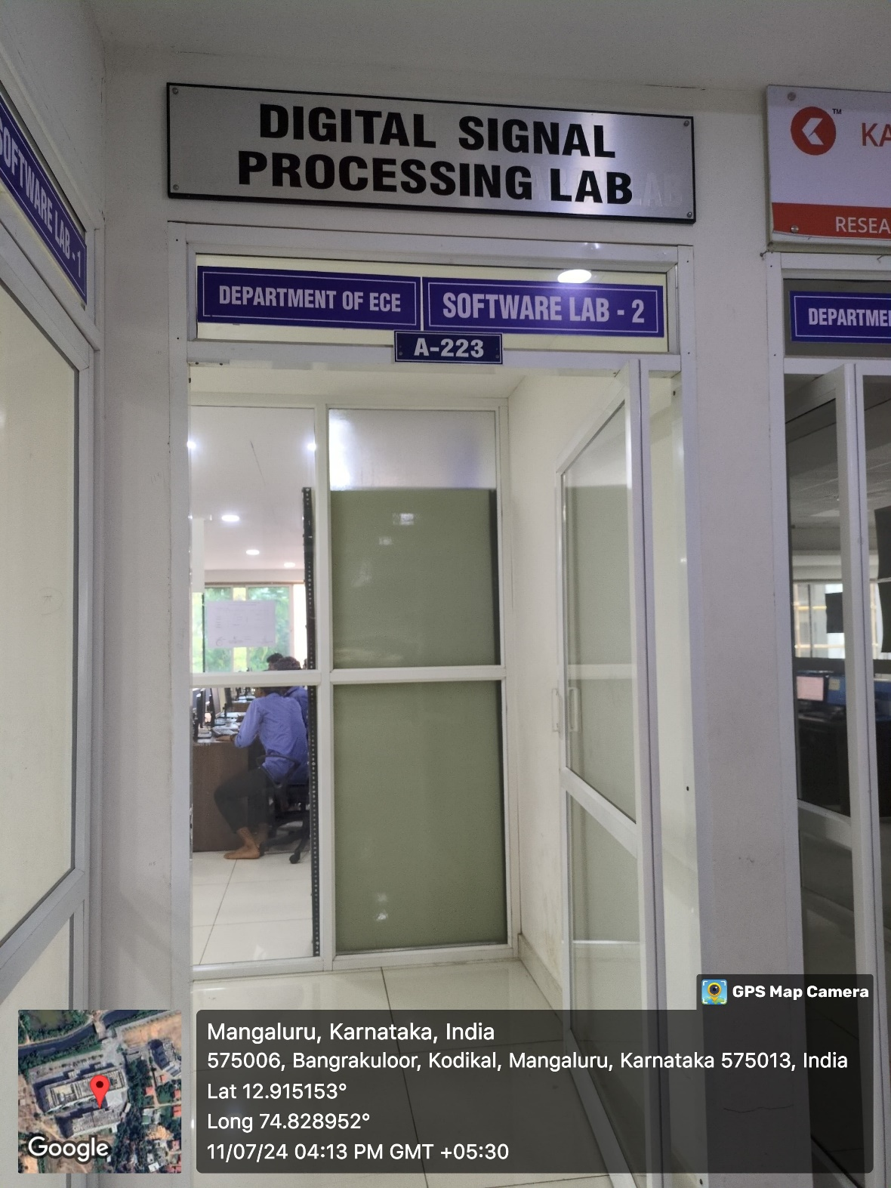

INNER VIEW
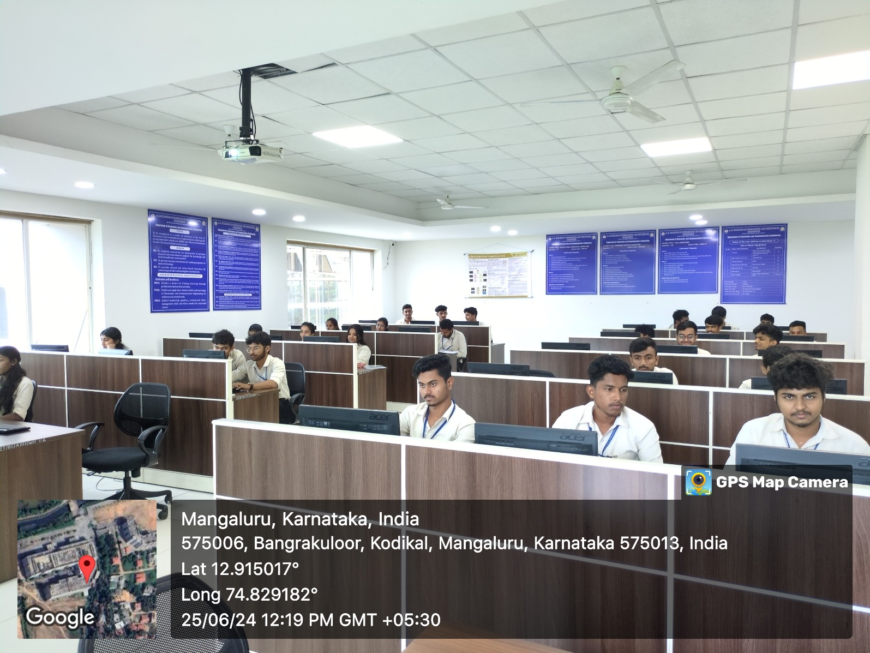

PROJECTOR (ICT TOOL)
