ECE_ A222_SoftwareLab_3
FRONT VIEW
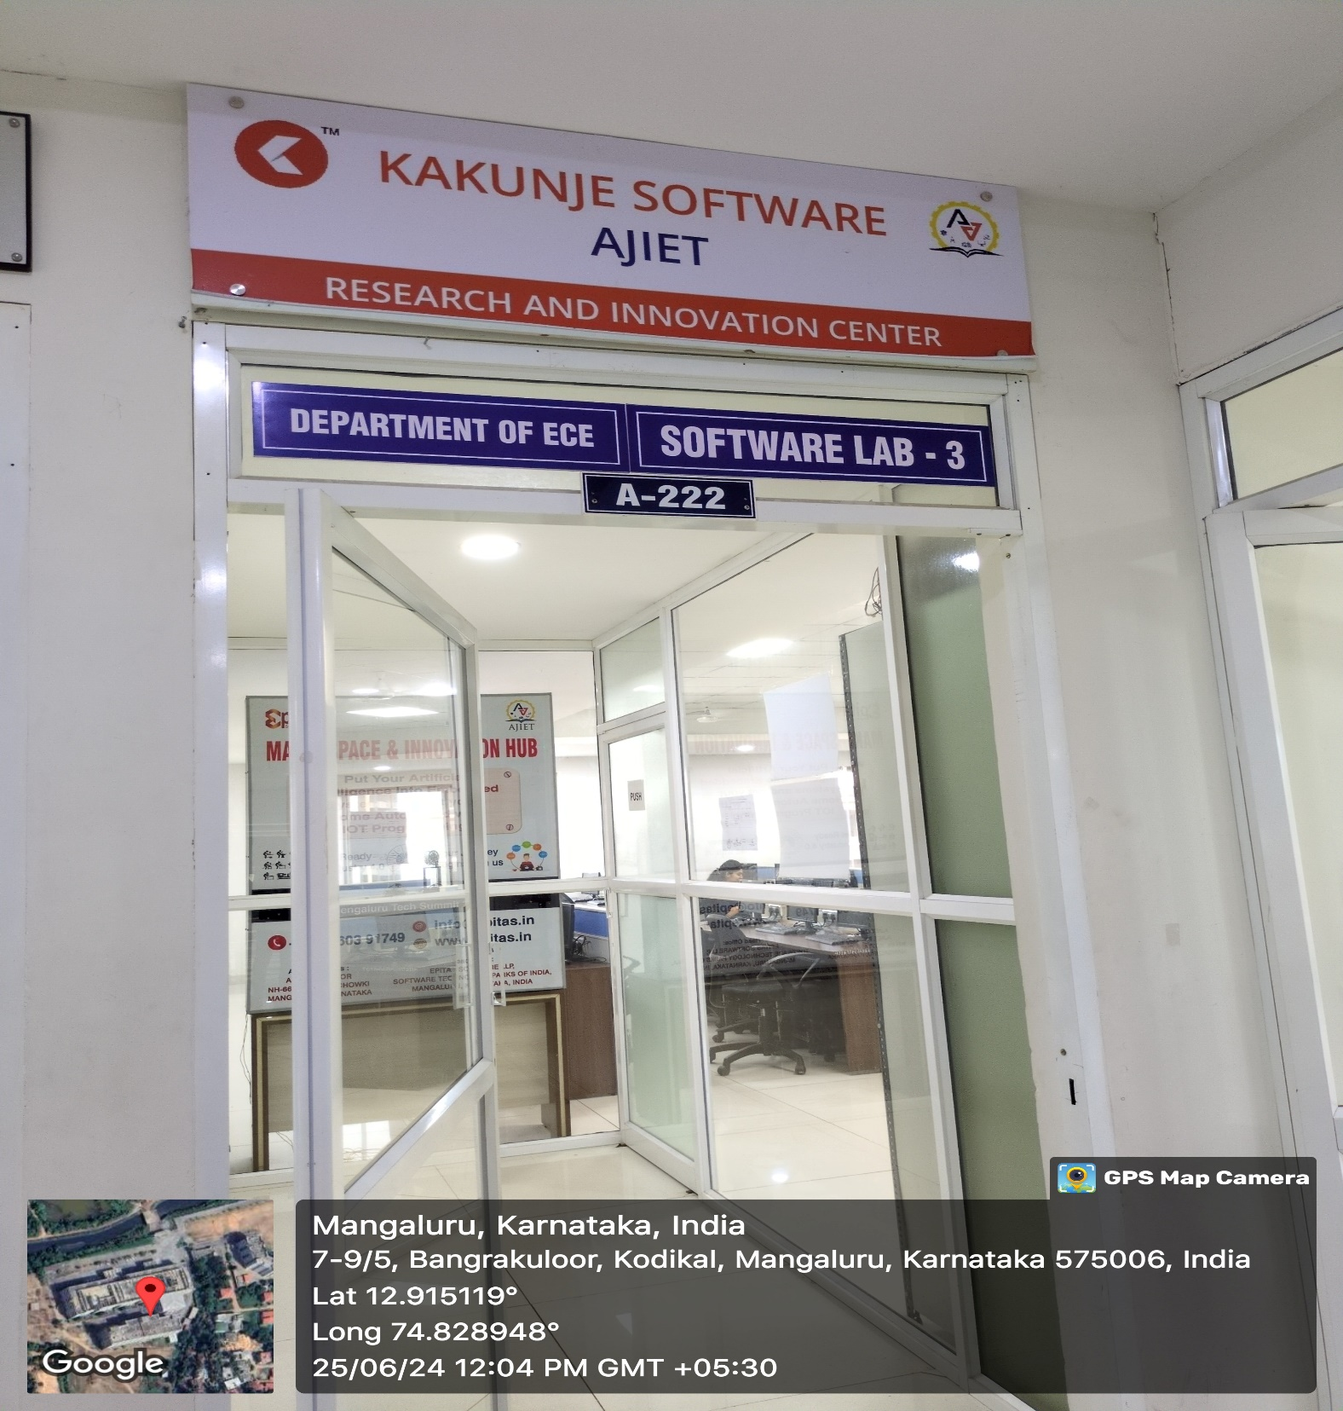

INNER VIEW
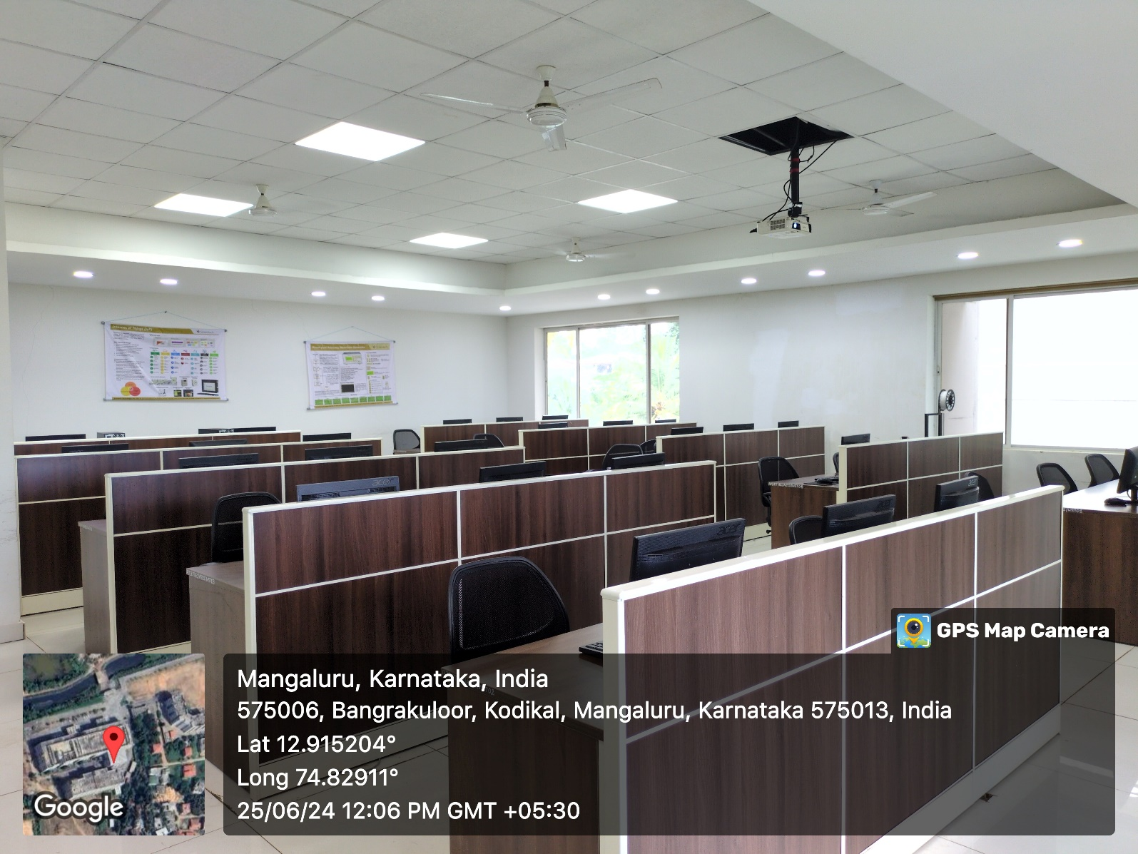

PROJECTOR (ICT TOOL)
