ECE_ A217_ClassRoom_3
FRONT VIEW
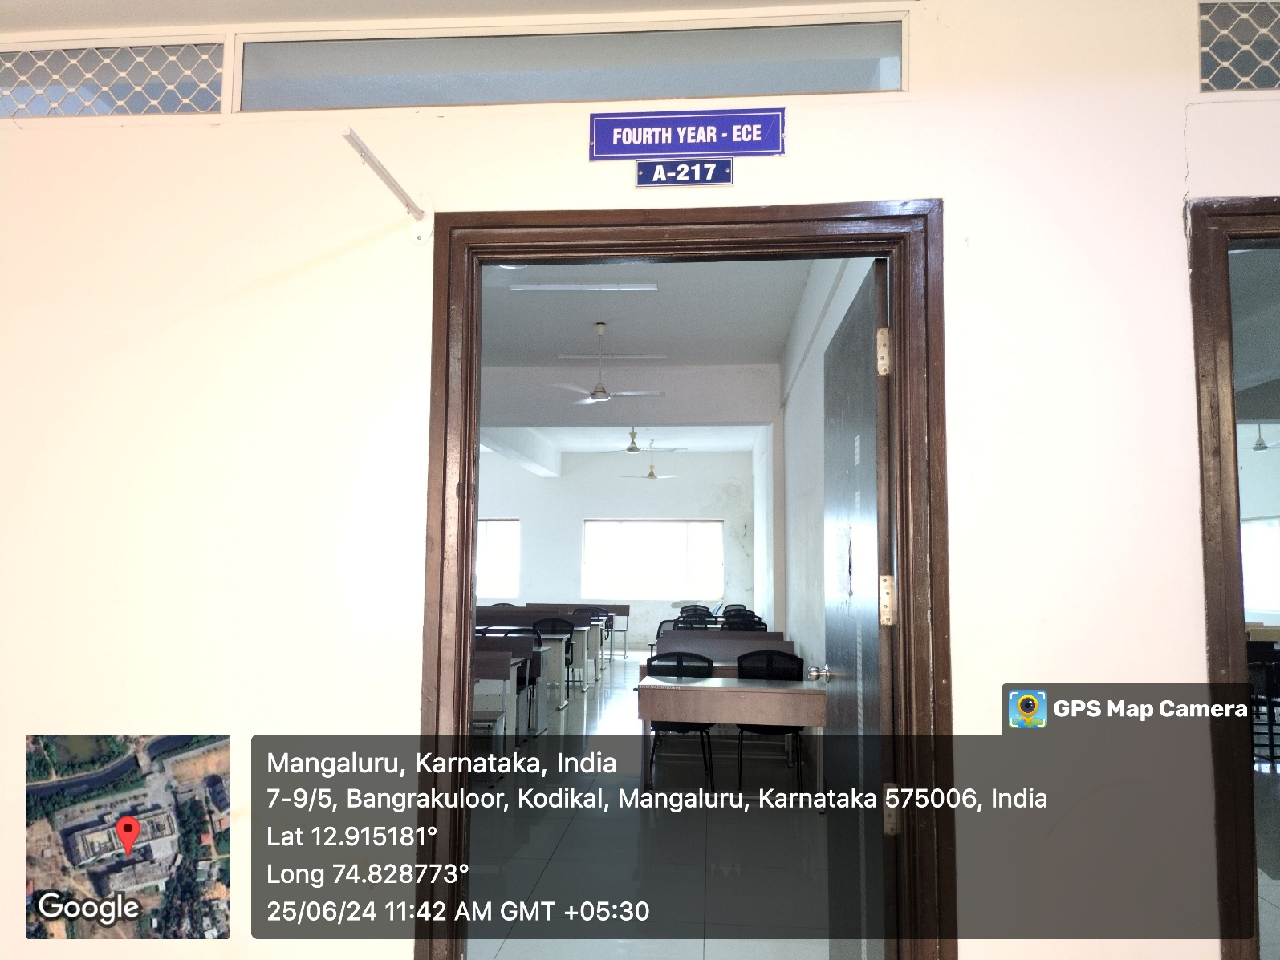

INNER VIEW
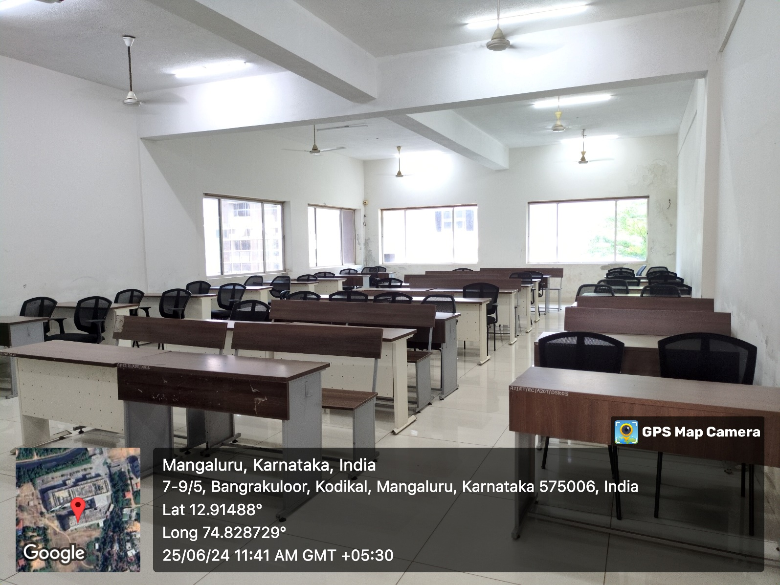

PROJECTOR (ICT TOOL)
