ECE_ A216_ClassRoom_Tutorial
FRONT VIEW
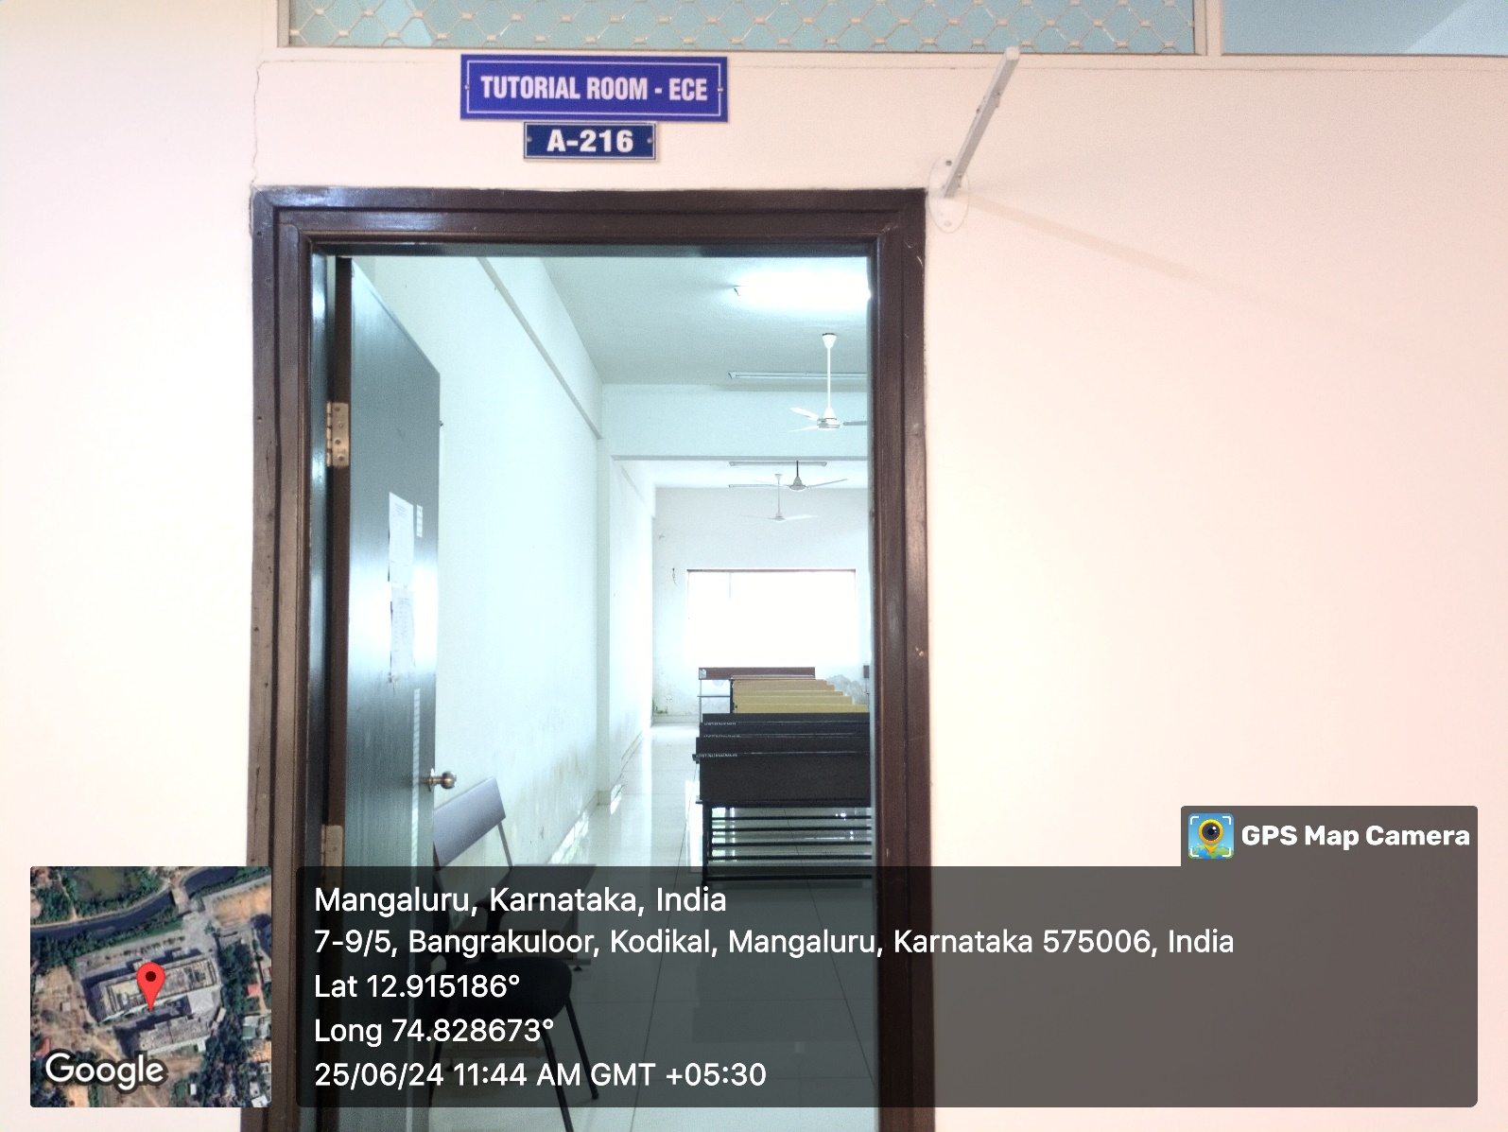

INNER VIEW-1
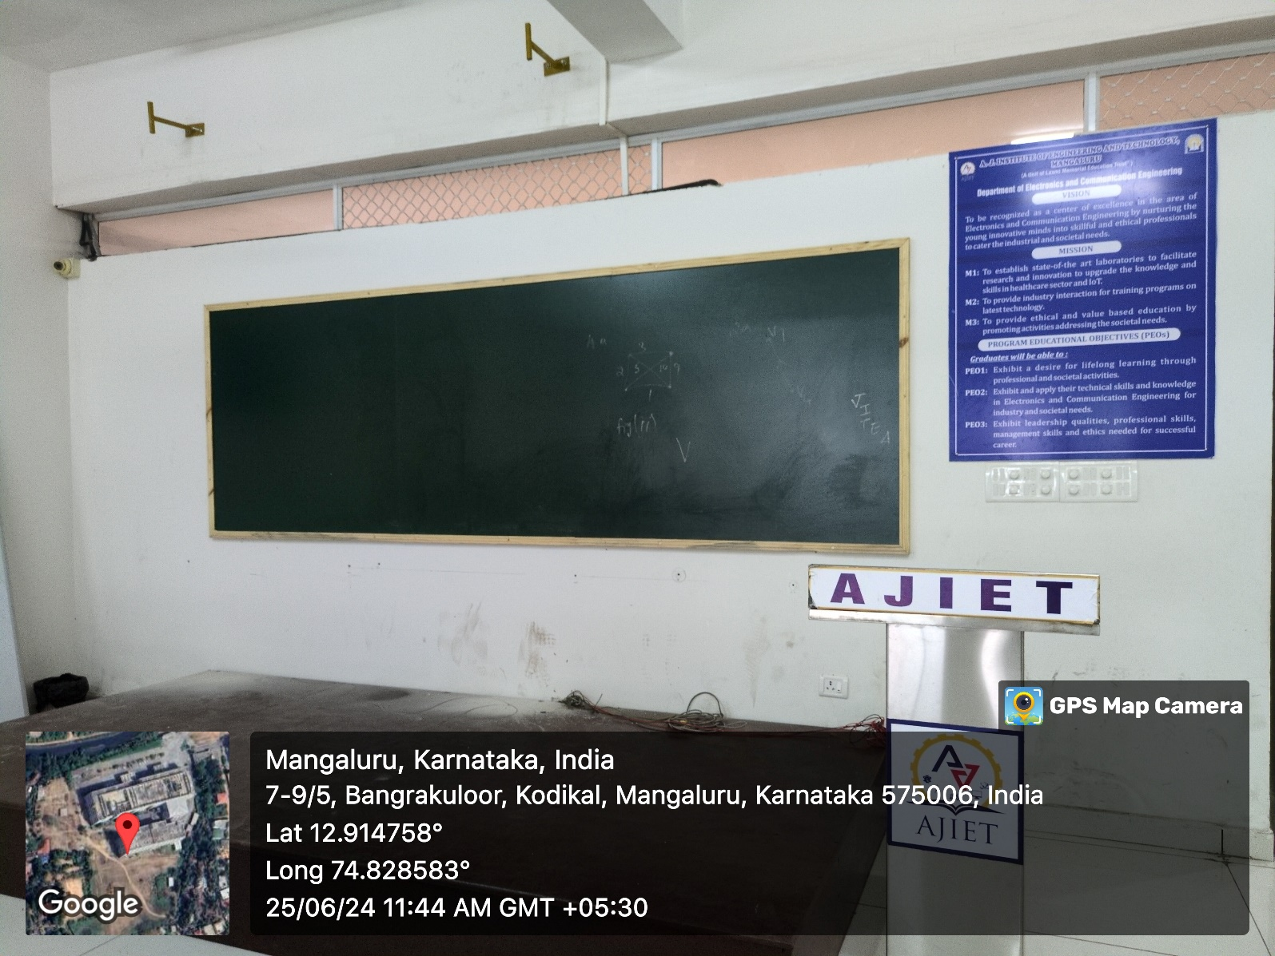

INNER VIEW-2
