ECE_ A215_ClassRoom_2
FRONT VIEW
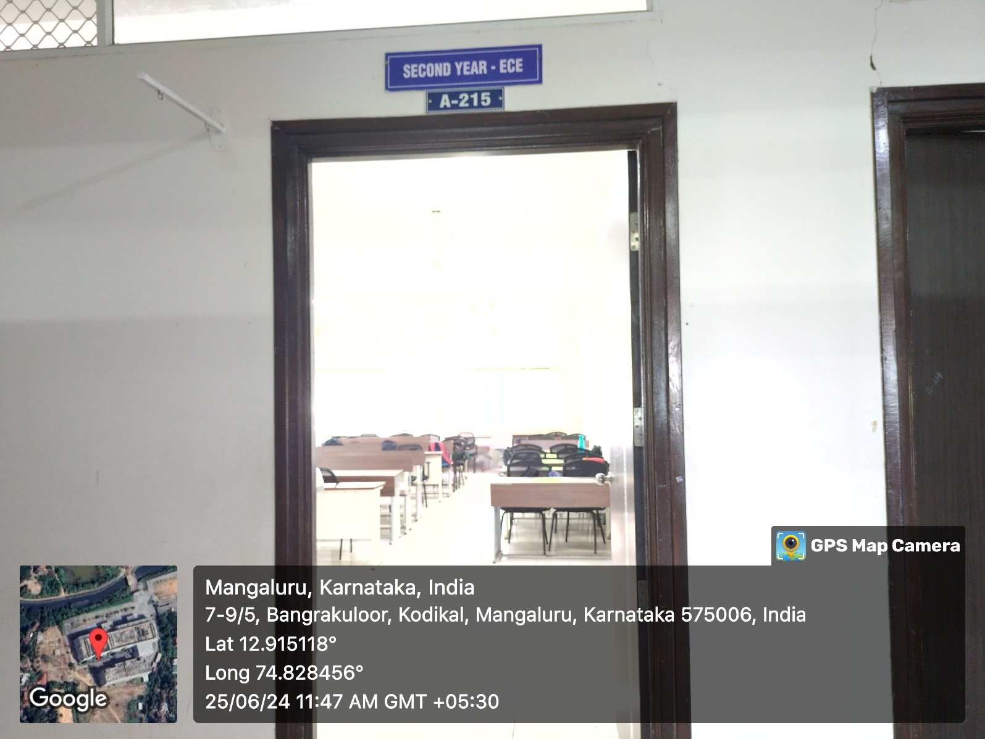

INNER VIEW
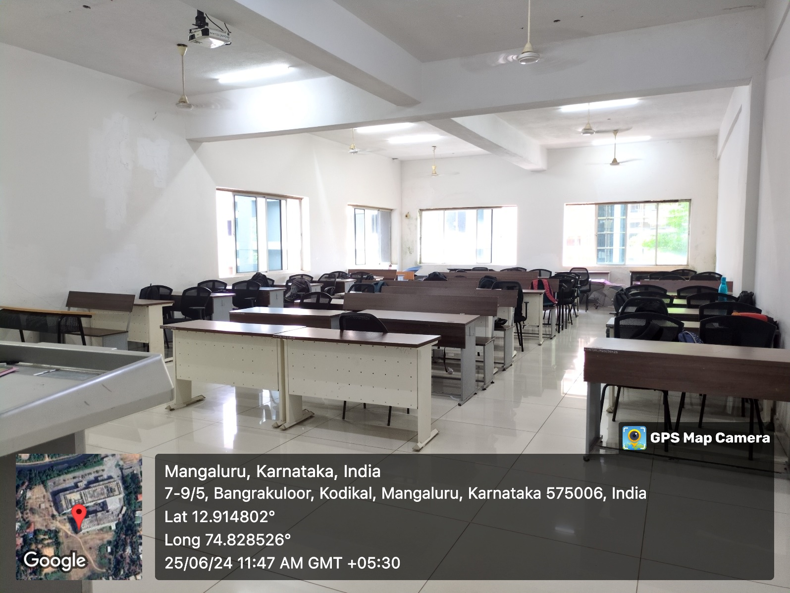

PROJECTOR (ICT TOOL)
