ECE_ A208_HardwareLab_1
FRONT VIEW
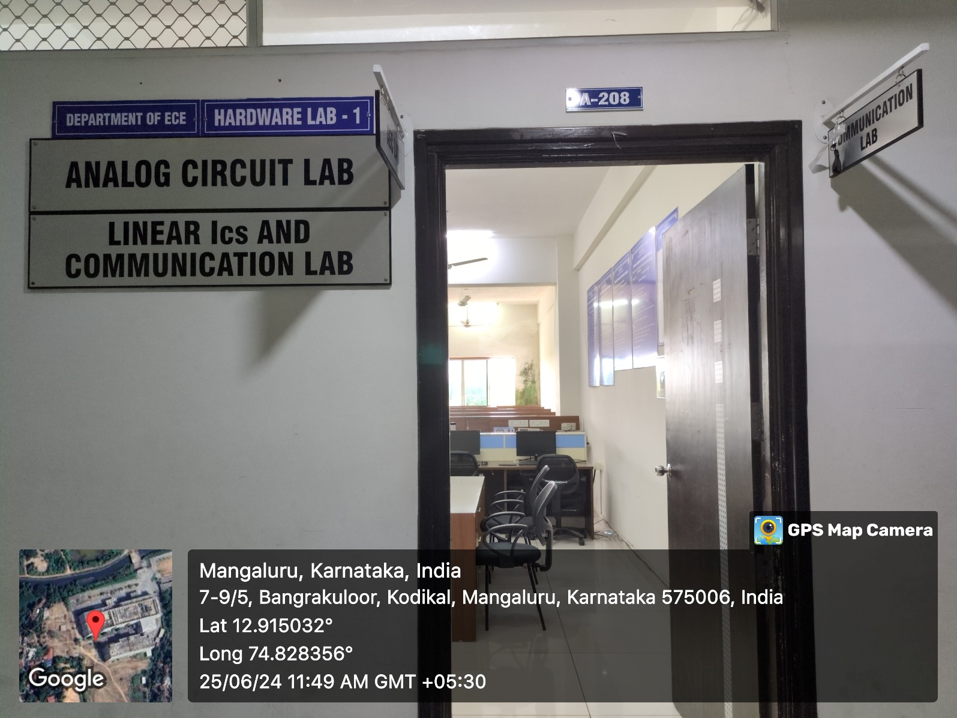

INNER VIEW_1
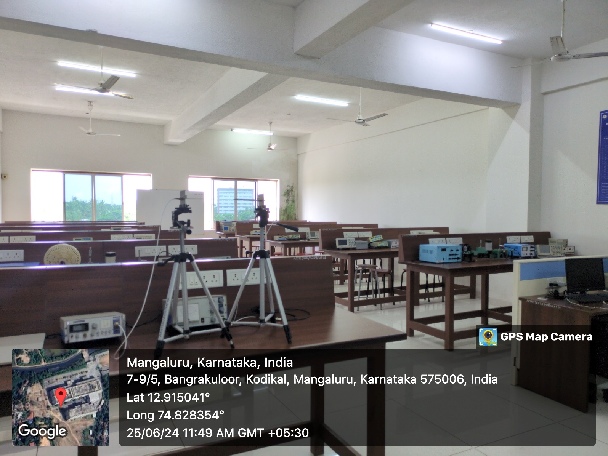

INNER VIEW_2
