ECE_ A207_HardwareLab_2
FRONT VIEW
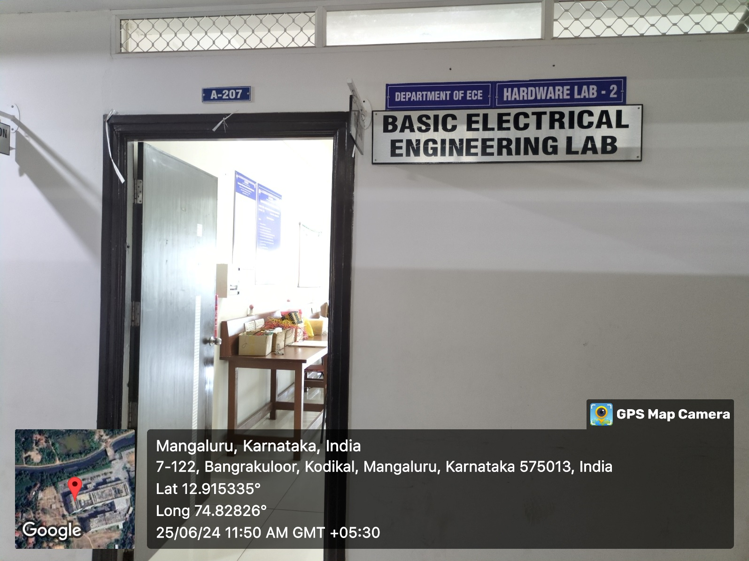

INNER VIEW
