ECE_ A206_HardwareLab_3
FRONT VIEW
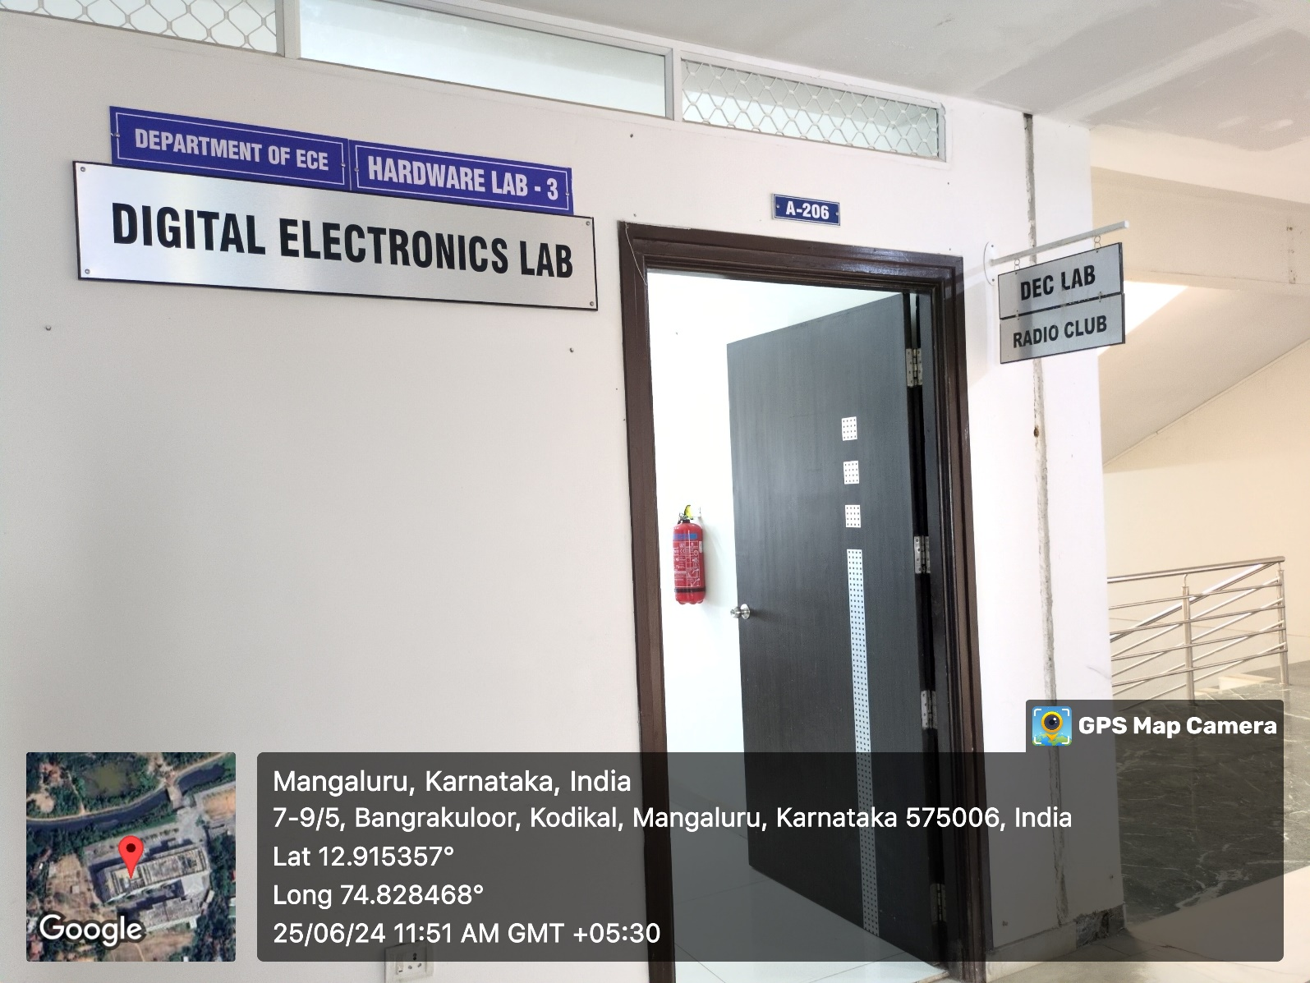

INNER VIEW_1
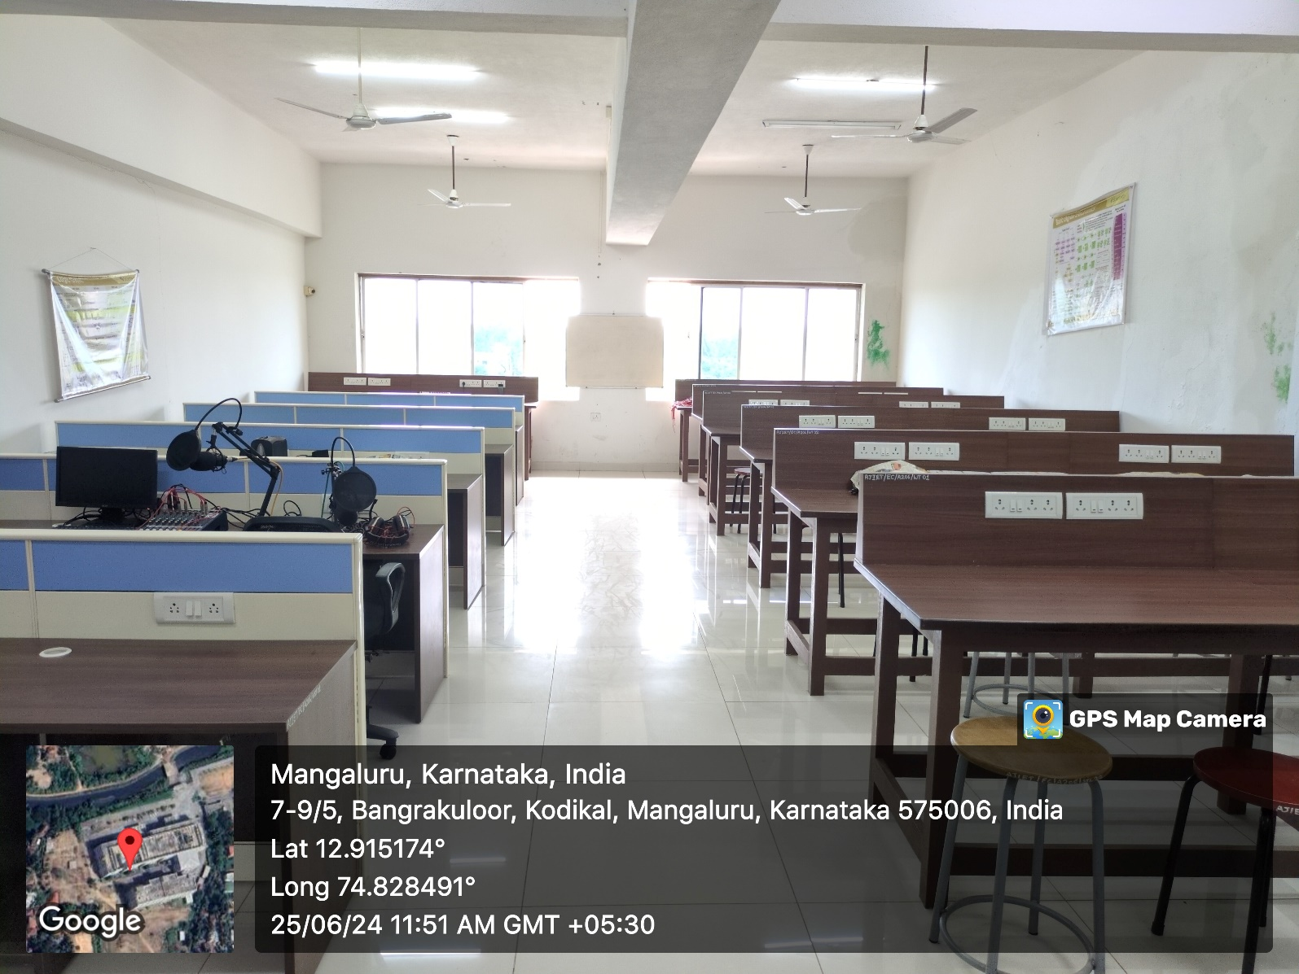

INNER VIEW_2
