CLASS ROOM – A204
FRONT VIEW
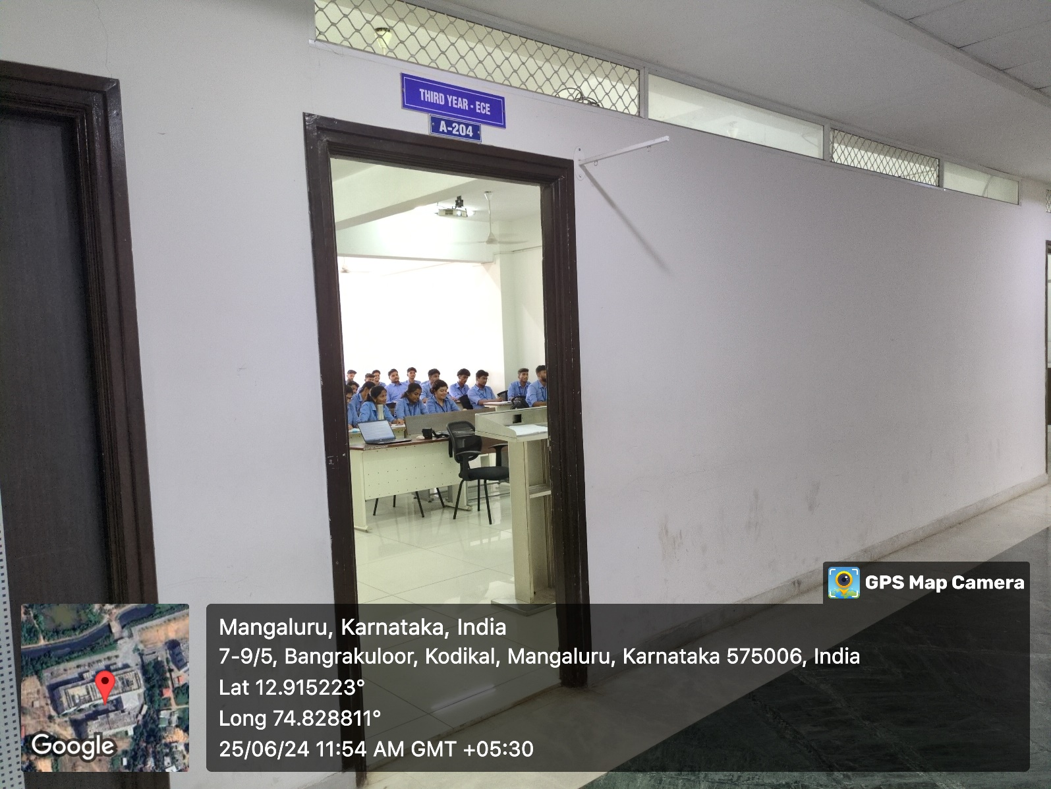

INNER VIEW
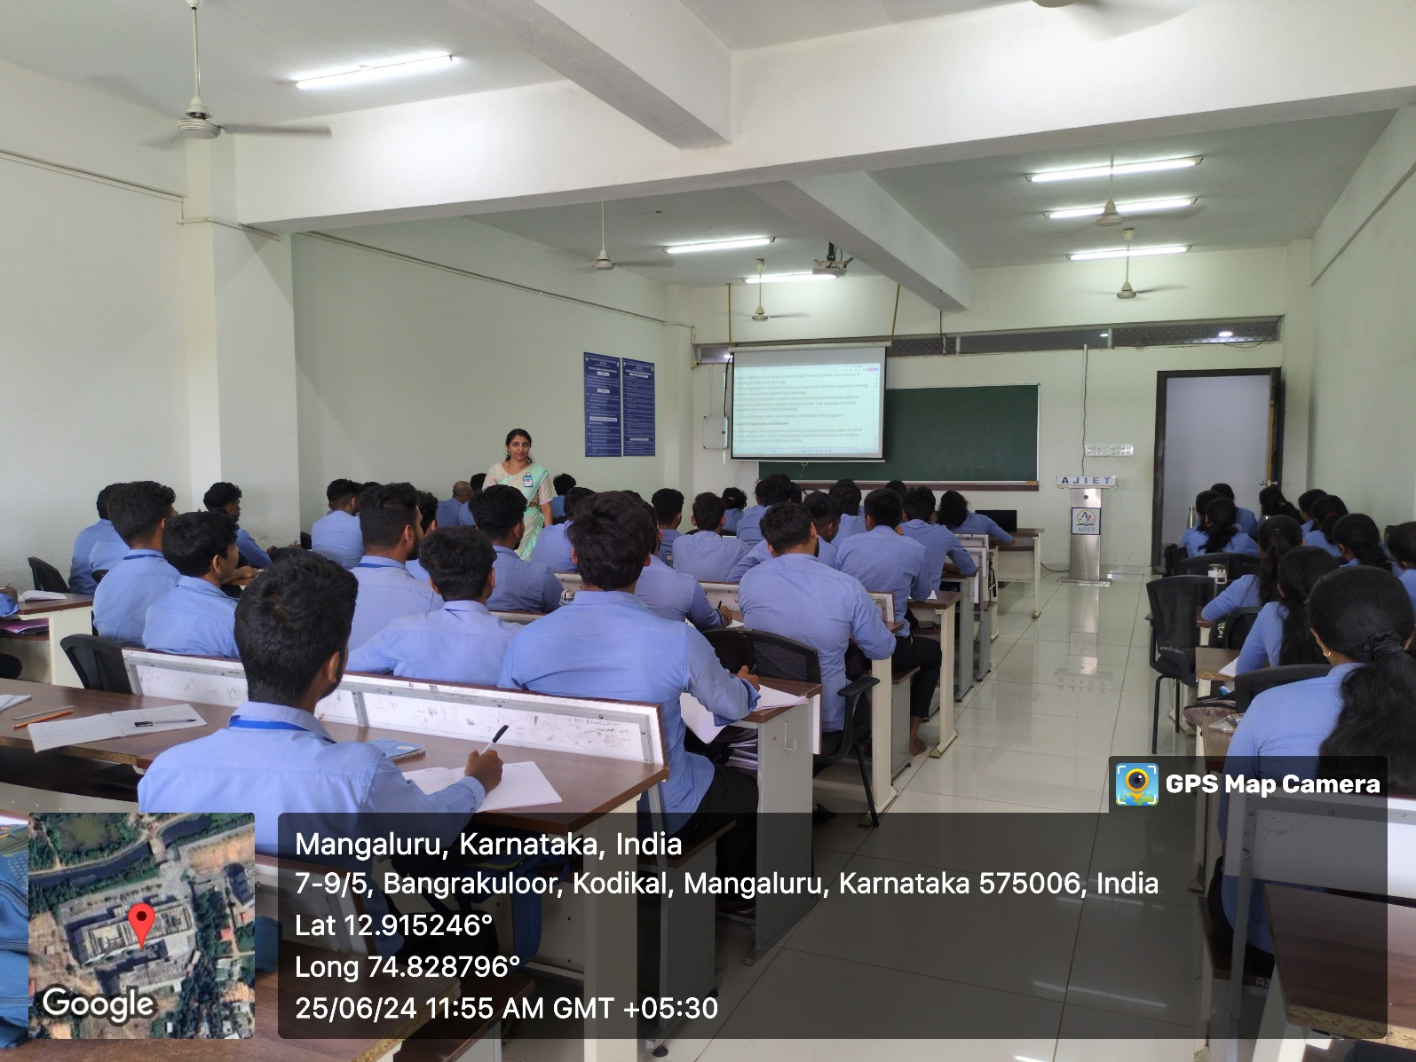

PROJECTOR (ICT TOOL)
