SEMINAR HALL 1 – A125
FRONT VIEW
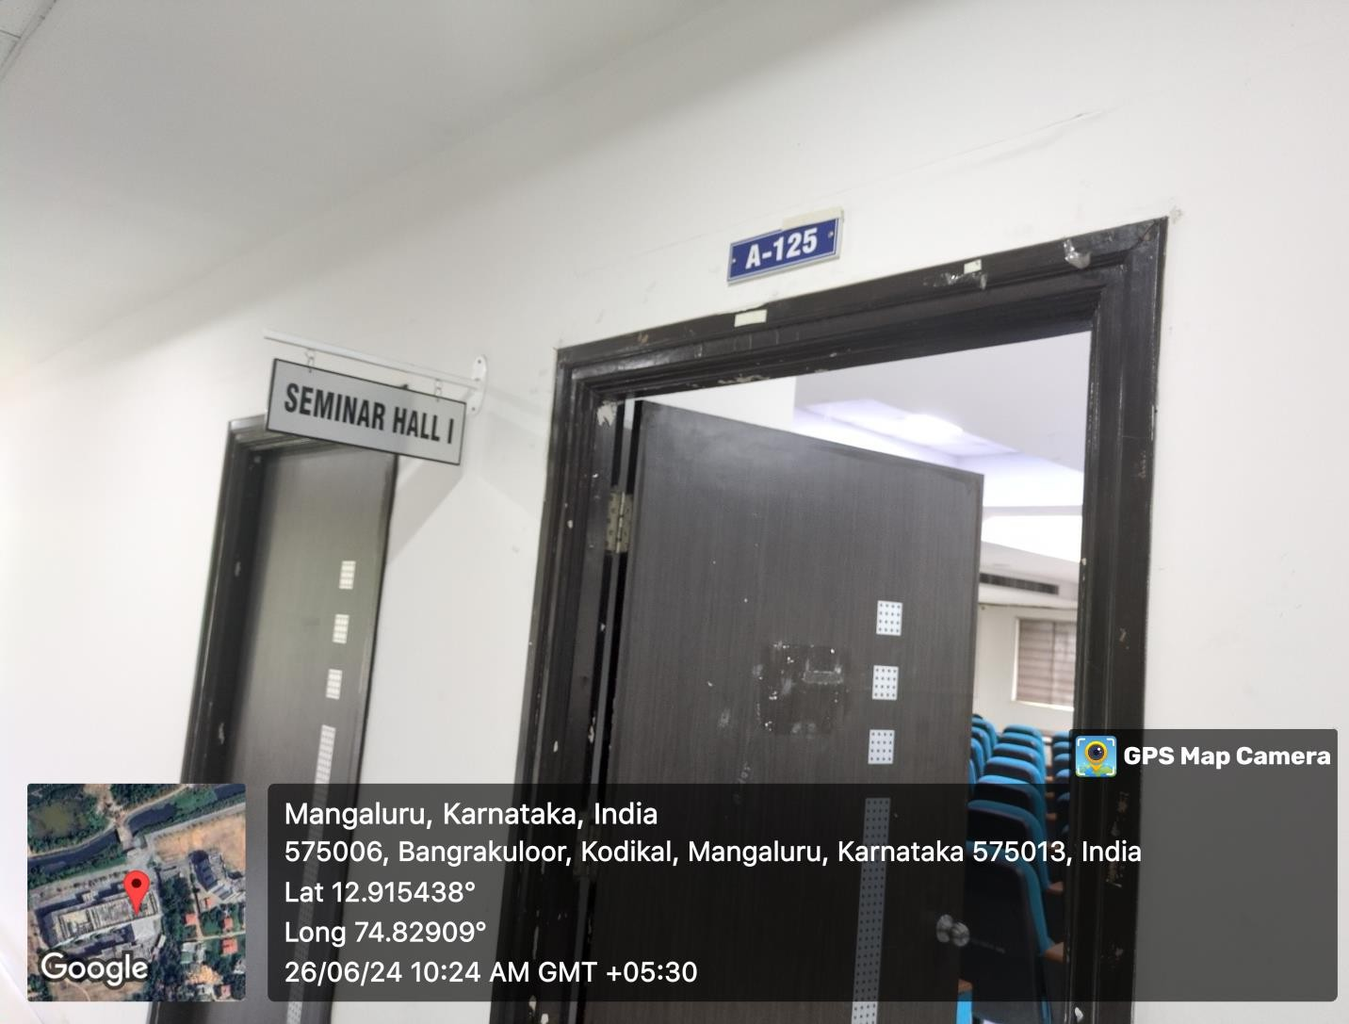

INNER VIEW
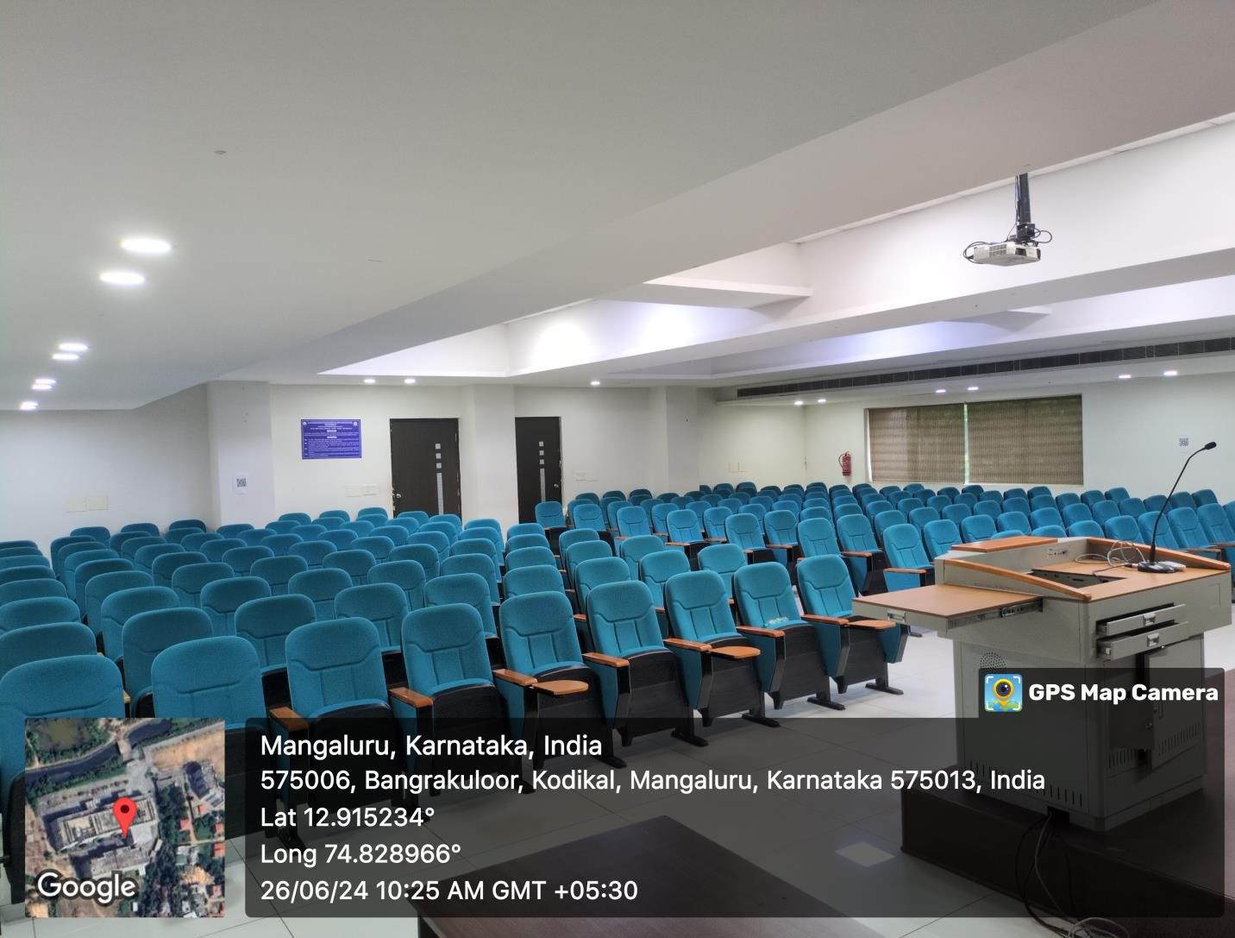

PROJECTOR (ICT TOOL)
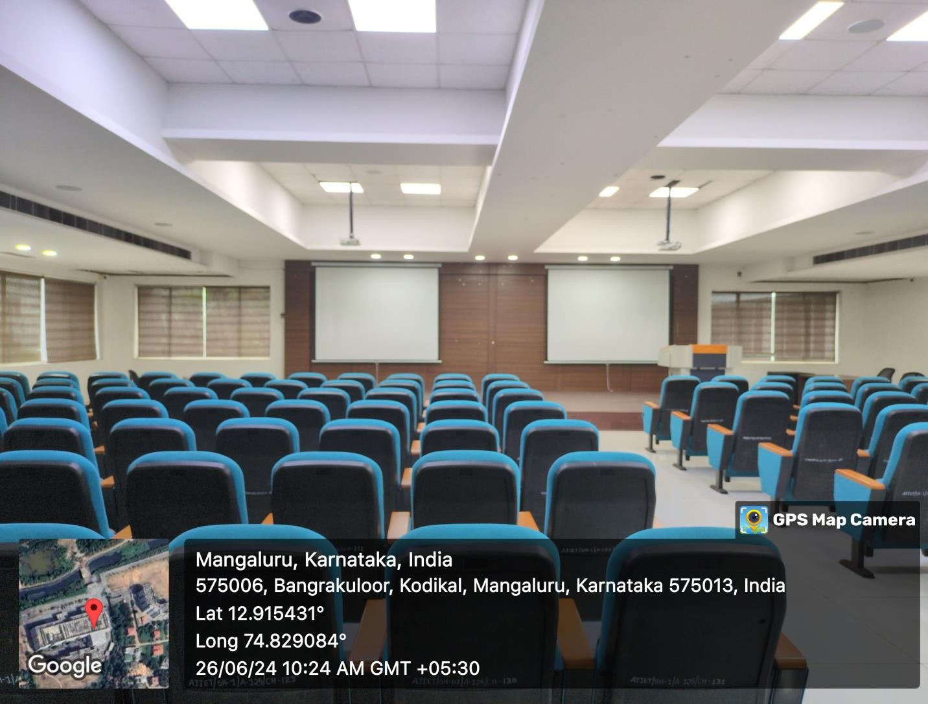

SEMINAR HALL 2 – A226
FRONT VIEW
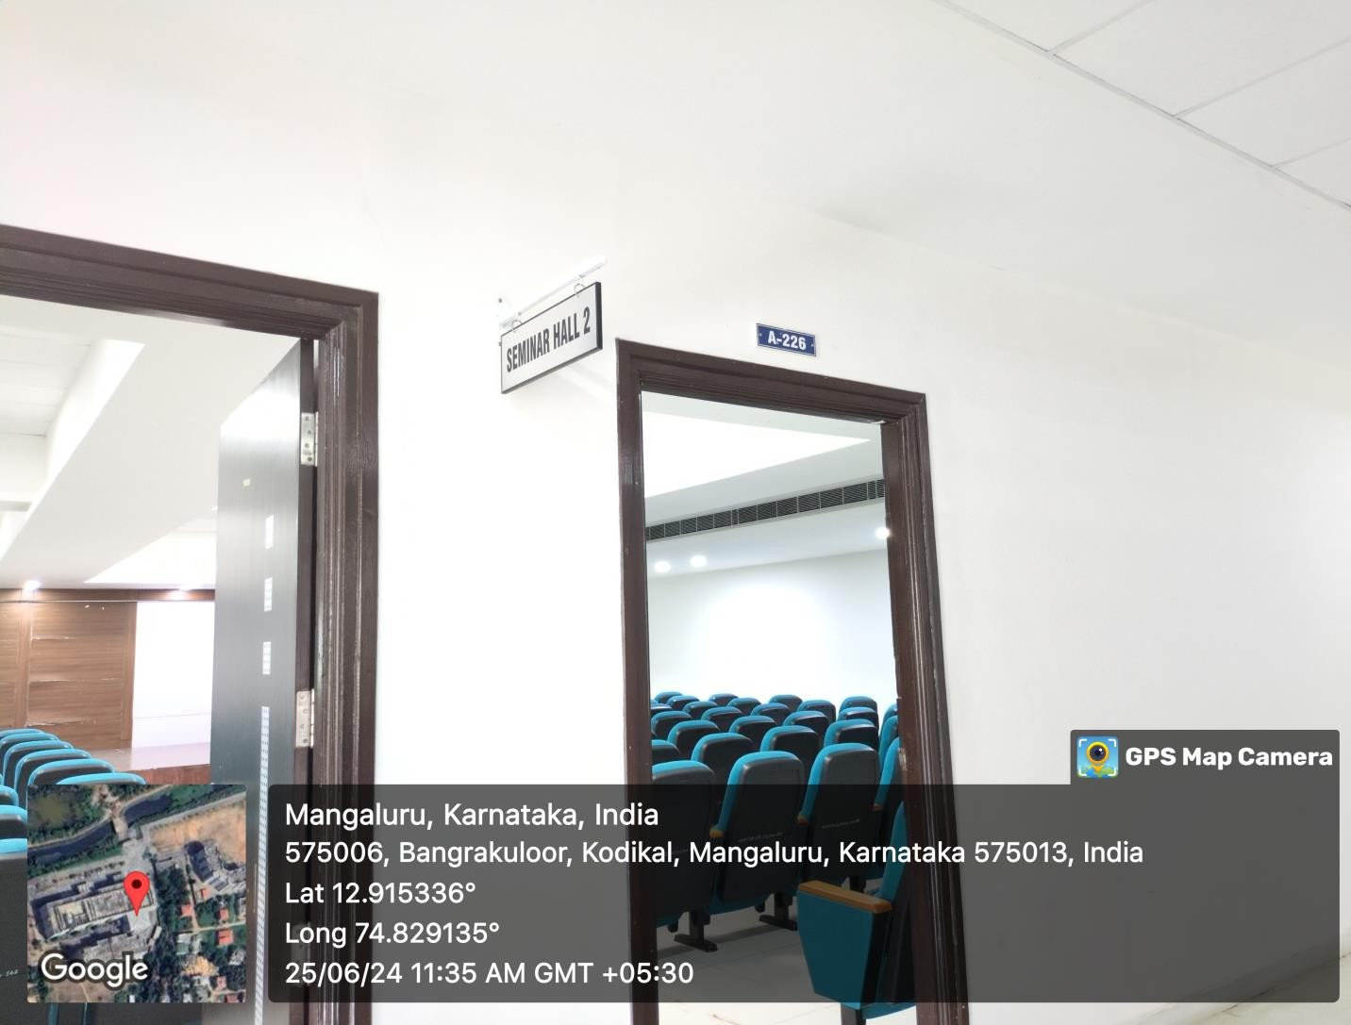

INNER VIEW
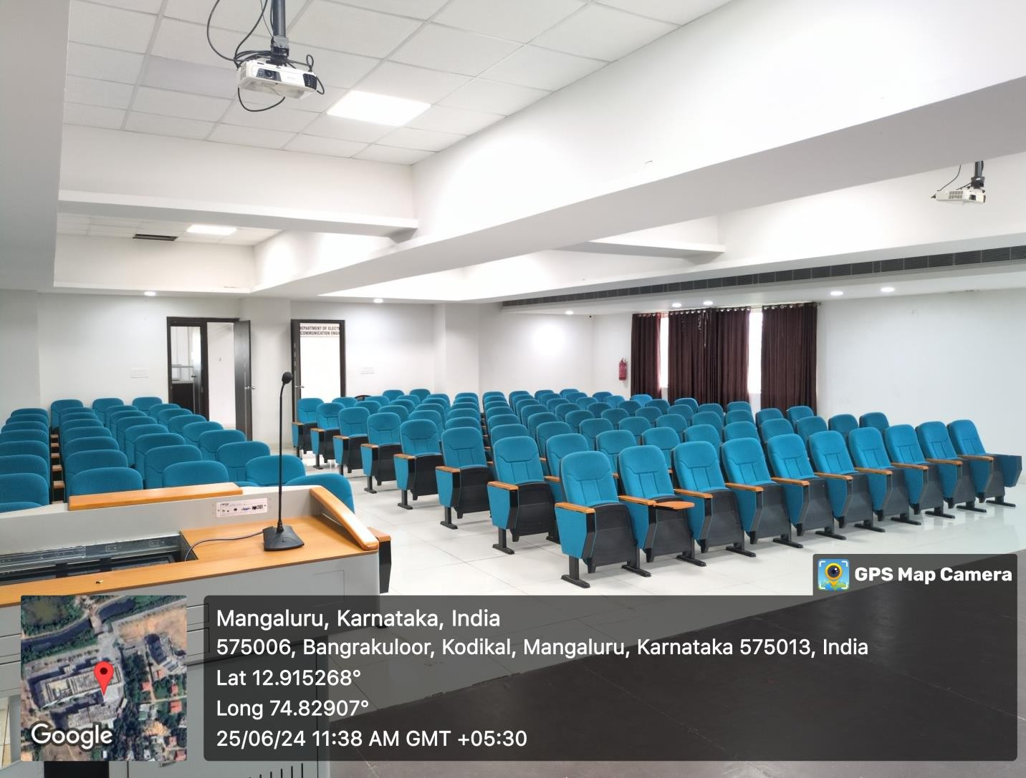

PROJECTOR (ICT TOOL)
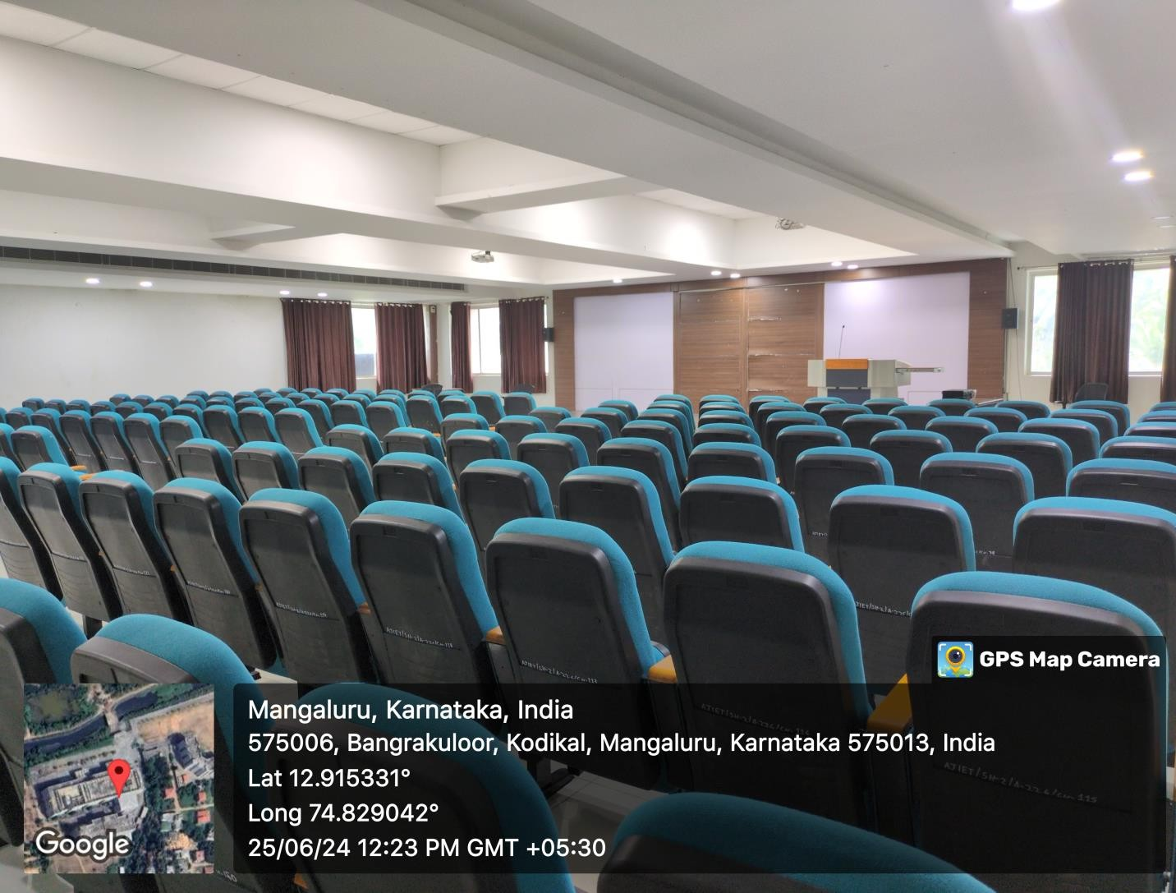

SEMINAR HALL 3 – A303
FRONT VIEW
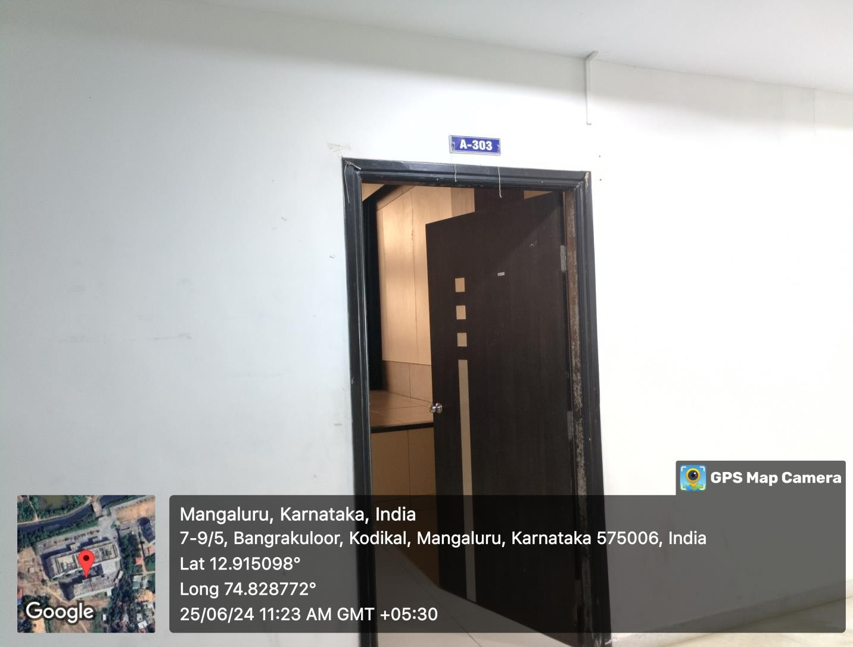

INNER VIEW
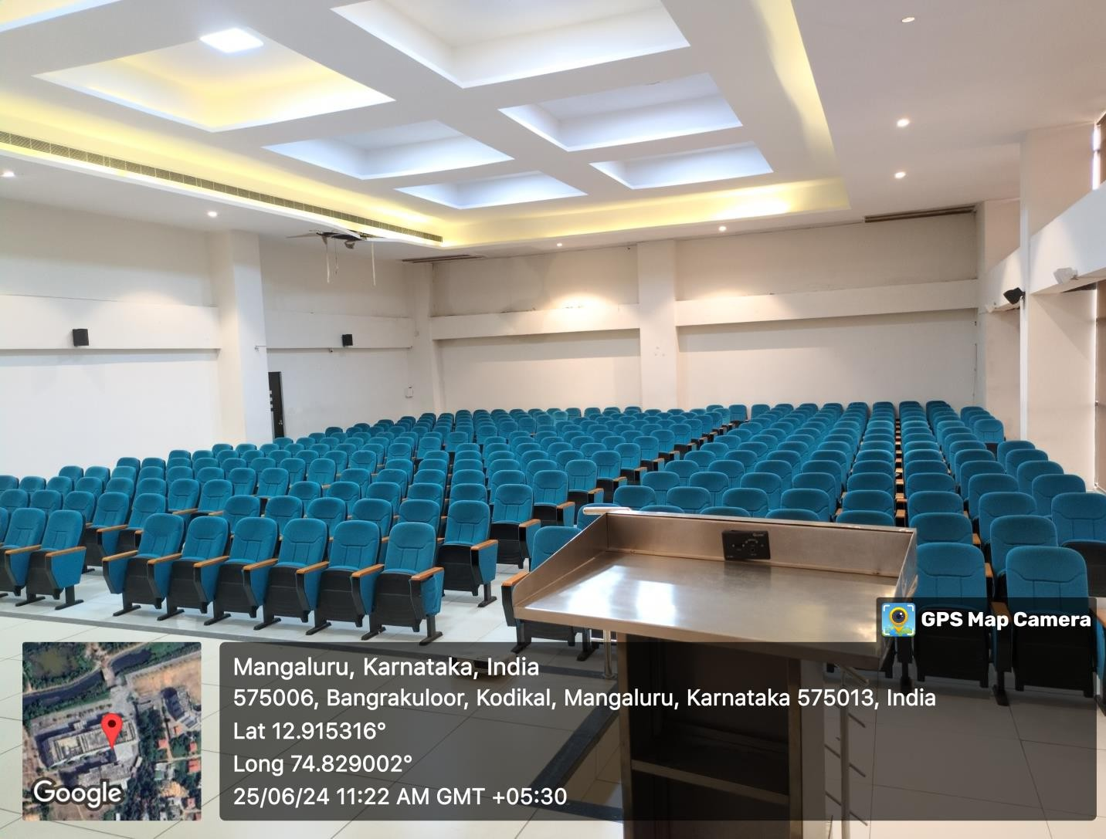

PROJECTOR (ICT TOOL)
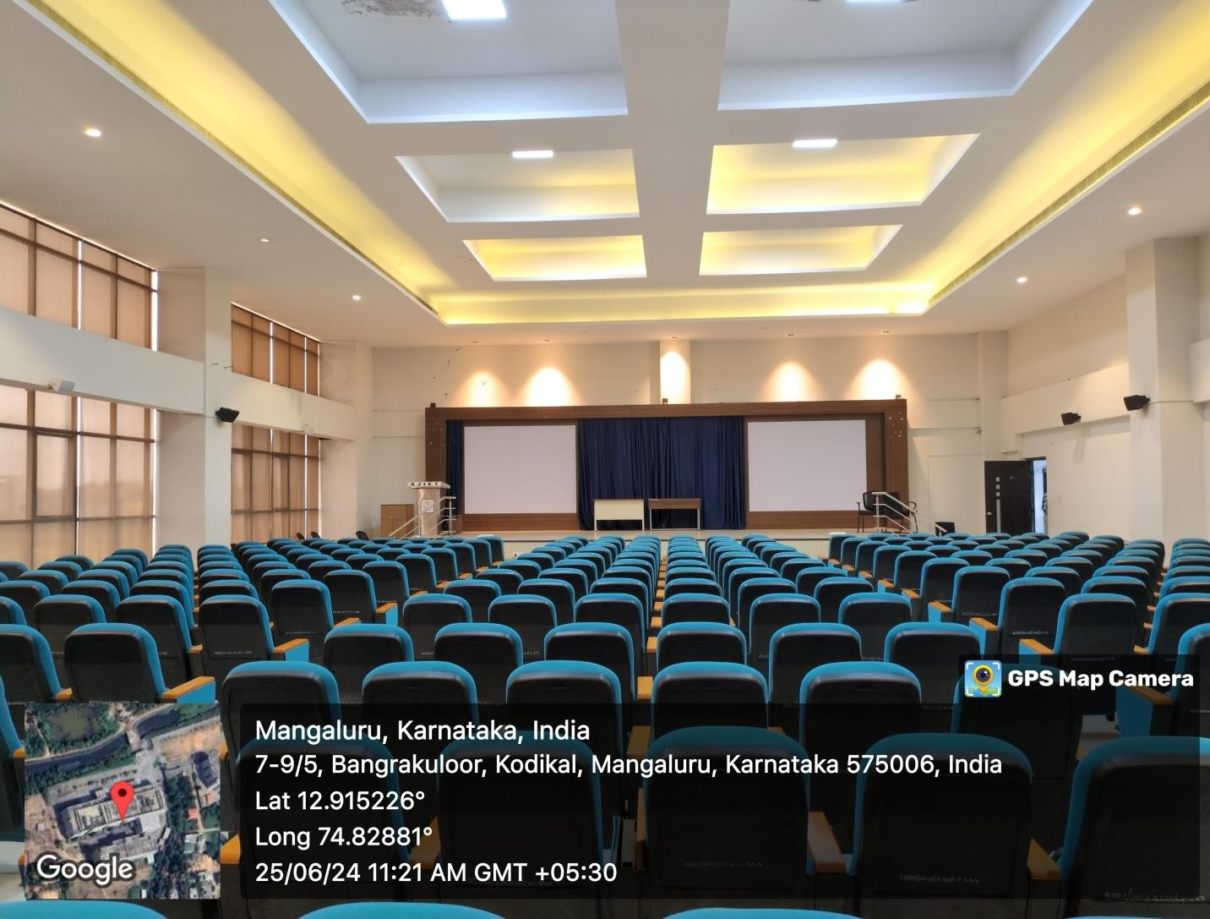

ENTRANCE LOUNGE
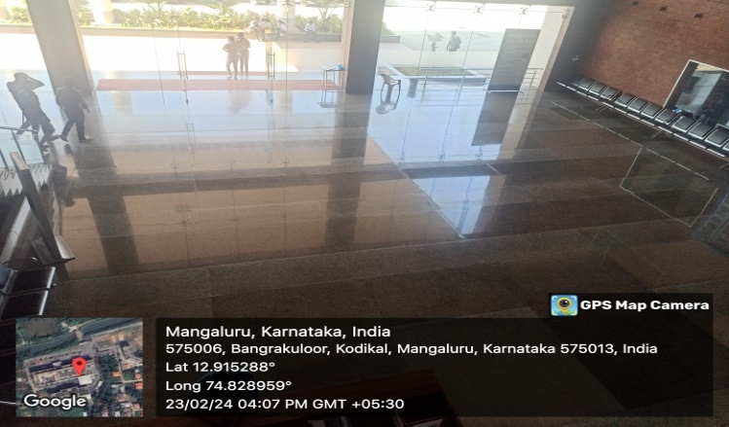

MAIN STAGE
