SEMINAR HALL 3 – A303
FRONT VIEW
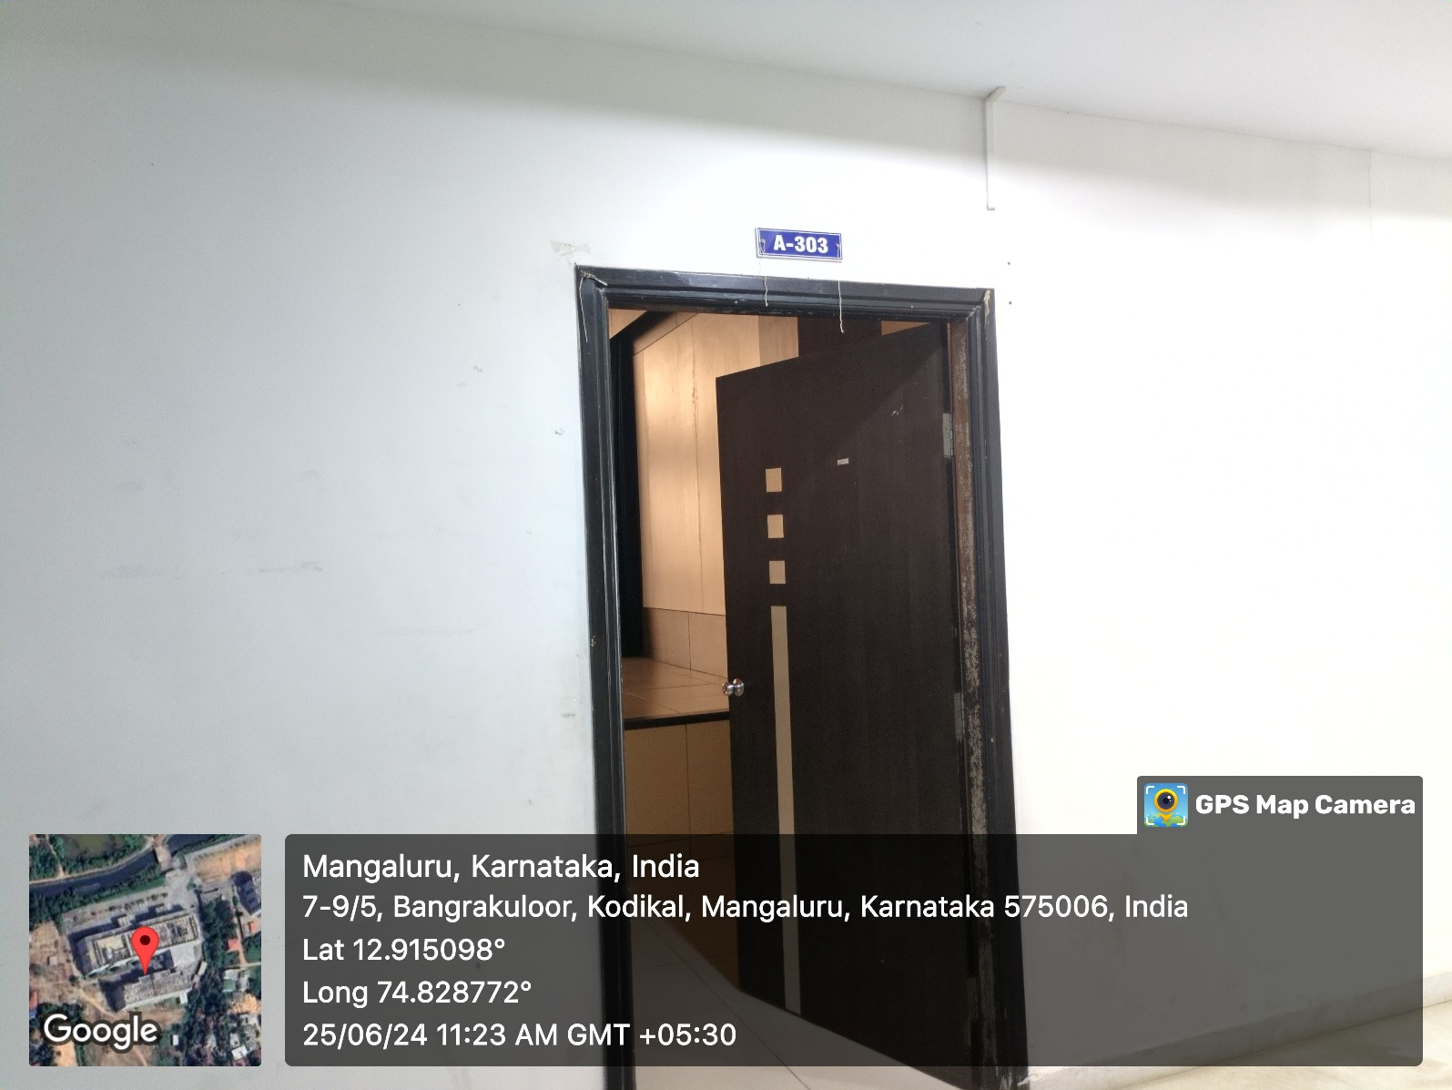

INNER VIEW
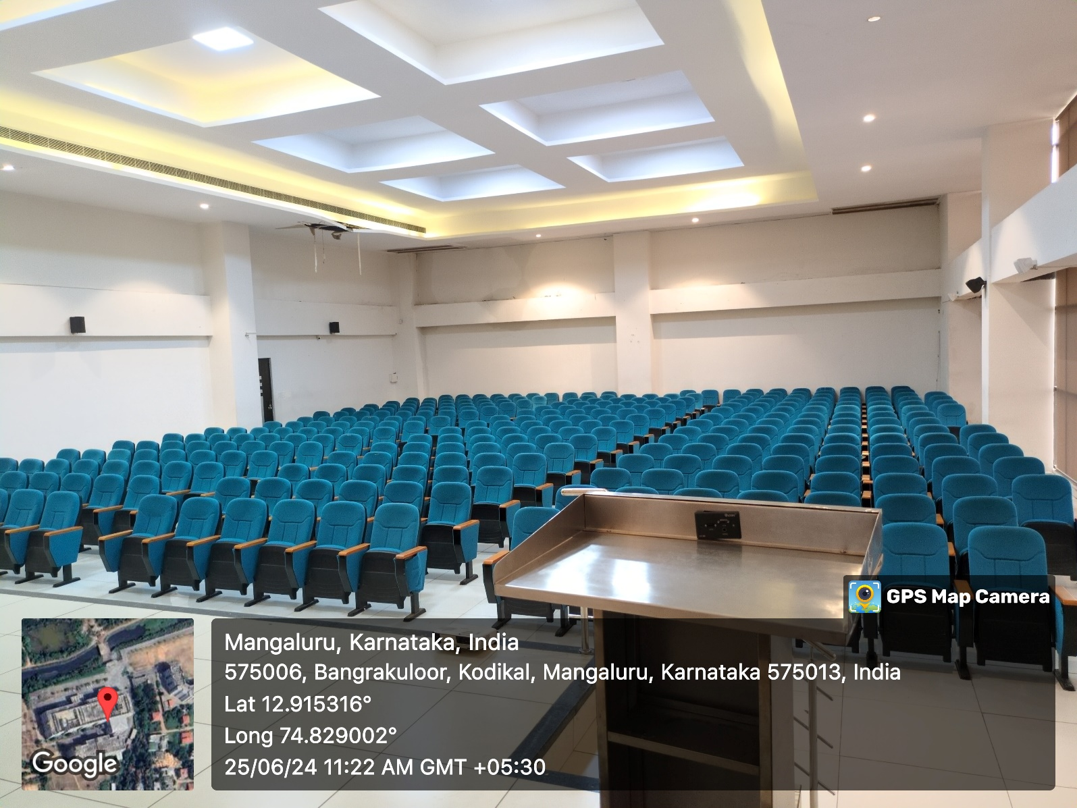

PROJECTOR (ICT TOOL)
