DEPARTMENT LIBRARY – A301B
FRONT VIEW
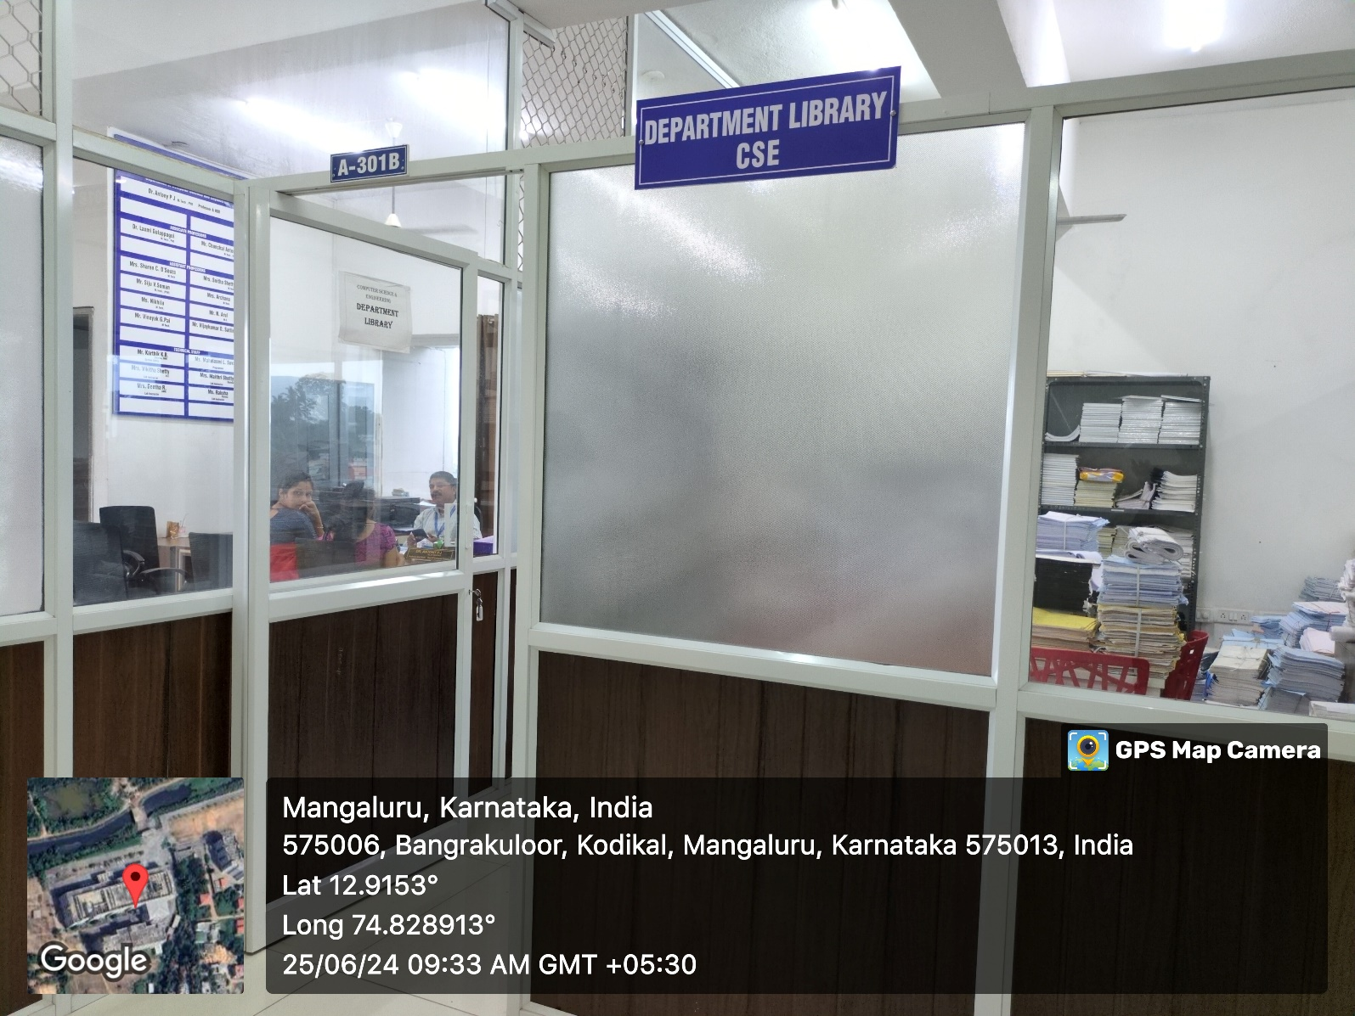

INNER VIEW
