CRITERION - 7



7.2.1
Best Practice-2 Environmental Consciousness and Sustainability Initiatives

Environment Sustainability Initiatives

At AJIET, our commitment to environmental sustainability is integral to our mission of make the students socially responsible. We strive to integrate environment sustainability into all aspects of our operations, education, and community engagement. The College has taken the following significant steps to integrate sustainable practices and environmental awareness.

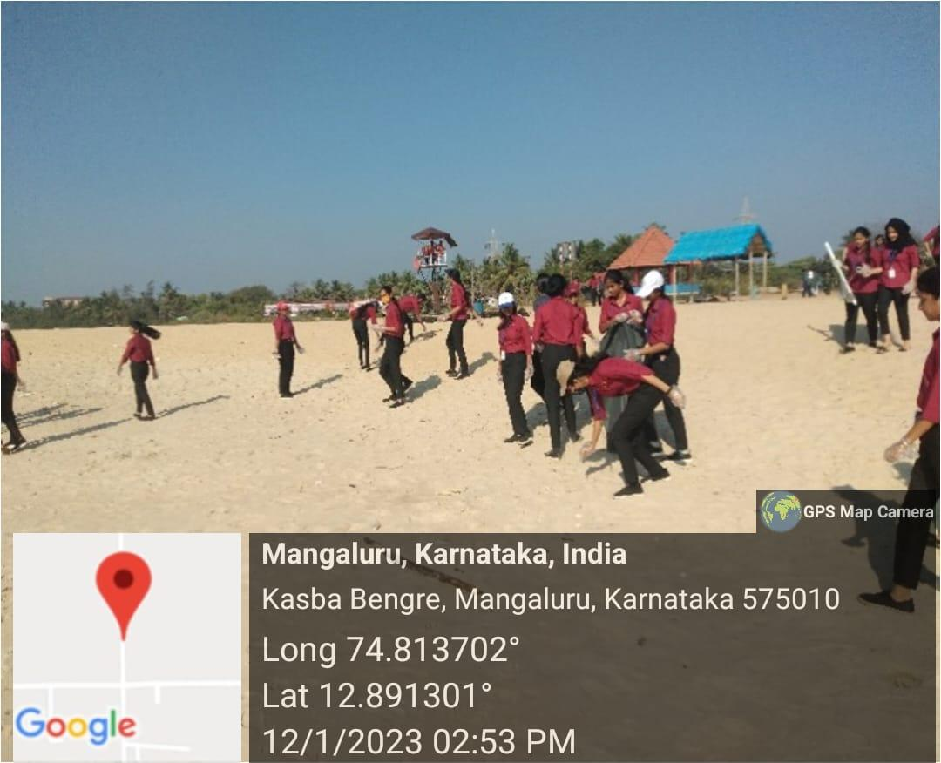
Beach Cleaning

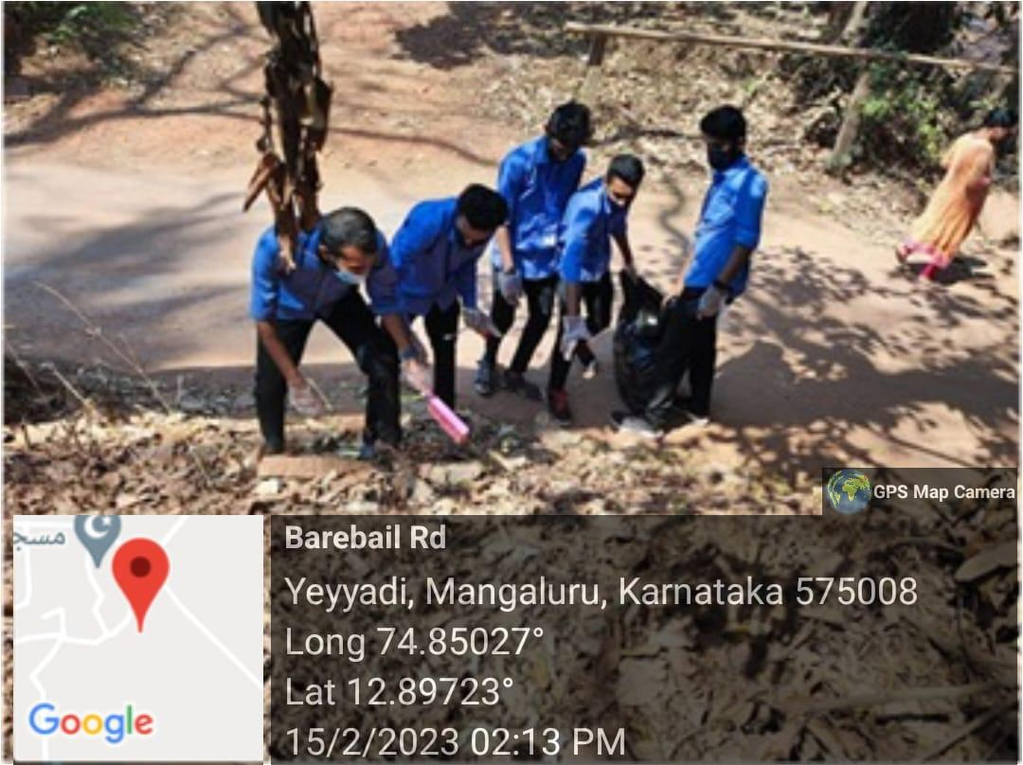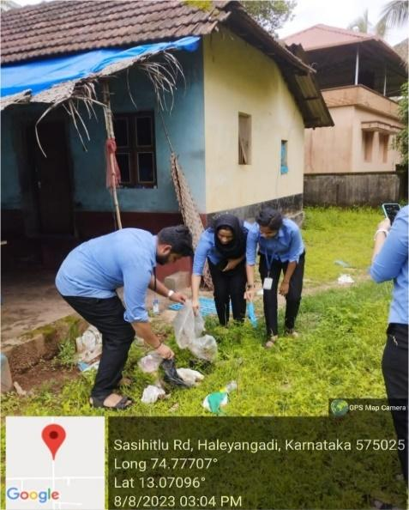

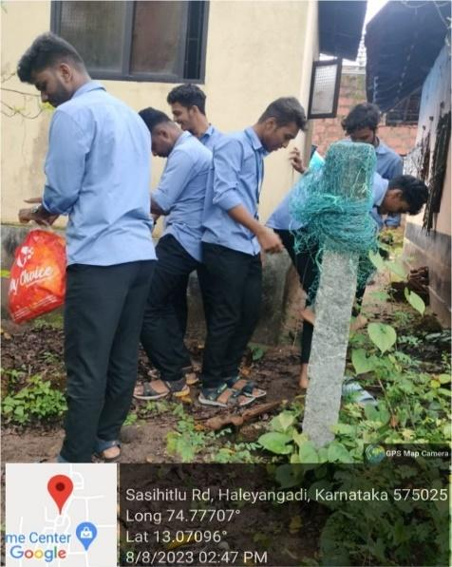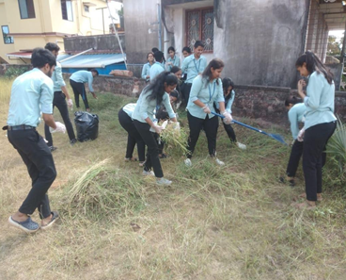
Swachh Bharath and shramadhan at different places

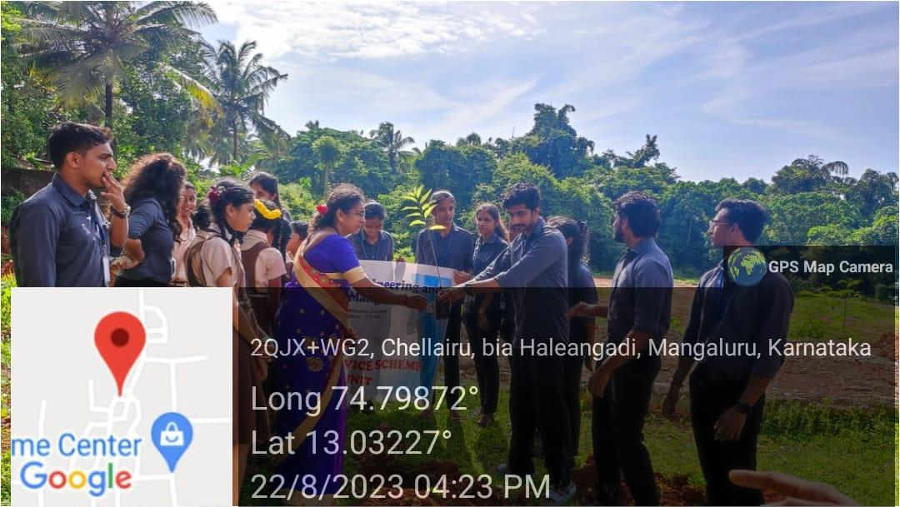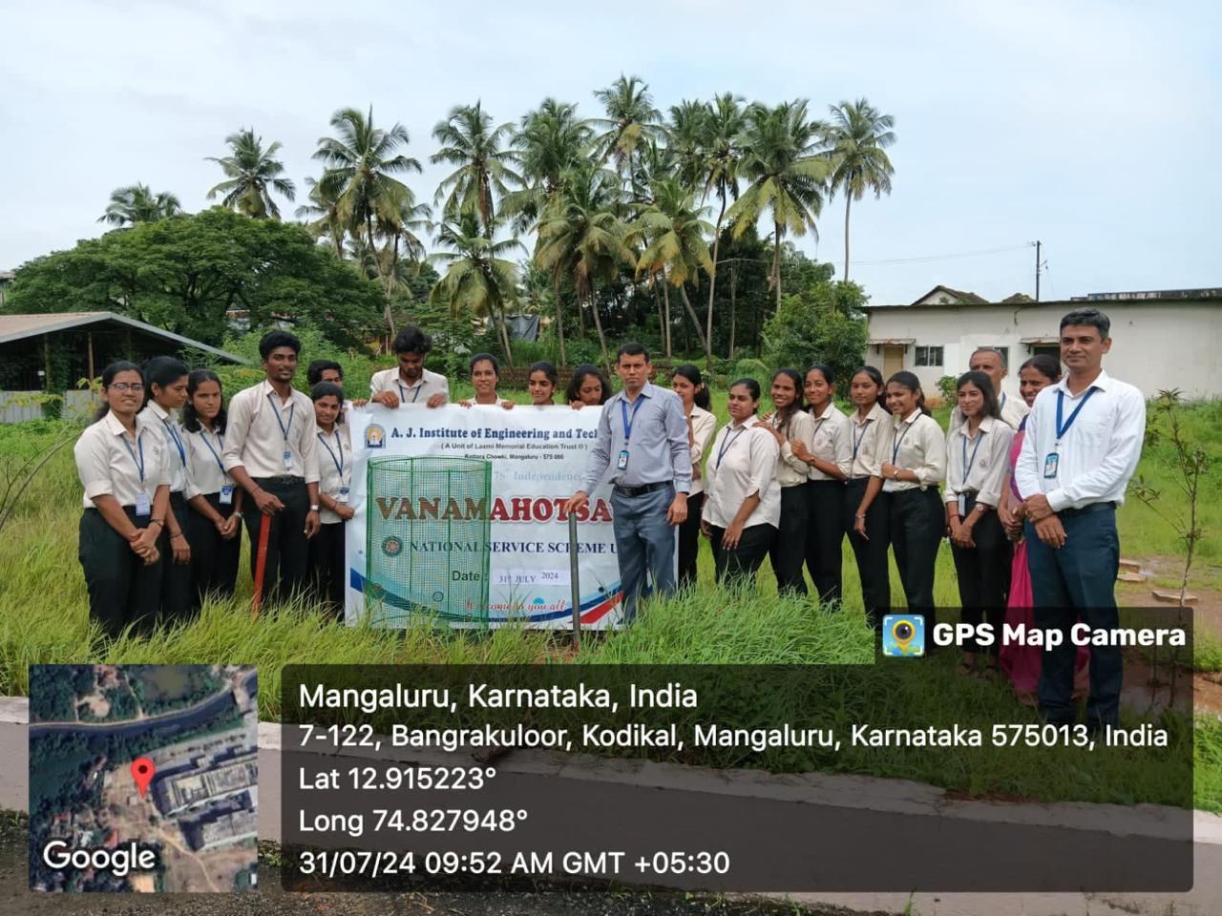

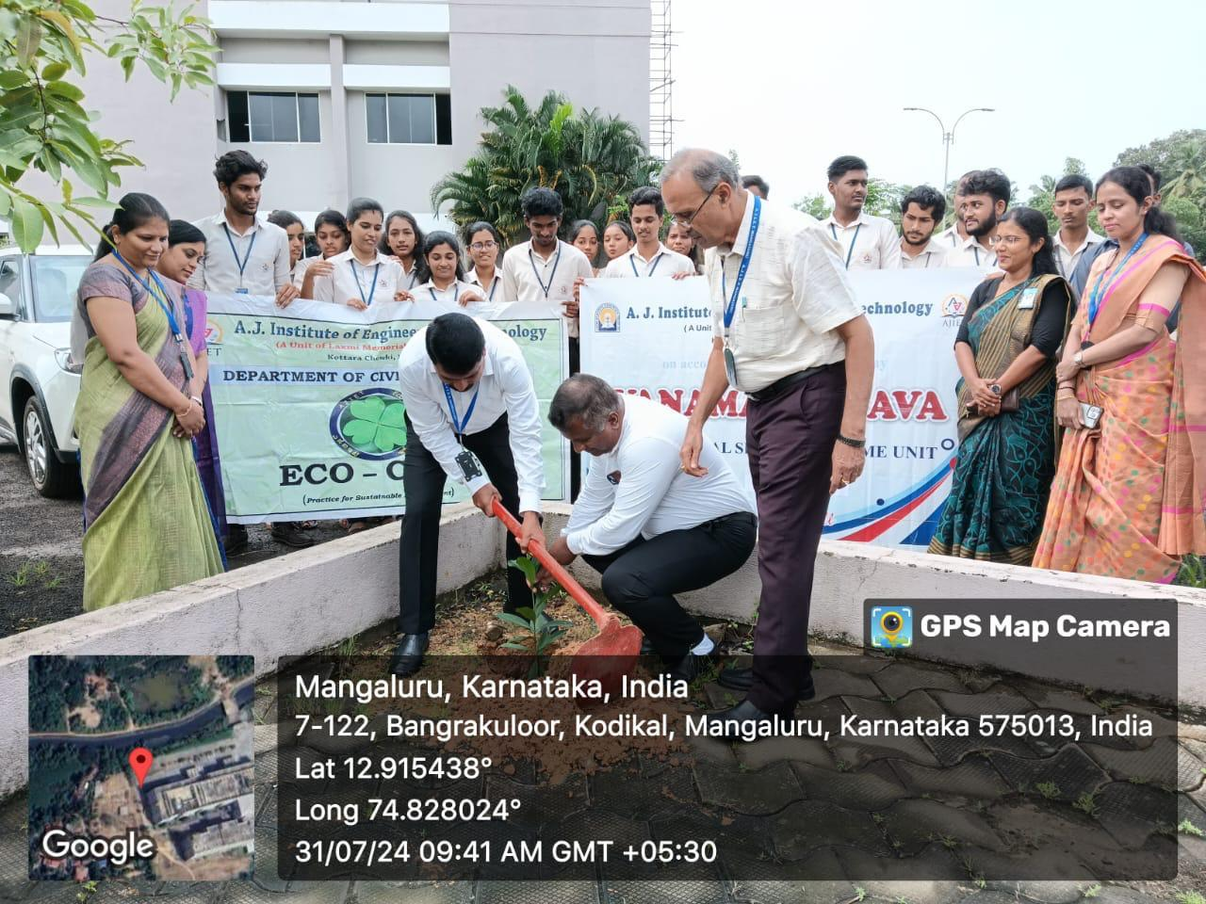
Plantation inside and outside the campus

Walkathon

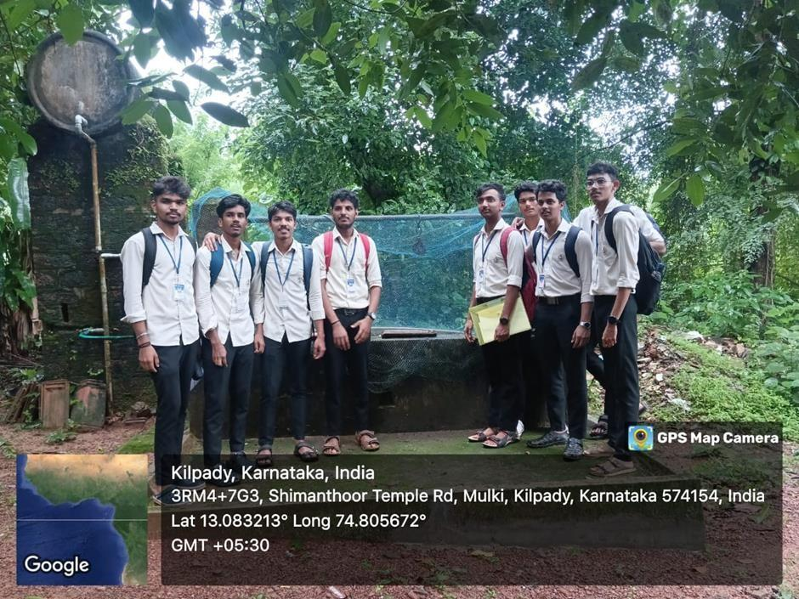
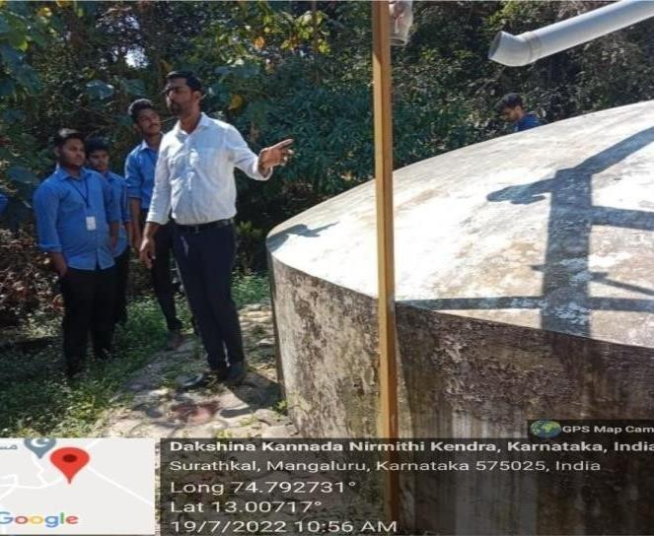
Water Conservation

The AJIET Environmental Sustainability Program embodies our dedication to creating a better future through responsible and sustainable practices. By integrating environment sustainability into our operations, education and community engagement, we strive to lead by example and inspire positive change within and beyond our campus.

