CRITERION - 7

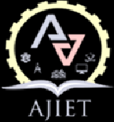
7.2
Best Practices
Supporting Documents

7.2 Two best practices successfully implemented by the Institution

Sl No | Best practices | Document
1 | Empowering high school students with technological updates through the involvement of AJIET staff and students | View Document
2 | Environment Consciousness and sustainability initiatives | View Document

