Water Conservation
Geotagged Photos | Videos
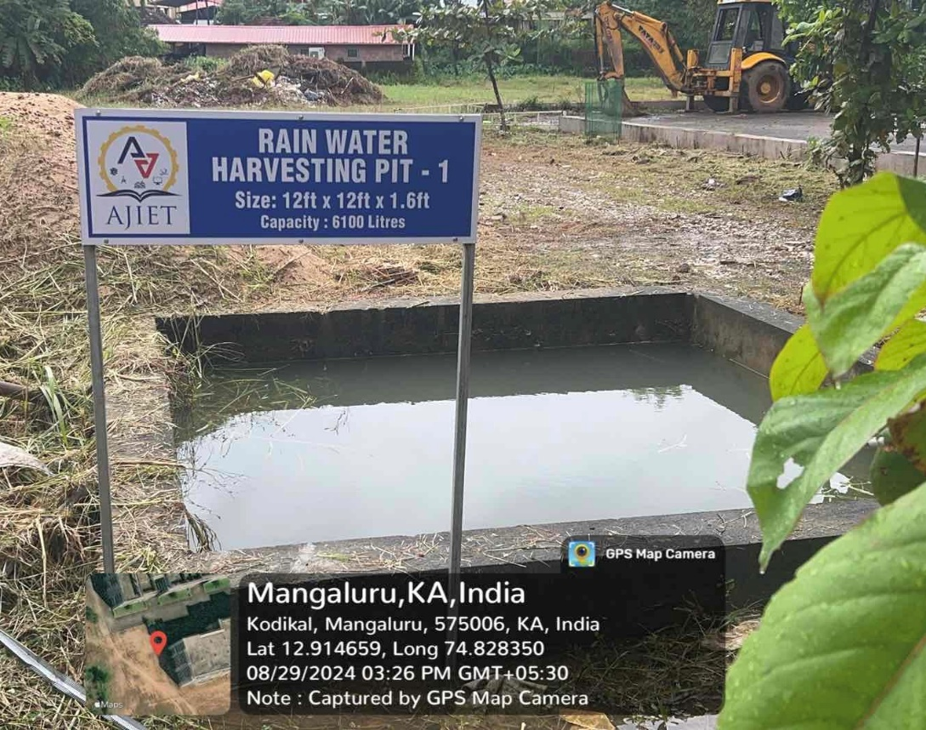  Rain Water Harvesting Pits  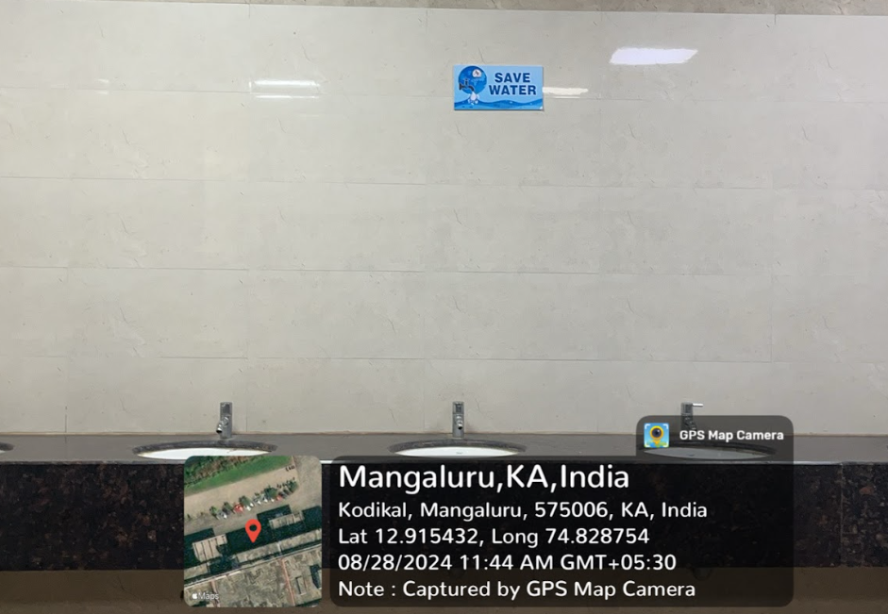 Save Water Hoardings  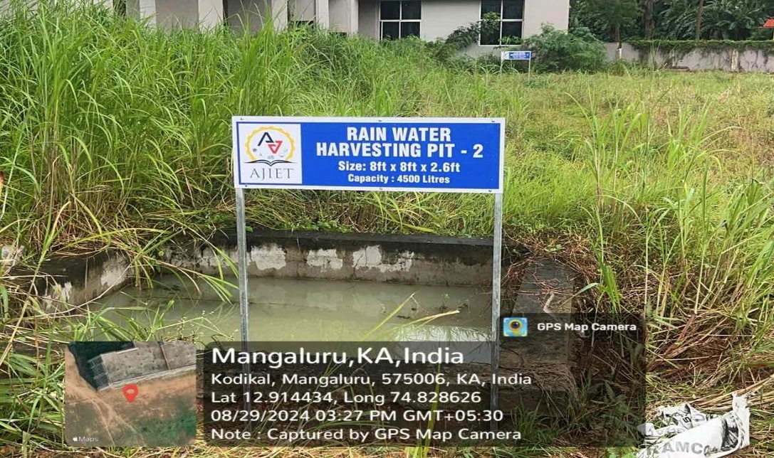  Rain Water Harvesting Pits  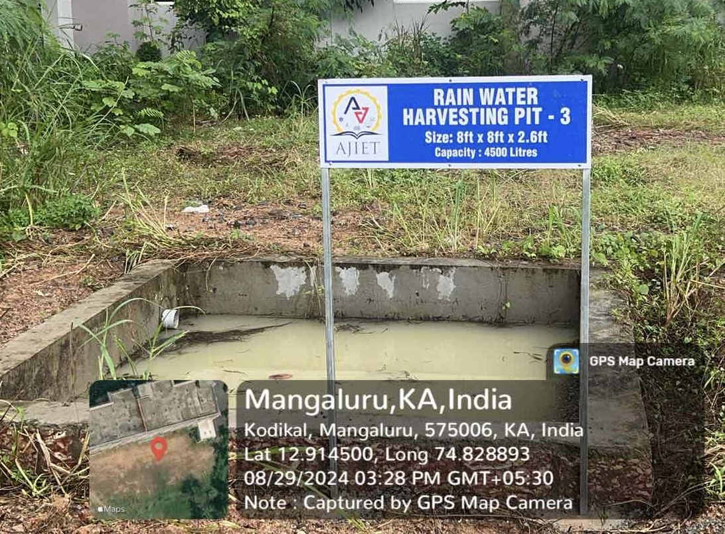  Rain Water Harvesting Pits  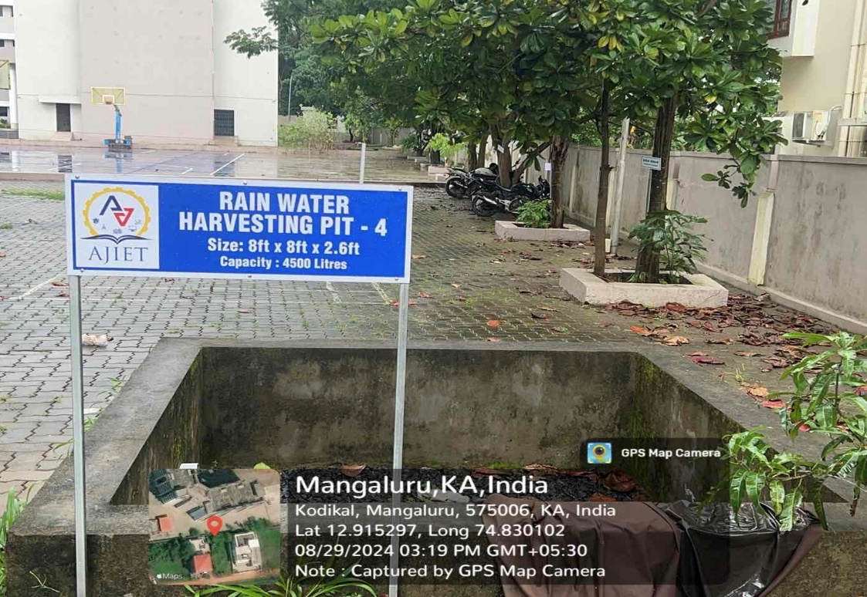  Rain Water Harvesting Pits | View Document

