Disabled-friendly, barrier-free environment Facility
Geotagged Photos | Videos
Physically Challenged washrooms  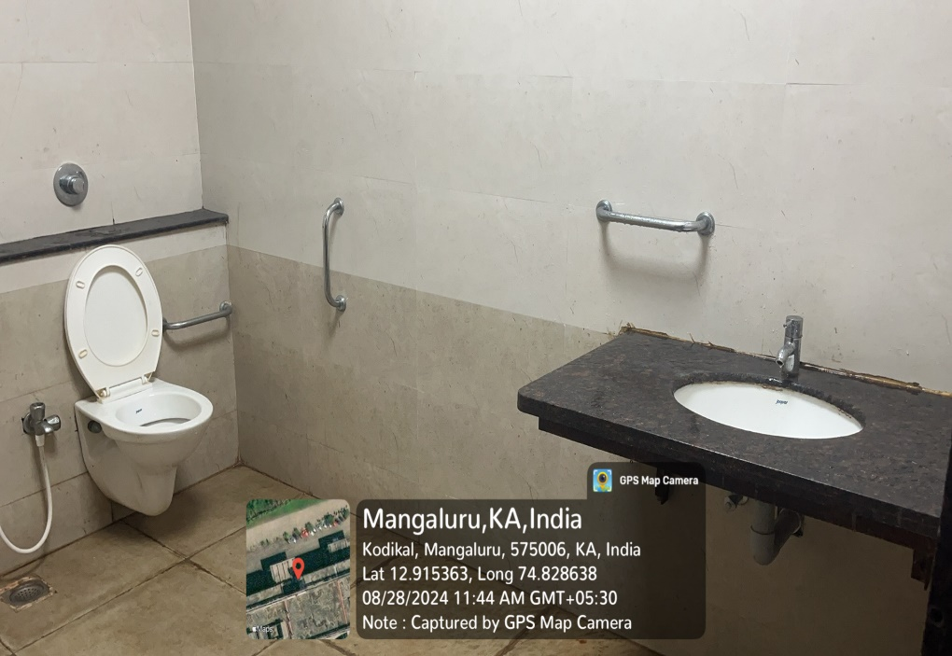  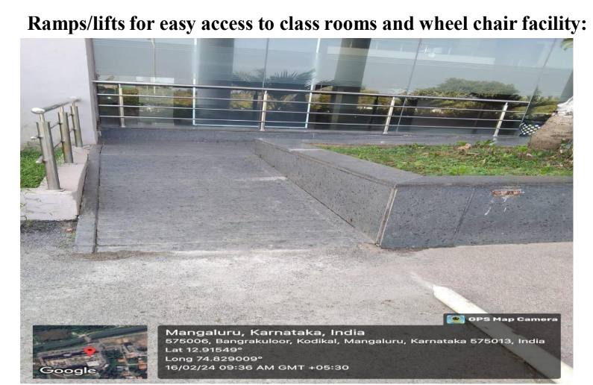  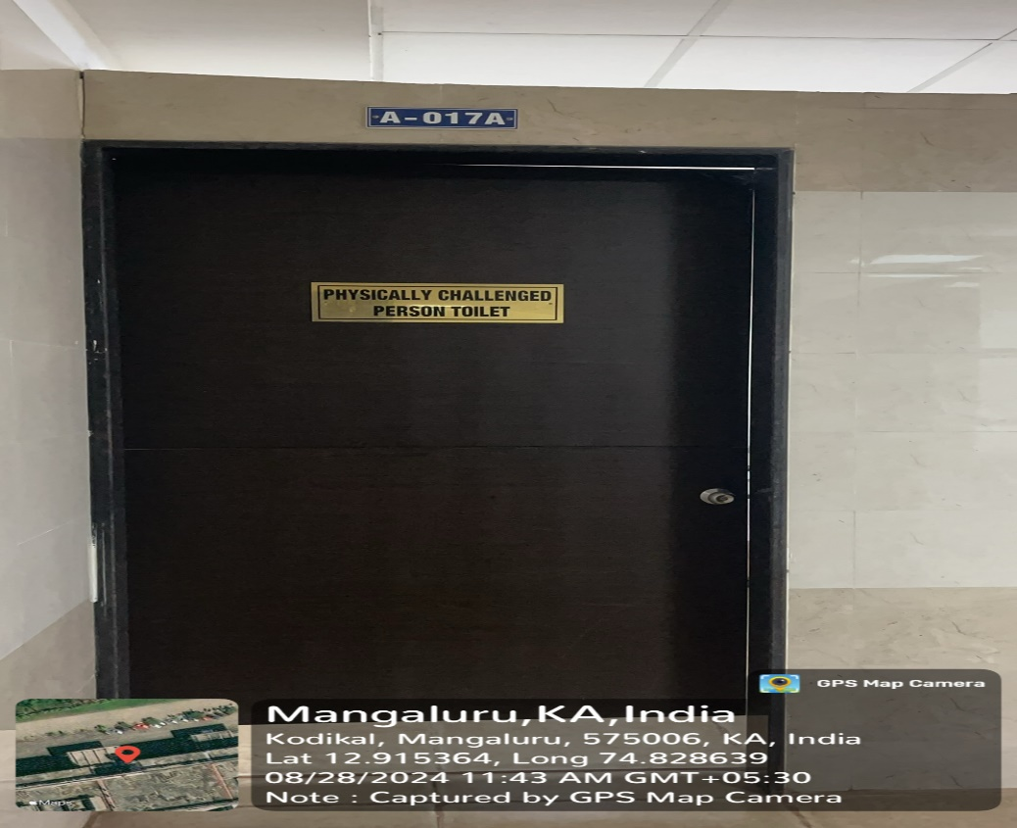 | View Document

