Use of LEDs for Energy Conservation
Geotagged Photos | Videos
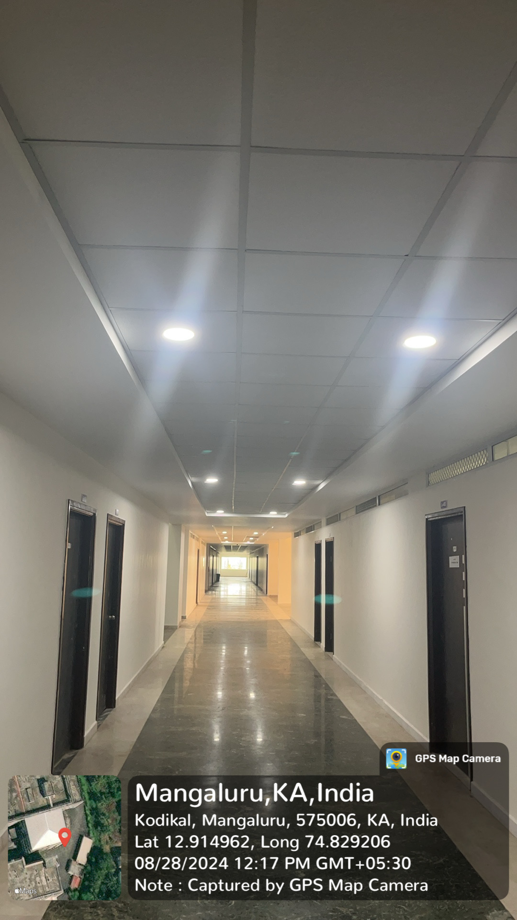  LED’s inside College Corridors  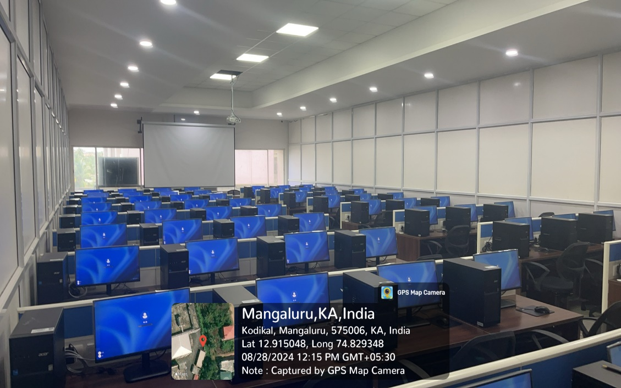  LED’s inside the Labs  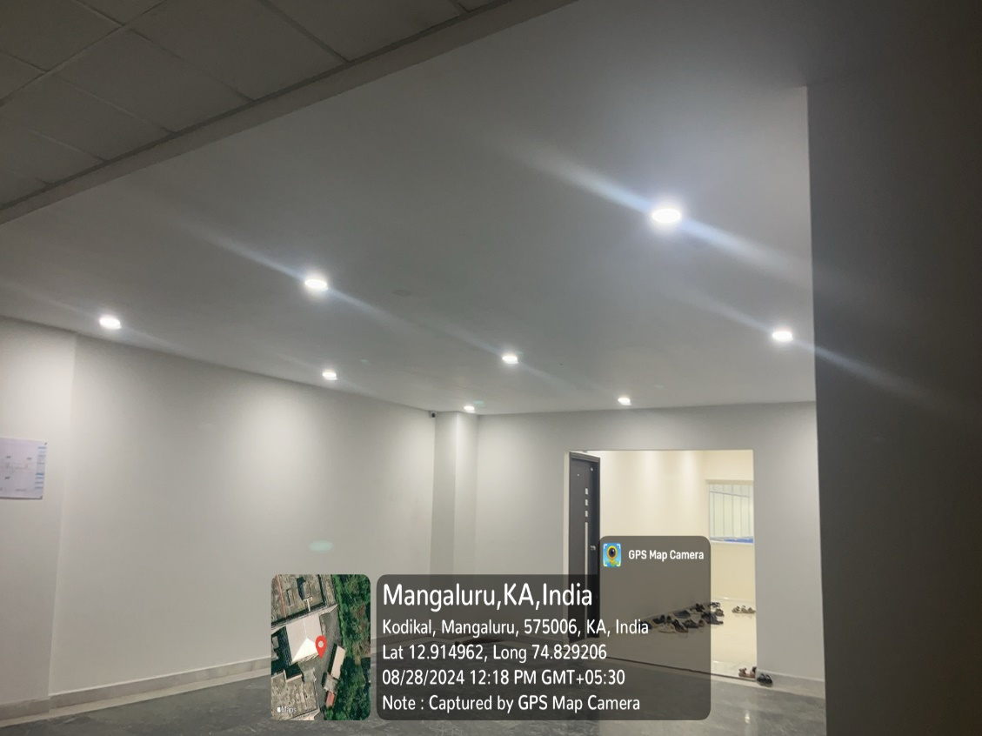  LED’s inside entire campus | View Document

