Solar Energy Utilization
Geotagged Photos | Videos
40KW Solar Panel to Produce Electricity  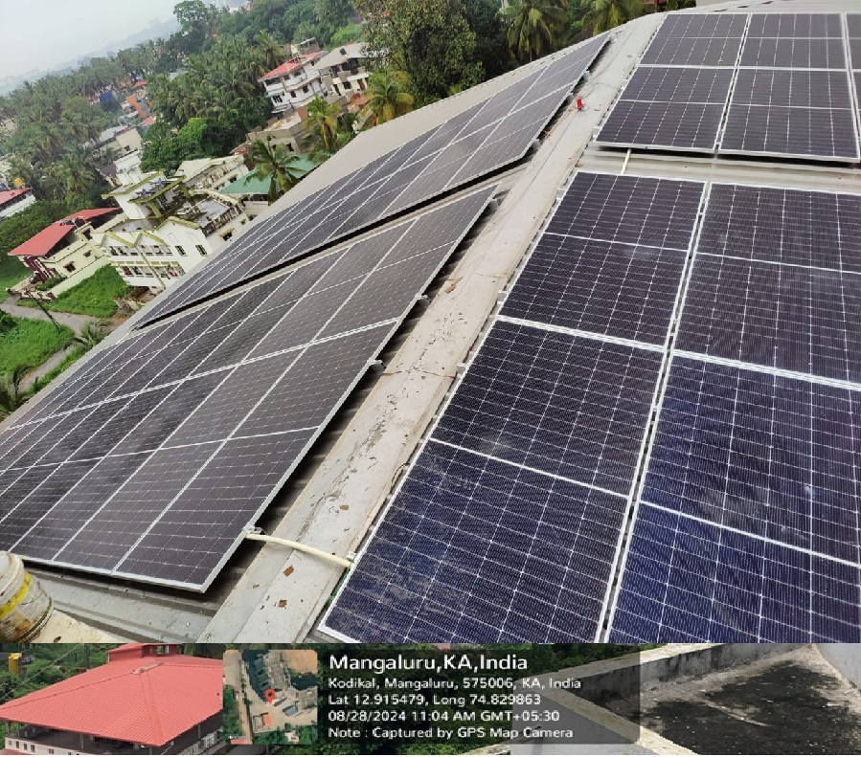  Photovoltaic panels for solar streetlights within Campus  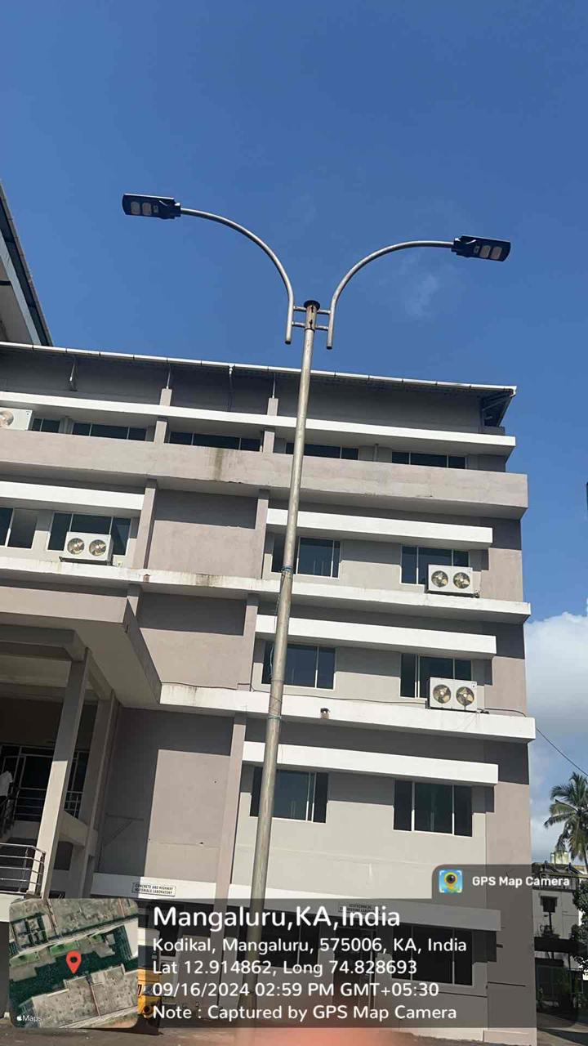  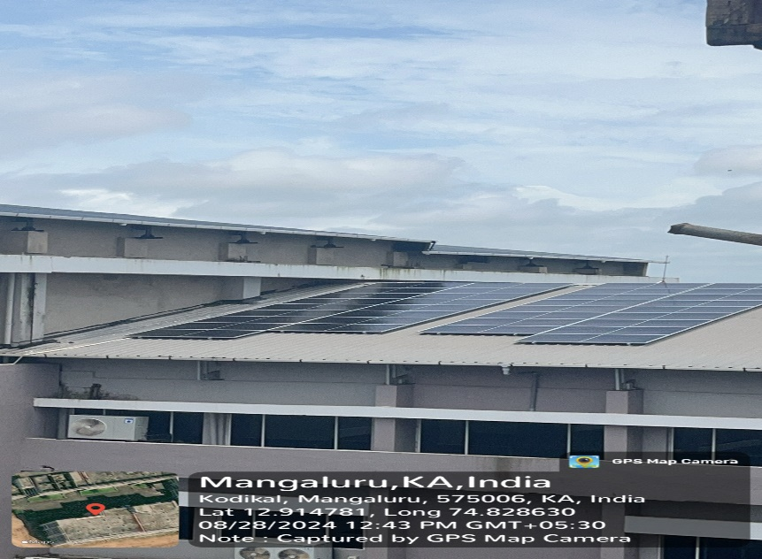 | View Document

