Green Campus Initiatives
Geotagged Photos | Videos
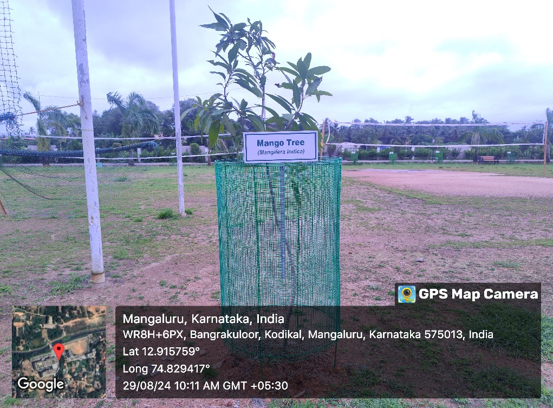  Sampling Plants  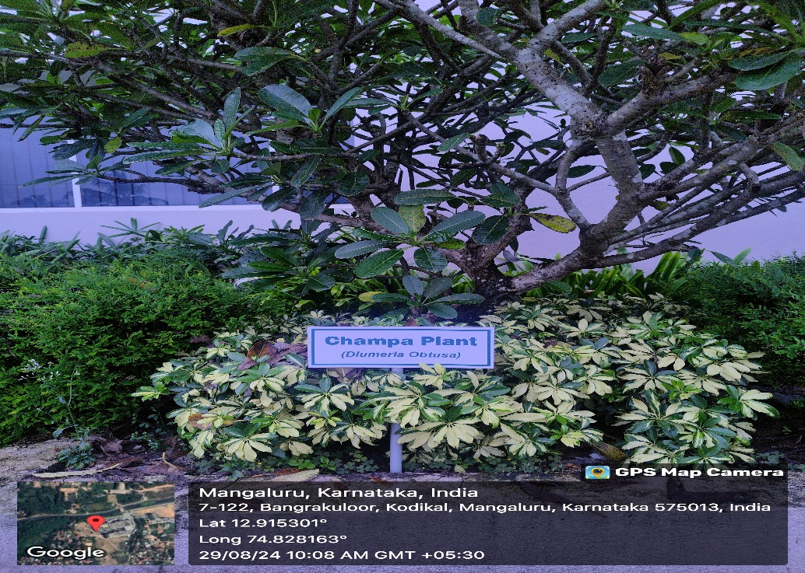  Plant Naming  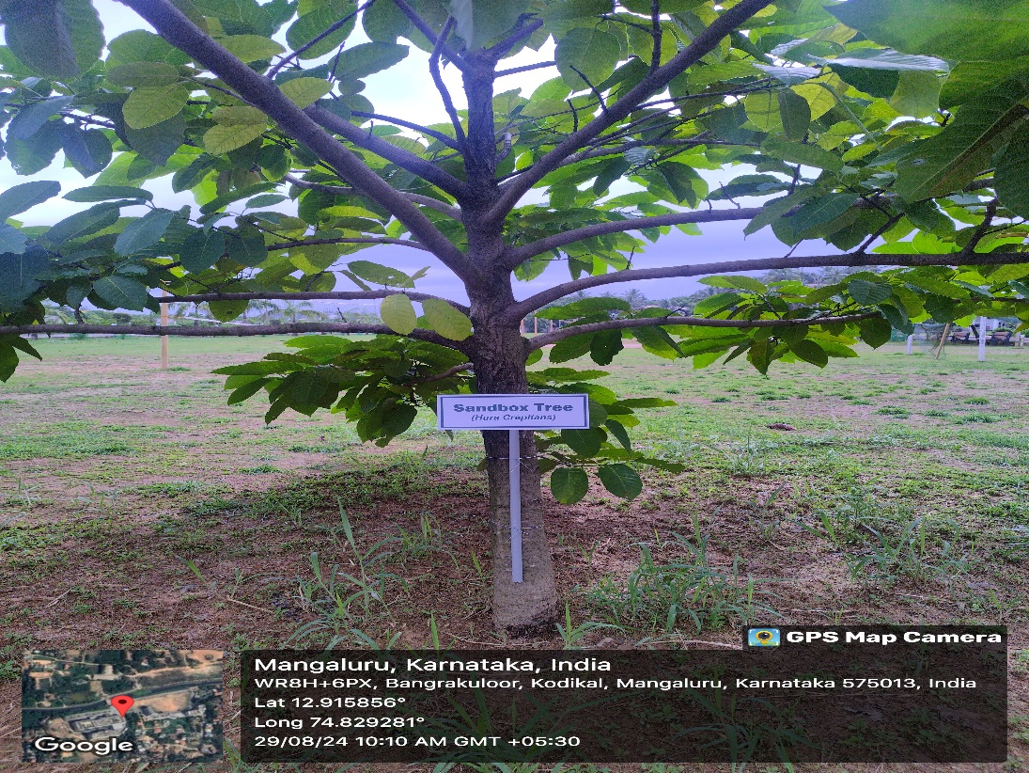  Trees within the Campus | View Document

