Degradable and non-degradable waste Management
Geotagged Photos | Videos
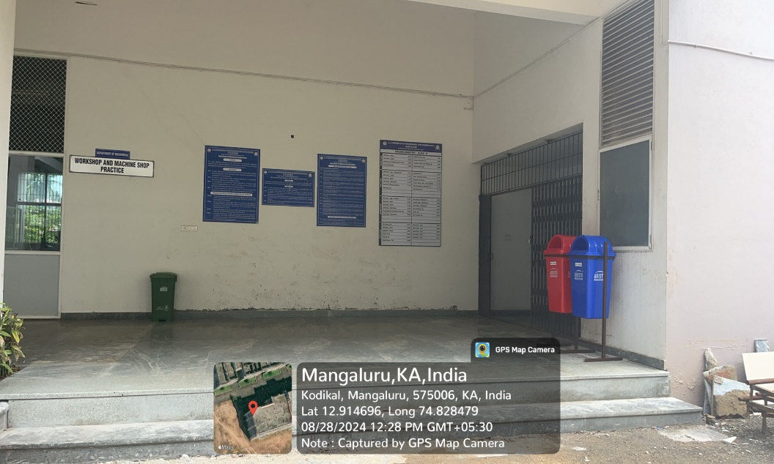  Separate Waste bins to Segregate Wet and Dry Waste  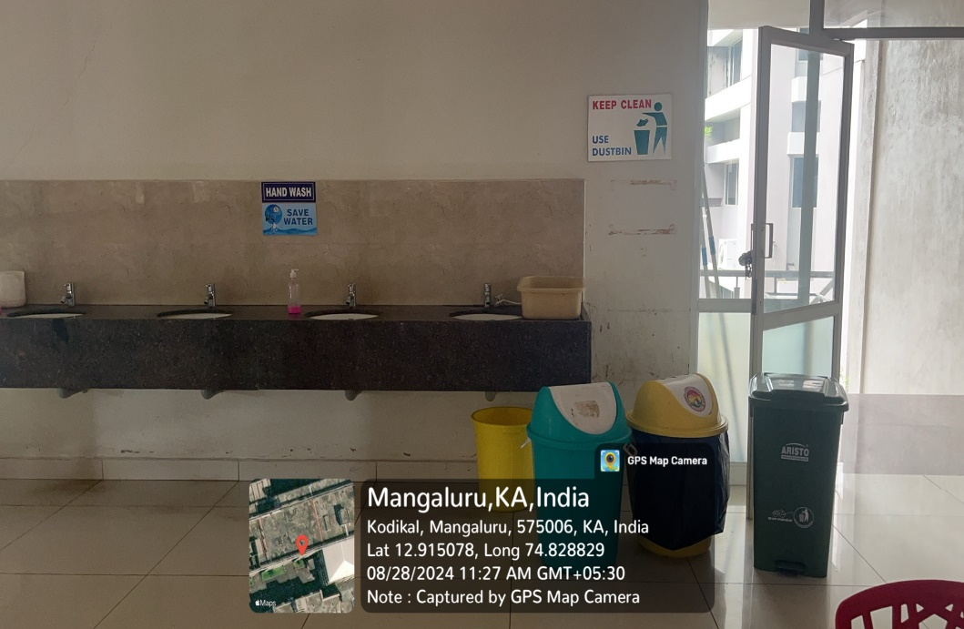  Waste bins  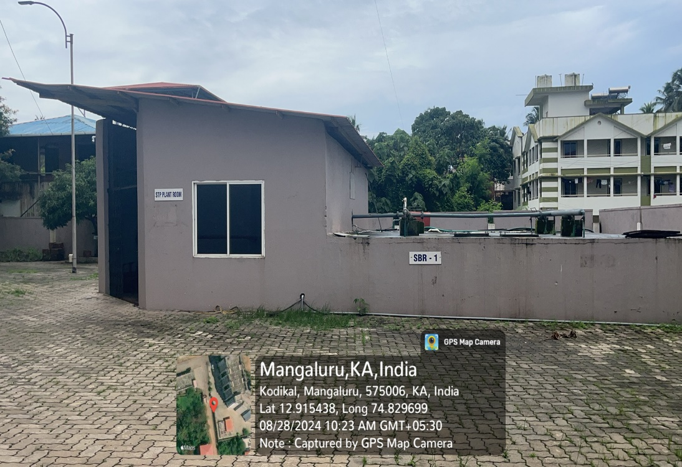  Sewage Treatment Plant  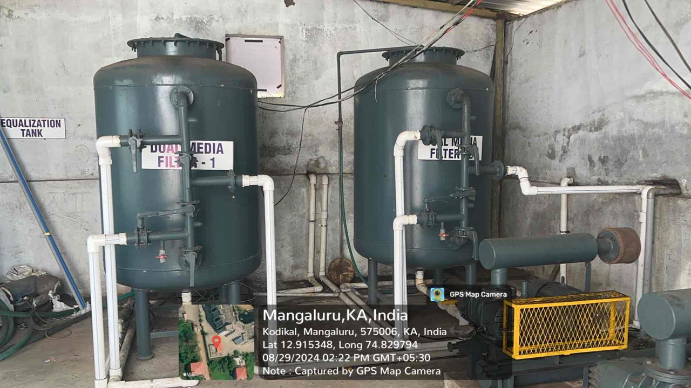  Equalizer Tanks inside Sewage Treatment Plant | View Document

