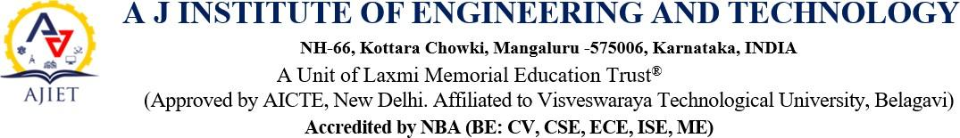

: The Institution has facilities for
      - Alternate sources of energy and energy conservation measures

Management of the various types of degradable and non-degradable waste
      - Water conservation

Green campus initiatives
      - Disabled-friendly, barrier free environment

BILLS

The institution has facilities and initiatives for |  |  | Bills
1 | Alternate Sources of  energy and energy conservation  measures | 1. Solar energy | View Document
1 |  | 2. Use of LED Bulbs/Power  efficient Equipment’s | View Document
2 | Management of  various types of  degradable and  non-degradable waste | Solid/Liquid waste  management and recycling system | View Document
3 | Water conservation | Rain water harvesting,  conservation and recycling | View Document
4 | Green campus initiatives | Landscaping with trees and  Plants | View Document
5 | Disabled friendly barrier free environment | - Lift | View Document
5 | Disabled friendly barrier free environment | - Wheelchair | View Document

