CRITERION - 7

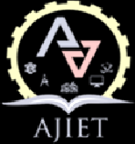
7.1.1
Women Welfare Committee
Activities reports

Supporting Documents

Gender Sensitization Reports
SL.NO | Description | Links
1. | Academic Year 2023-24 | View Document
2. | Academic Year 2022-23 | View Document
3. | Academic Year 2021-22 | View Document
4 | Academic Year 2020-21 | View Document
5 | Academic Year 2019-20 | View Document

