Safety and Security
To ensure the safety and security of female students and faculty, a committee for grievance resolution has been established. Our Internal Compliances committee is always on the lookout for instances of sexual abuse directed towards female employees and students. We also employ covert monitoring services, who closely watch the entire campus, to try to stop these kinds of harassments. CCTVs are being installed all across campus to provide 24-hour security.
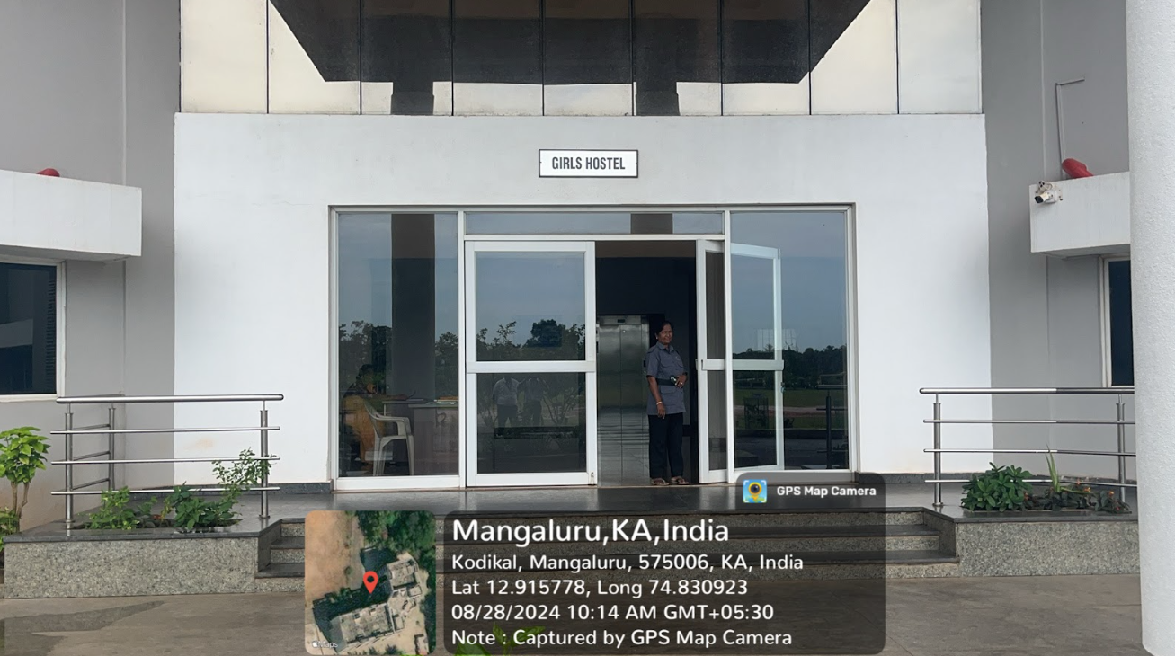
Hostel Entrance with Security

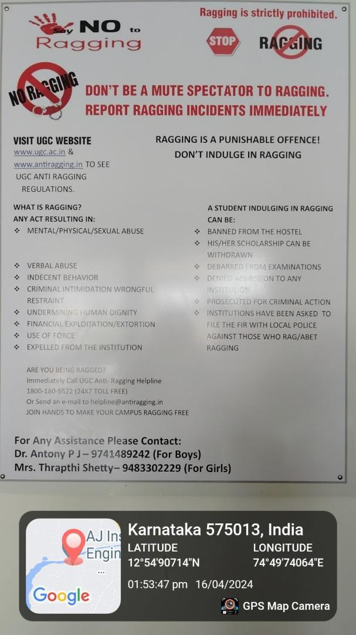
No Ragging: Displayed in various places of college/Hostel premises.

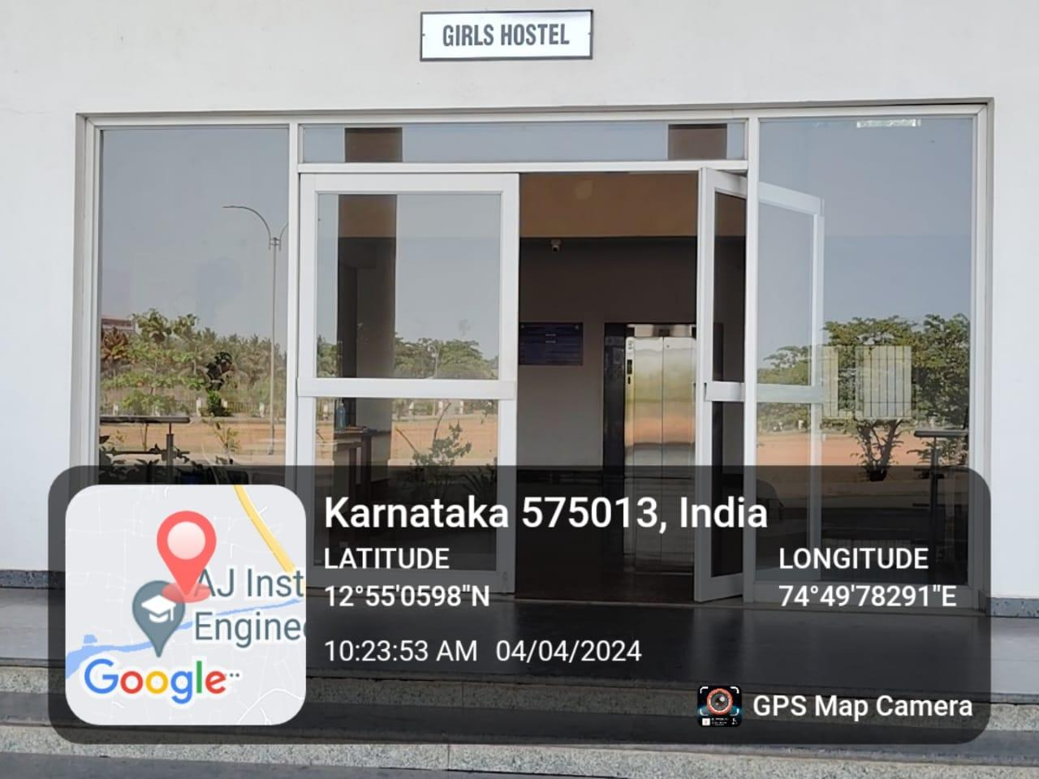
Girls Hostel Entrance

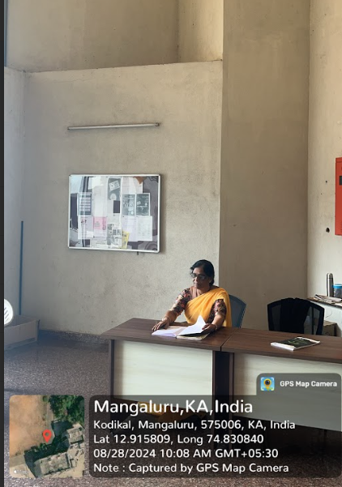
Girls Hostel Warden
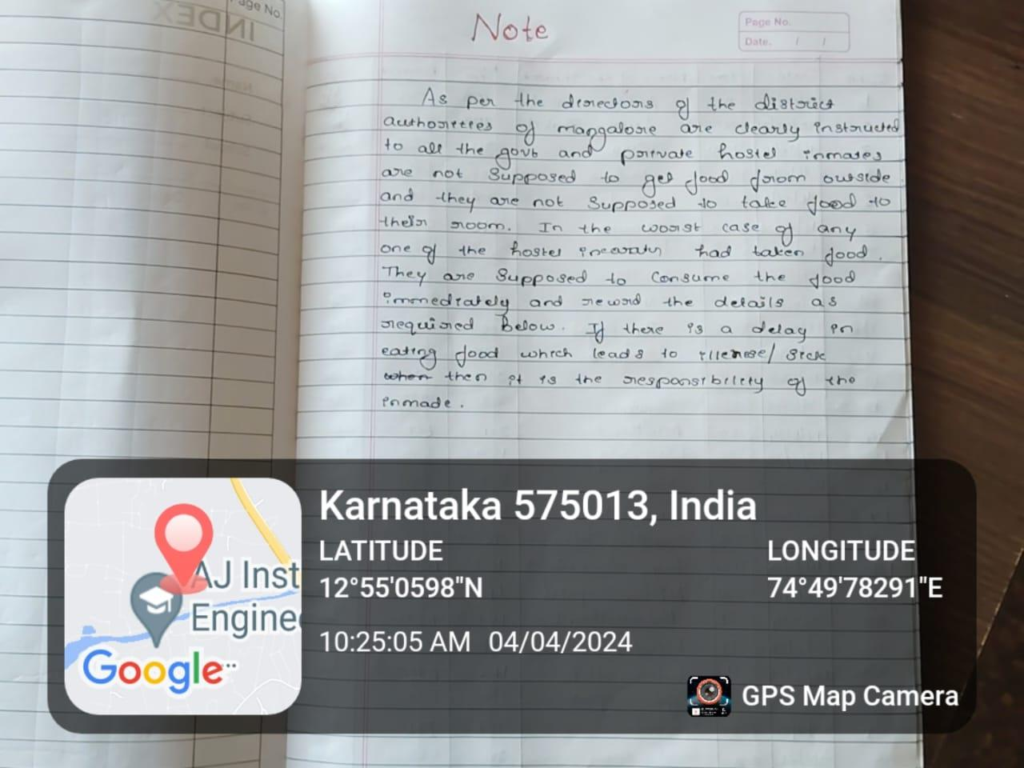
Notice in Girls Hostel: regarding outside foods are not allowed in hostel

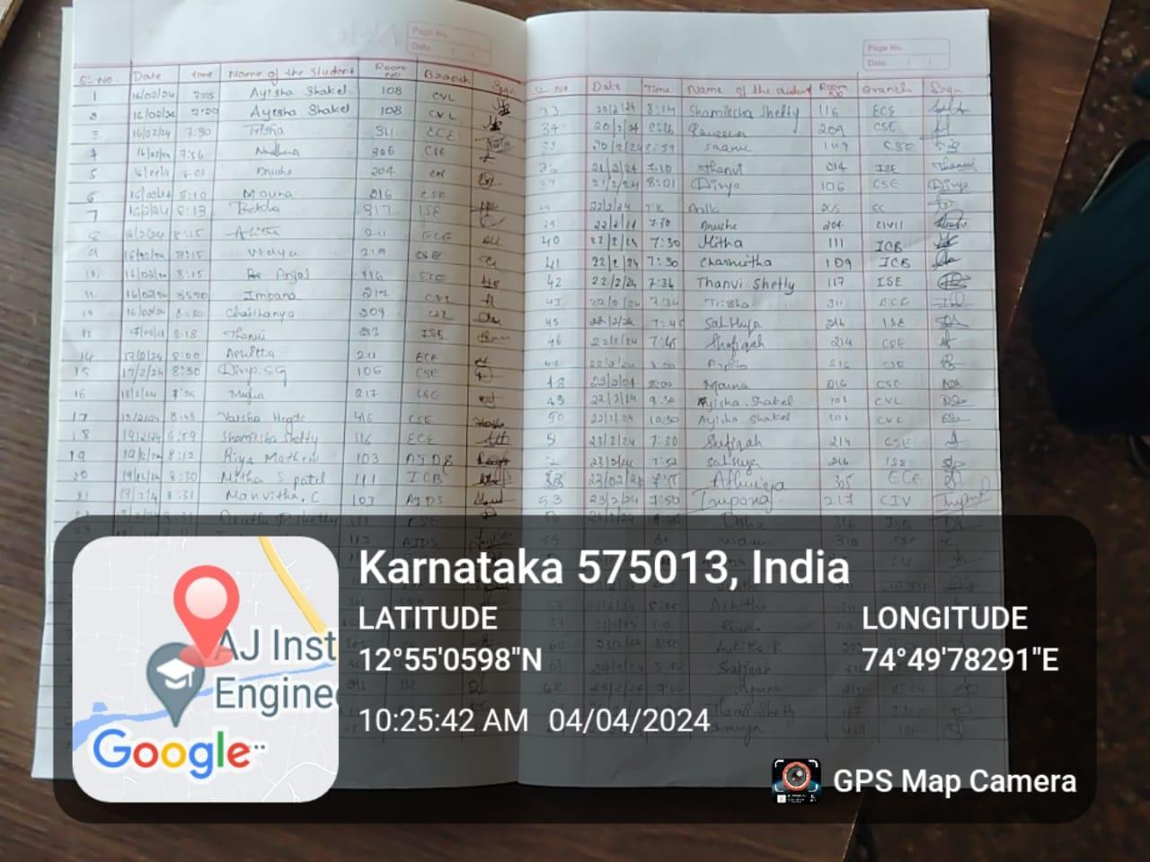
Login/Logout Book Maintained in Girls Hostel

L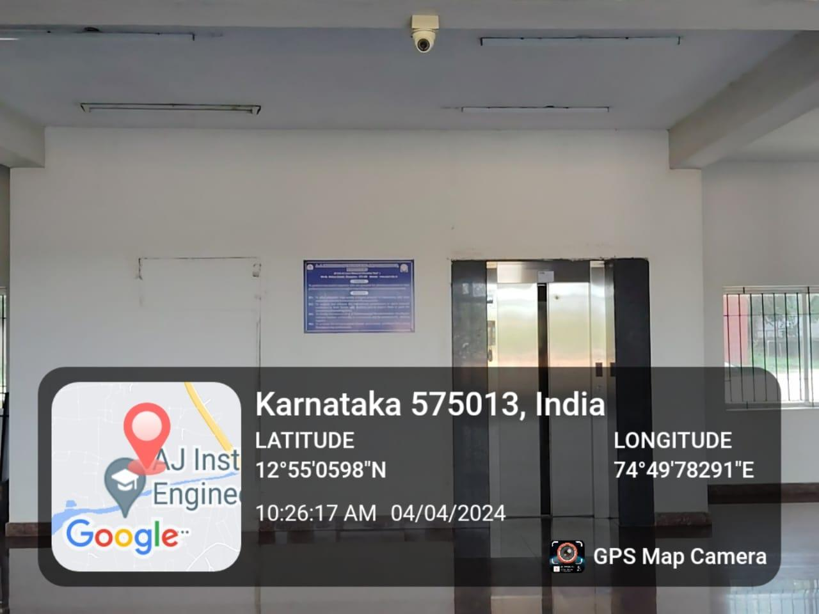
CCTV Camera Surveillance in Girls Hostel

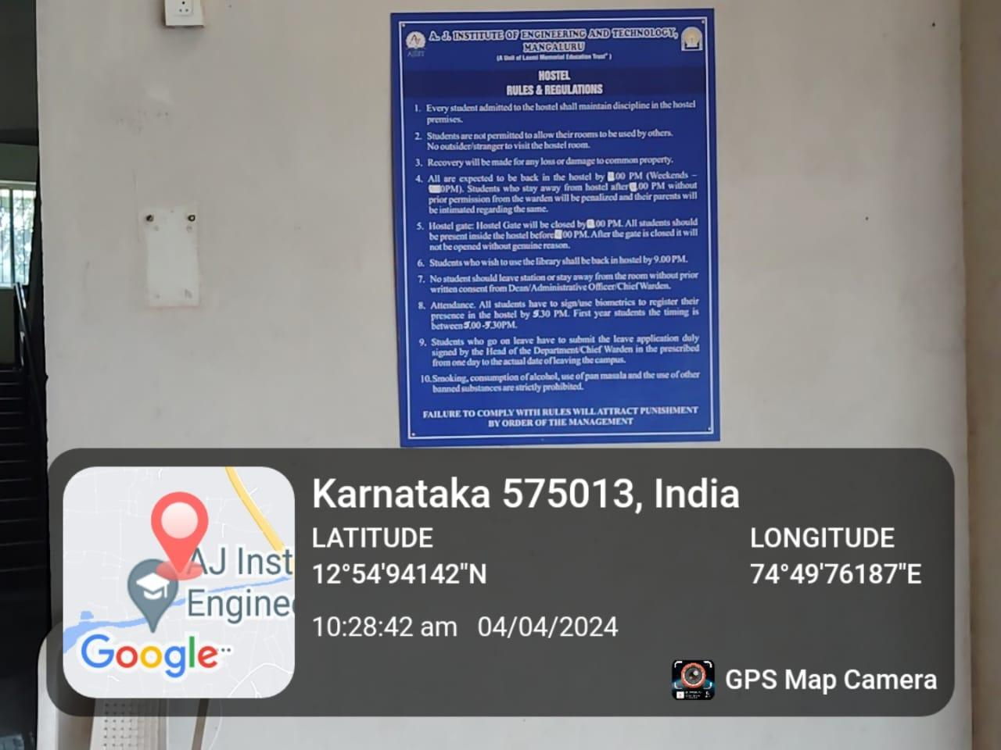
Rules and Regulations of Girls Hostel

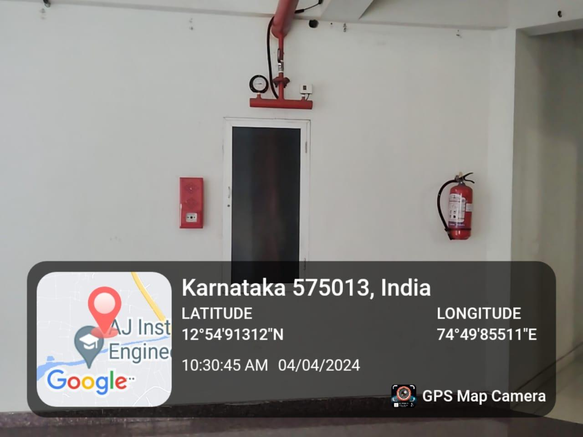
Fire Safety in Girls Hostel

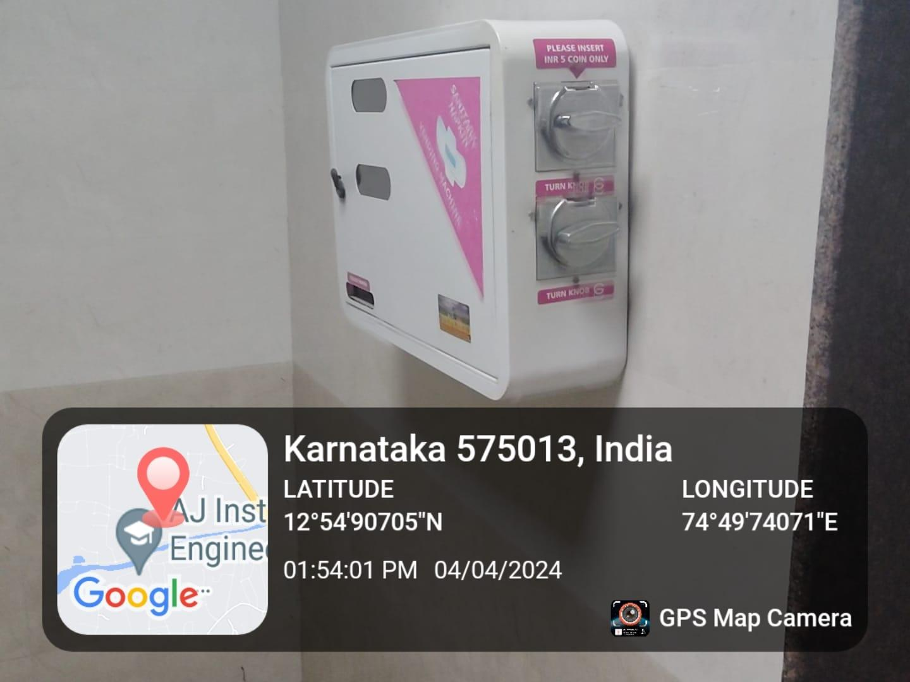

Sanitary Napkin Vending Machine placed at Girls Hostel
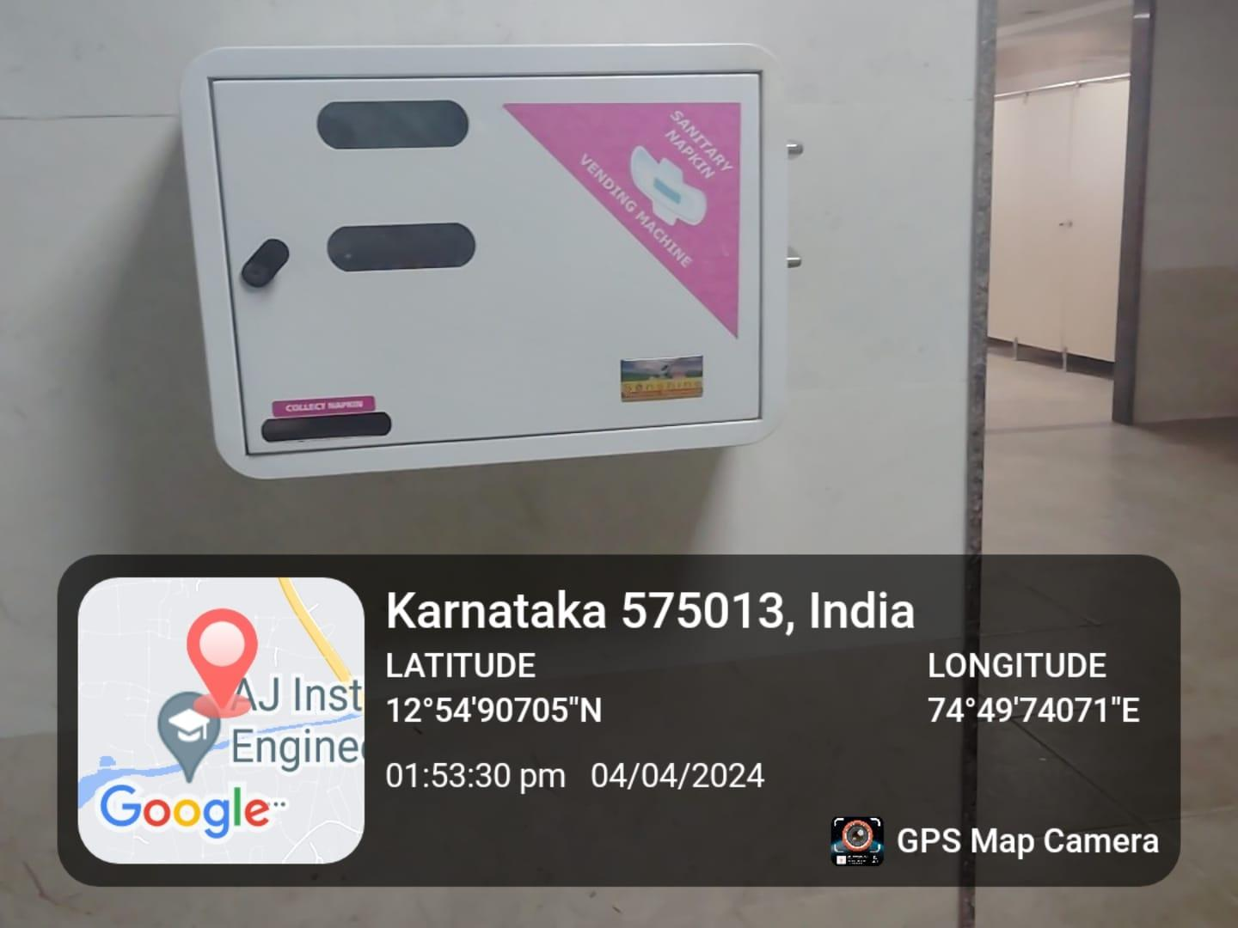

Sanitary Napkin Vending Machine placed at Girls Hostel
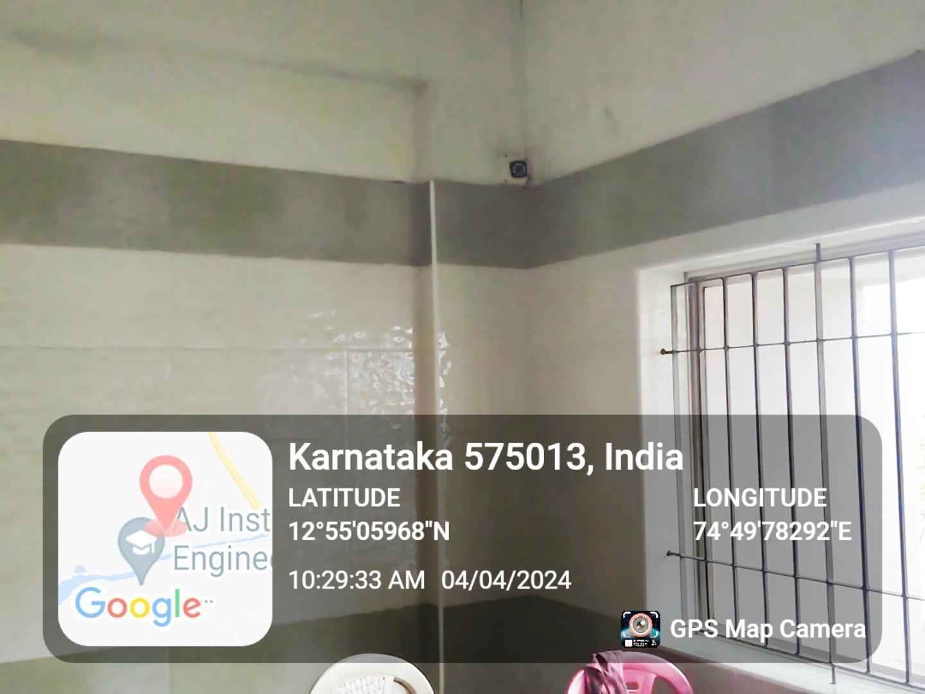
CCTV Camera Surveillance in Girls Hostel Rooms

