5.1.4 c Mechanisms for submission of online/offline students’ grievances

- Suggestion/complaint boxes have been installed at the main entrances of the institution, allowing students to drop their grievances and suggestions for improving the college's academics and administration.

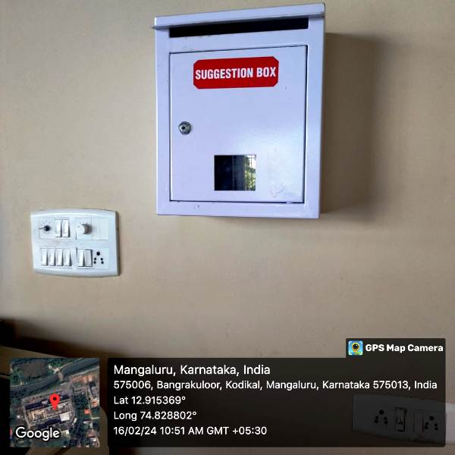
A snapshot of the suggestion box stationed in the main block, inviting anonymous complaints and suggestions to foster a transparent and inclusive environment

5.1.4 c Mechanisms for submission of online/offline students’ grievances

- The Institution has a transparent mechanism for timely redressal of student grievances including sexual harassment and ragging cases

The students can register their grievances in online at
WEBSITE LINK:
https://www.ajiet.edu.in/grievance-and-redressal-committee.php
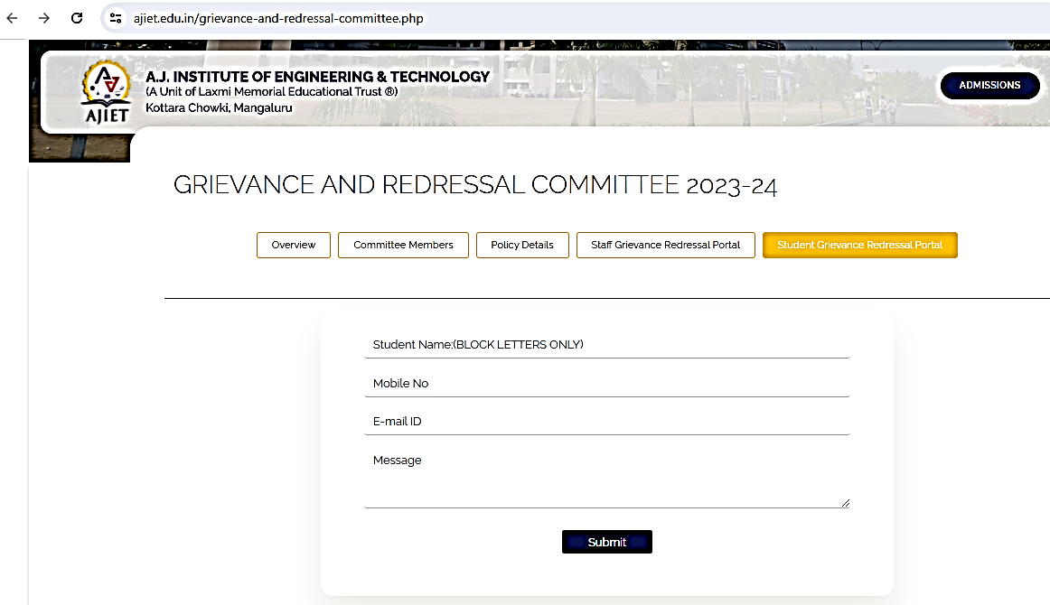
Screenshot of the institution's online grievance form, providing a user-friendly platform for students to report various concerns, ensuring prompt resolution and accountability.
Available at: https://www.ajiet.edu.in/grievance-and-redressal-committee.php

5.1.4 c Mechanisms for submission of online/offline students’ grievances

- The Institution has a transparent mechanism for timely redressal of student grievances including sexual harassment and ragging cases

The staff can register their grievances in online at
WEBSITE LINK:
https://www.ajiet.edu.in/grievance-and-redressal-committee.php
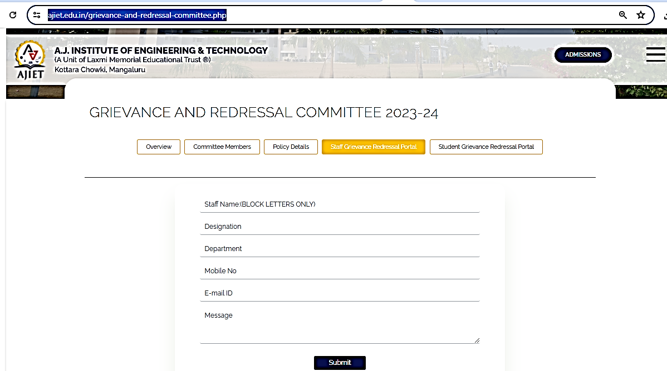
Screenshot of the institution's online grievance form, providing a user-friendly platform for staff to report various concerns, ensuring prompt resolution and accountability.
Available at: https://www.ajiet.edu.in/grievance-and-redressal-committee.php

5.1.4 c Mechanisms for submission of online/offline students’ grievances

- Sample documents of undertakings and Anti ragging Affidavit from students and parents

5.1.4 c Mechanisms for submission of online/offline students’ grievances

