5.1.4.c Proof related to mechanism for submission of Online/Offline student’s grievances
Complaint/suggestion box
Suggestion/complaint boxes have been installed at the main entrances of the institution, allowing students to drop their grievances and suggestions for improving the college's academics and administration.

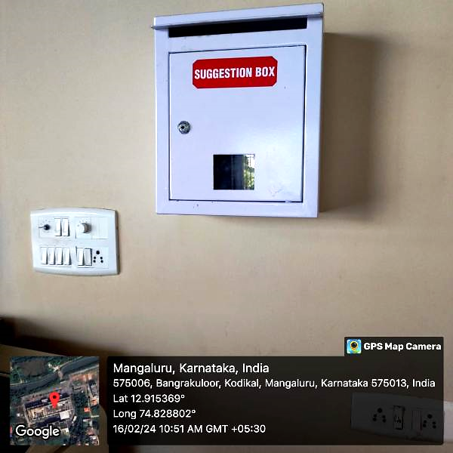
A snapshot of the suggestion box stationed in the main block, inviting anonymous complaints and suggestions to foster a transparent and inclusive environment

