5.1.4.c Proof related to mechanism for submission of Online/Offline student’s grievances

Online submission of Woman’s Welfare/ Sexual Harassment Eradication/ Internal Complaints Committee through college website and other details

The students can register their grievances in online at
WEBSITE LINK: https://www.ajiet.edu.in/women-welfare-committee.php

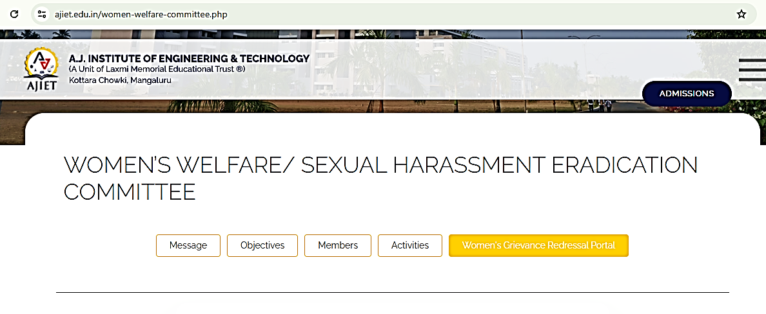
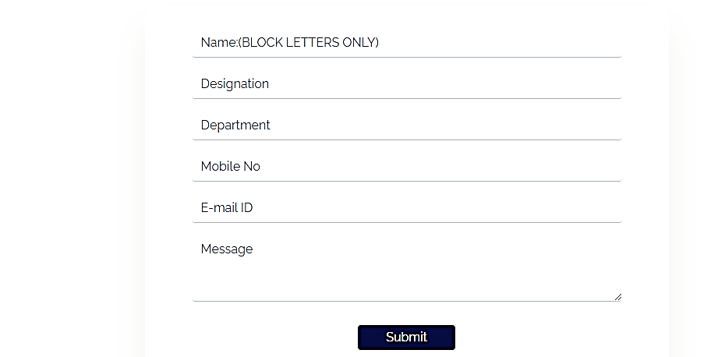
Screenshot of the institution's online submission of Woman’s Welfare/ Sexual Harassment/ Internal Complaints cases through the college website and other details. Available at: https://www.ajiet.edu.in/women-welfare-committee.php
Committee Members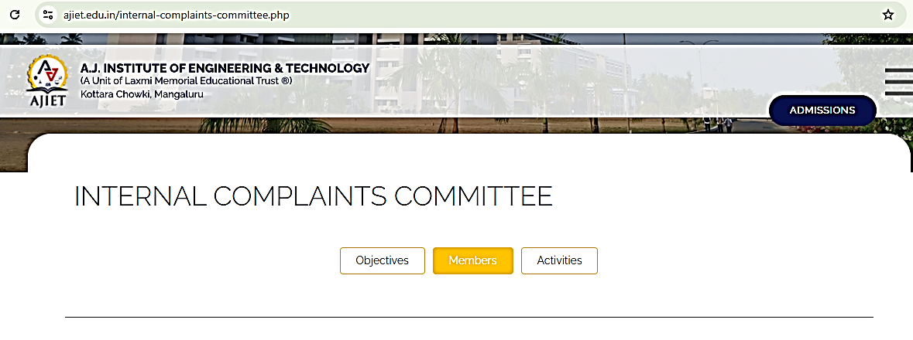 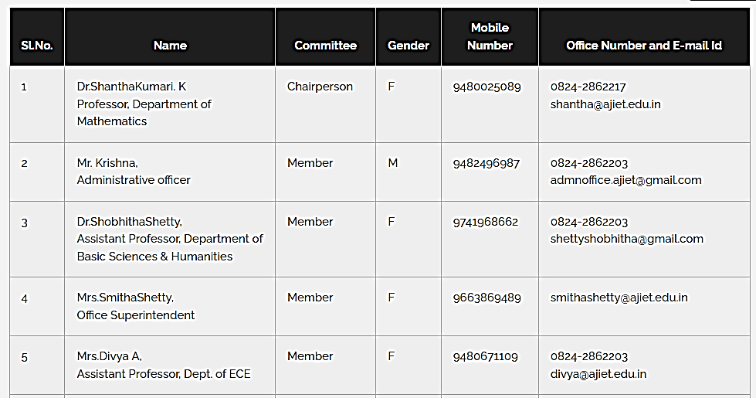
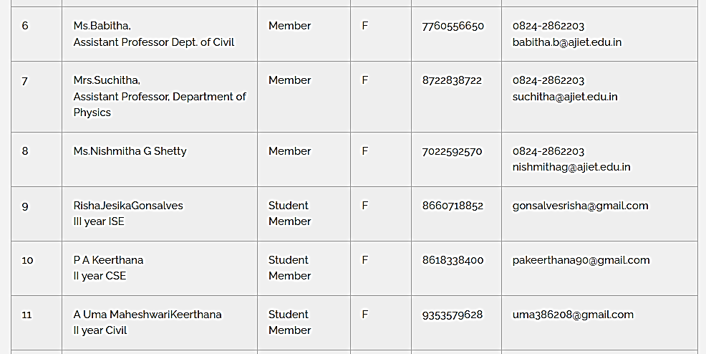
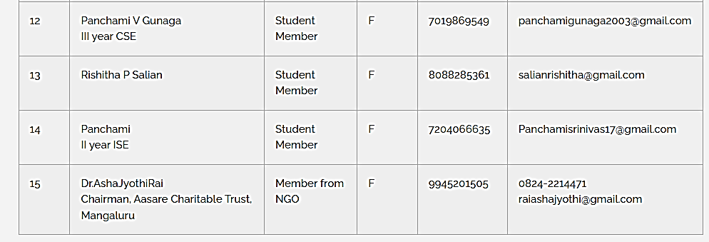
Screenshot of list of Woman’s Welfare/ Sexual Harassment Eradication/ Internal Complaints Committee Members of available on the website.

