5.1.4.c Proof related to mechanism for submission of Online/Offline student’s grievances

Online submission of ragging cases through college website and other details

The students can register their grievances in online at
WEBSITE LINK: https://www.ajiet.edu.in/anti-ragging-committee.php

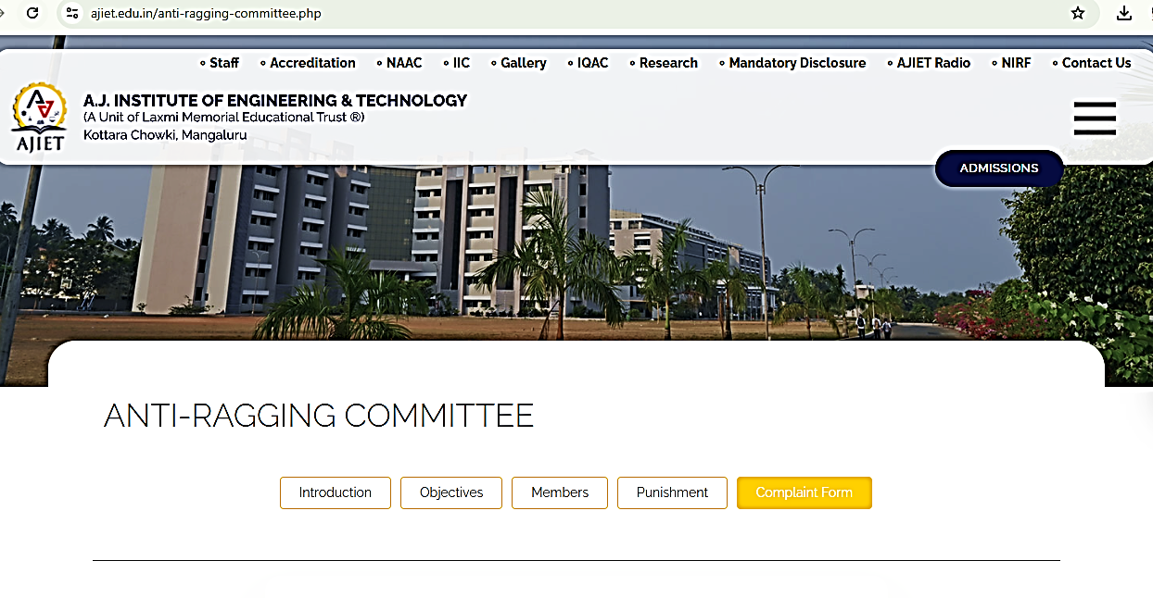
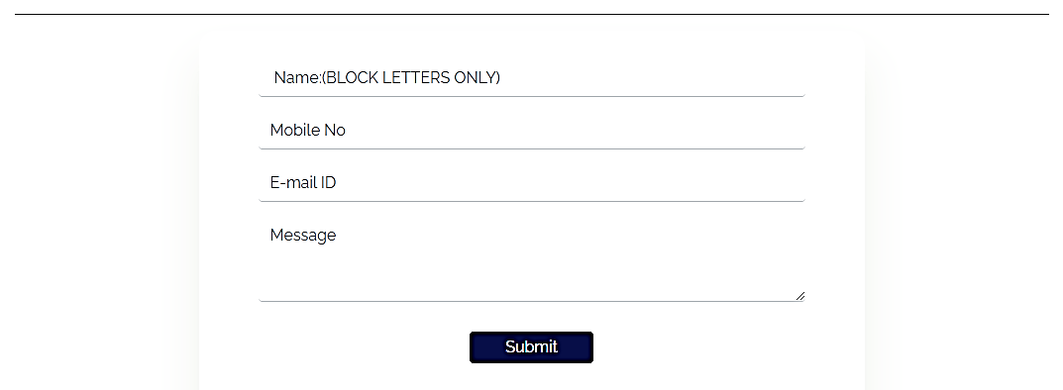
Screenshot of the institution's online submission of ragging cases through the college website and other details. Available at: https://www.ajiet.edu.in/anti-ragging-committee.php
Committee Members
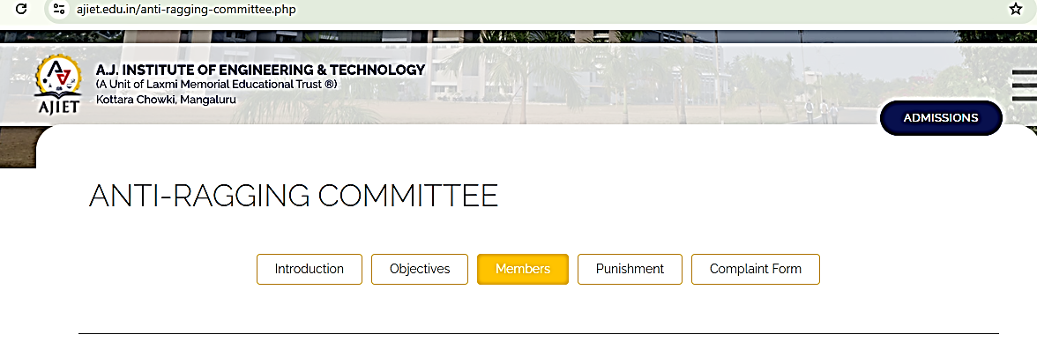
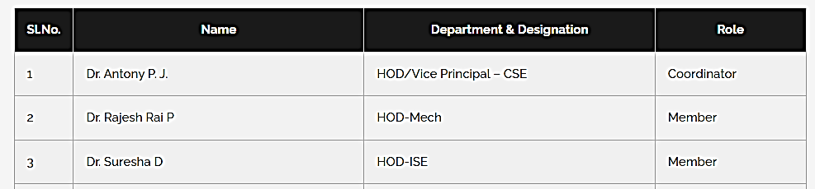
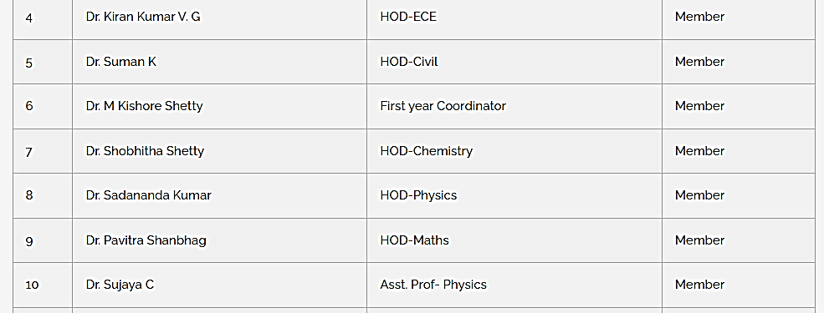
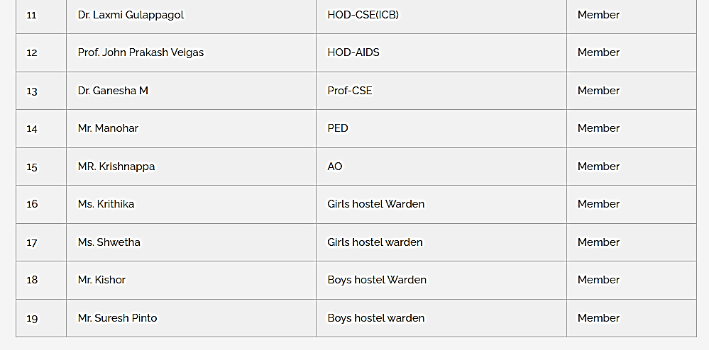
Screenshot of list of Anti Ragging Committee Members of available on the website.

