5.1.4.c Proof related to mechanism for submission of Online/Offline student’s grievances

Online Students Grievance Redressal Portal through college website
The students can register their grievances in online at
WEBSITE LINK:
https://www.ajiet.edu.in/grievance-and-redressal-committee.php
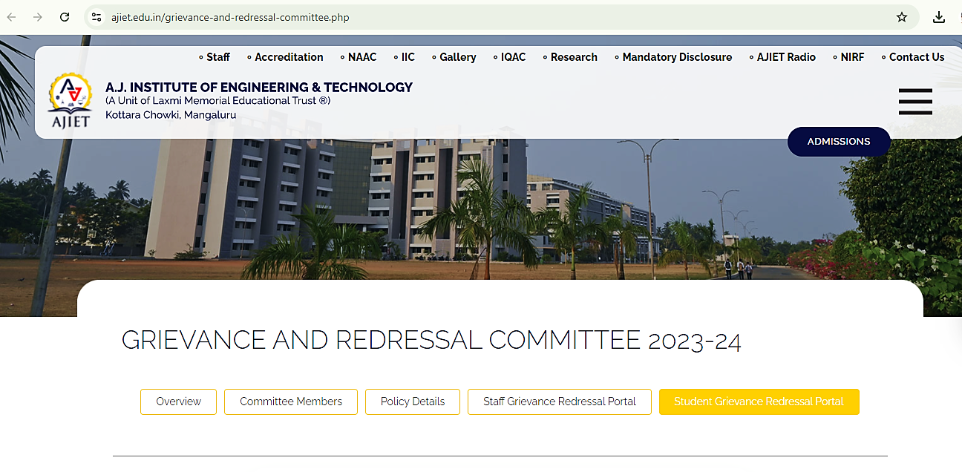
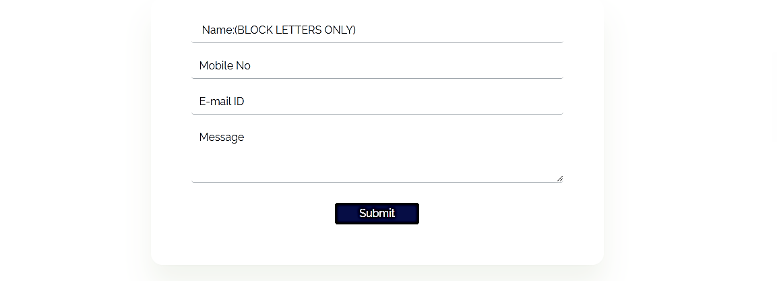
Screenshot of the institution's online grievance form, providing a user-friendly platform for Students to report various concerns, ensuring prompt resolution and accountability.
Available at: https://www.ajiet.edu.in/grievance-and-redressal-committee.php
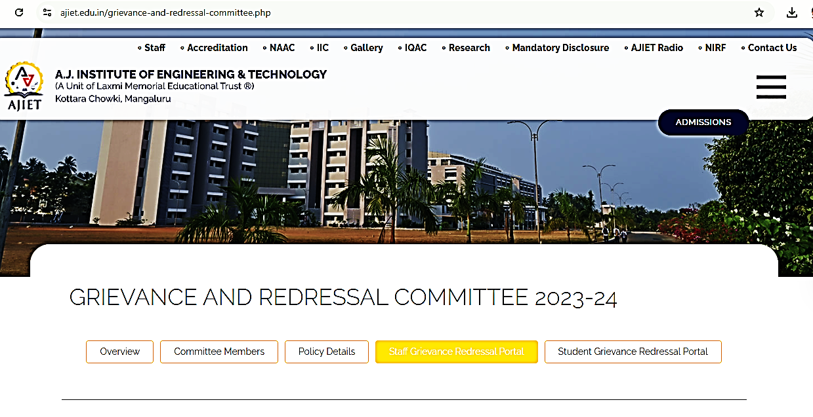
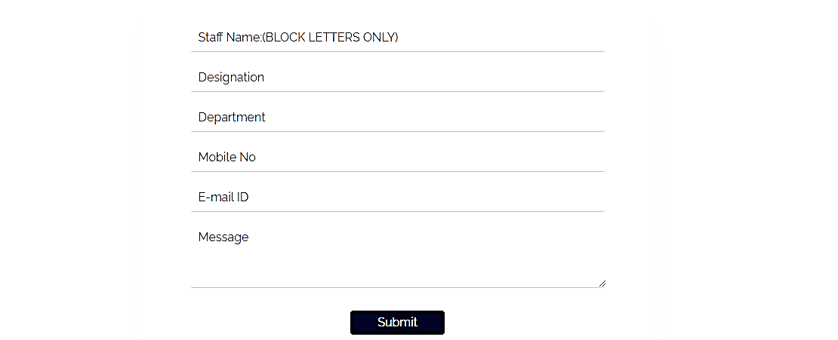Screenshot of the institution's online grievance form, providing a user-friendly platform for Staff to report various concerns, ensuring prompt resolution and accountability.
Available at: https://www.ajiet.edu.in/grievance-and-redressal-committee.php

Committee Members
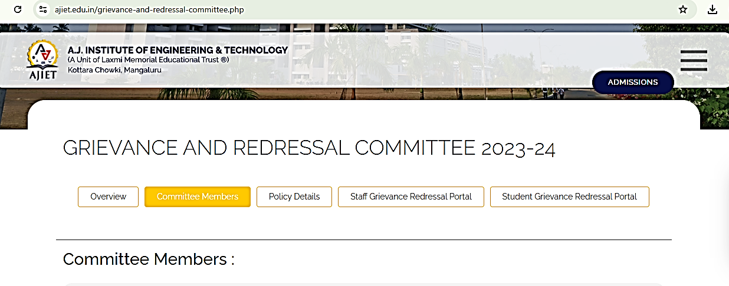
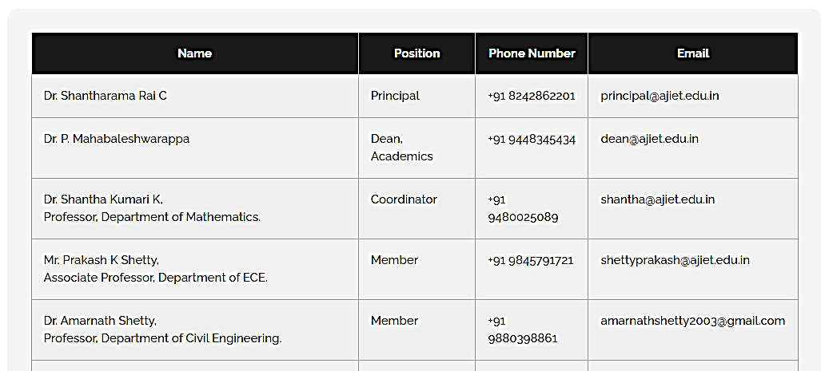
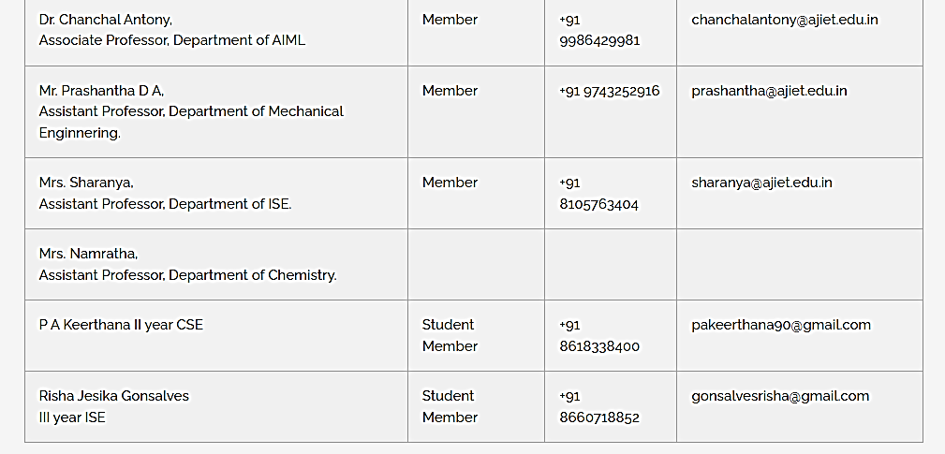
Screenshot of list of Grievance Committee Members of available on the website.

