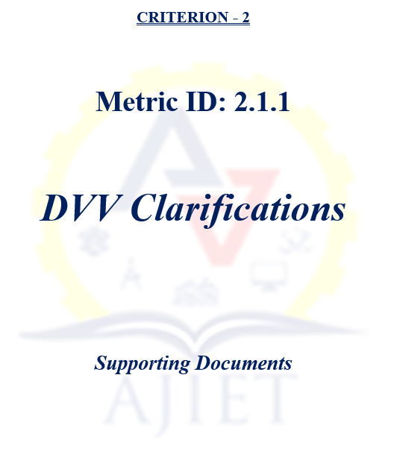

2.6.3: Pass percentage of Students during last five years
Metric No | Findings by DVV | Response by HEI | Supporting Documents
2.6.3 | 1. HEI is requested to provide year-wise result sheet published by the affiliating university for the last five years | The year-wise result sheets for the final semester students, published by the affiliating University, are available for the academic years 2019-20, 2020-21, 2021-22, 2022-23 at the provided link. The result sheet for the year 2023-24 is yet to be generated by the University. | View Document
2.6.3 | 2. Please provide Certified report from Head of the institution / Controller of Examination of the affiliating university indicating pass percentage of students of the final year (final semester) eligible for the degree program- wise / year-wise, with sealed and singed by the head of the institute. | Please find attached the certified report from the Head of the Institution, indicating the pass percentage of final-year (final semester) students eligible for the degree, detailed program-wise and year-wise. The report has been duly signed and sealed by the Head of the Institution for your kind reference. | View Document
2.6.3 | 3. kindly note that Only final year student data will be considered for all the years of the assessment. | Thank you for the kind clarification. We have ensured that only the final-year student data has been considered for all years of the assessment, as requested. | ----

